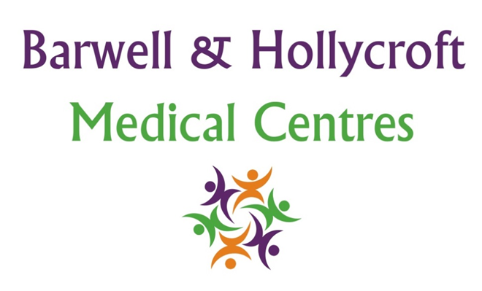
Vaccination Policy
at Barwell & Hollycroft Medical Centres
(Website Version)

Creation and Implementation:
Version: | Created: | Created by: | Approved by: | Review date: | Comments:
1 | 29/01/25 | Rohitkumar Rajyaguru | The Partners | 31/01/2025

Review of Policy:
Version: | Review date: | Edited by: | Approved by: | Comments:

At Barwell & Hollycroft Medical Centres, we are dedicated to providing high-quality healthcare services to protect the health and well-being of our patients. Vaccination is one of the most effective ways to prevent infectious diseases, and we offer a variety of vaccination services to ensure that our patients are protected.
This policy outlines the vaccination services we provide, how to access them, and the guidelines surrounding consent and scheduling.
Available Vaccinations
We offer a wide range of vaccinations to meet the needs of our patients. These include:
- Flu Vaccinations: Seasonal flu vaccinations are available to eligible patients, including those aged 65 and over, pregnant women, and individuals with certain underlying health conditions. The flu vaccine is generally offered during the autumn and winter months.
- Childhood Immunisations: We follow the NHS vaccination schedule for children, which includes vaccines such as MMR (measles, mumps, and rubella), DTP (diphtheria, tetanus, and pertussis), and other important vaccinations. These are provided in line with the national immunisation programme and recommended at specific ages.
- Travel Vaccinations: If you are planning to travel abroad, we offer travel vaccines to protect against diseases that may be prevalent in certain regions. Common vaccines include those for hepatitis A, typhoid, yellow fever, and malaria prevention (where appropriate). Please contact the practice well in advance of your travel to discuss required vaccinations.
- Other Vaccinations: We also offer certain additional vaccines, such as the shingles vaccine for older adults and pneumococcal vaccines for those at risk of respiratory infections.
Vaccination Schedule and How to Book
- Flu Vaccination: Flu vaccinations are available each autumn. You can book your flu vaccine by contacting us on 01455 849149. Please do not contact us until we have messaged you to offer the vaccine. We may also offer online booking options, which will be made available on our website closer to flu season.
- Childhood Immunisations: Childhood vaccinations are scheduled in accordance with the NHS vaccination programme. Parents or guardians will be contacted by our practice to schedule these appointments at the appropriate times for each child. If you have concerns about your child’s immunisations or need to rearrange an appointment, please contact us.
- Travel Vaccinations: Travel vaccinations should be booked at least 6-8 weeks before your planned departure. Please contact the practice to discuss your travel plans and schedule a vaccination appointment. Our clinicians will assess your requirements based on the countries you are visiting.
- Other Vaccinations: If you are eligible for a shingles vaccine, pneumococcal vaccine, or other vaccinations, please contact the practice to schedule your appointment. We will advise you on the recommended times for these vaccinations.
You can book vaccinations by calling 01455 849149 or using our online booking system if available.
Vaccines Covered Under the NHS
The NHS provides free vaccinations for individuals who meet specific criteria, including:
- Seasonal Flu Vaccine: Available free for individuals aged 65 and over, pregnant women, children aged 2-3 years, and individuals with certain health conditions.
- Childhood Immunisations: All recommended childhood vaccinations are provided free of charge under the NHS immunisation schedule.
- Shingles Vaccine: Available for individuals aged 70 to 79 as part of the NHS immunisation programme.
- Pneumococcal Vaccine: Free for individuals over 65 and those with certain health conditions.
- Respiratory Syncitial Virus (RSV): Free for those 75 or older, pregnant people who are at least 28 weeks.
Please contact the practice to find out if you are eligible for any of these free NHS vaccinations.
Guidelines on Consent for Vaccination
Before receiving any vaccination, patients (or parents/guardians in the case of children) will be asked to provide consent. This ensures that you understand the benefits and potential risks of the vaccine.
- For Children: Parental or guardian consent is required for all childhood immunisations. Our staff will discuss the vaccination with you, answer any questions, and ensure that you are fully informed before providing consent.
- For Adults: For adult vaccinations, including the flu vaccine and travel vaccines, you will be asked to consent to the vaccination during your appointment. Our clinicians will provide you with information about the vaccine and address any concerns you may have if requested.
If you have any concerns about the vaccinations or need further information, please ask our team. We are happy to discuss any aspects of the vaccination process to ensure you are comfortable with your decision.

Contact Us
For further information on available vaccinations, to book an appointment, or to discuss your vaccination needs, please contact us:
- Phone: 01455 849149
We are committed to keeping you safe and healthy. Thank you for trusting Barwell & Hollycroft Medical Centres with your healthcare needs.

