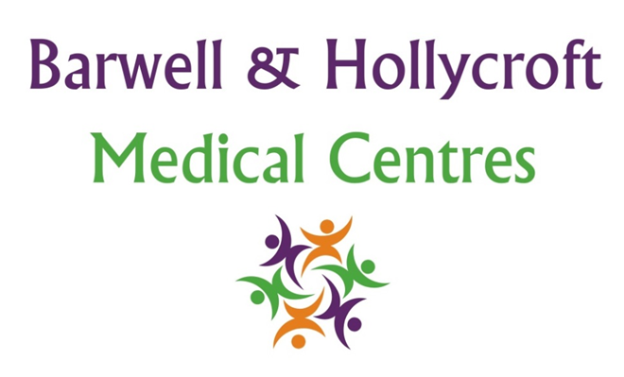
Visitor and Patient Behaviour Policy
at Barwell & Hollycroft Medical Centres
(Website Version)

Creation and Implementation:
Version: | Created: | Created by: | Approved by: | Review date: | Comments:
1 | 29/01/25 | Rohitkumar Rajyaguru | The Partners | 31/01/2025

Review of Policy:
Version: | Review date: | Edited by: | Approved by: | Comments:

At Barwell & Hollycroft Medical Centres, we are committed to providing a safe and welcoming environment for all of our patients, visitors, and staff. This policy outlines the expected behaviours and conduct within our practice, ensuring that all individuals feel respected, safe, and valued during their visits.
Expected Behaviours for Patients and Visitors
We ask that all patients and visitors treat our staff, fellow patients, and the practice environment with respect and consideration. The following behaviours are expected:
- Respectful Interaction: We expect all patients and visitors to engage with our staff and other patients in a courteous and respectful manner. This includes using appropriate language, maintaining a calm and cooperative attitude, and being mindful of others’ needs.
- Confidentiality: We ask that patients and visitors respect the confidentiality of others by not overhearing or discussing other people’s personal health information.
- Cleanliness and Order: We encourage patients and visitors to maintain cleanliness in the waiting areas and to dispose of any waste (e.g., tissues, wrappers) in the bins provided.
Consequences for Disruptive or Abusive Behaviour
The safety and wellbeing of our patients and staff are of the utmost importance. Disruptive, aggressive, or abusive behaviour will not be tolerated. We consider behaviours such as shouting, swearing, threatening, or any form of physical violence to be unacceptable. In the event of such behaviour:
- Removal from Premises: Any individual displaying disruptive or abusive behaviour may be asked to leave the premises immediately. We may also refuse to provide further services if necessary.
- Reporting to Authorities: If the behaviour is deemed severe or poses a risk to safety, we may involve the relevant authorities, such as the police, to ensure the safety and security of everyone in the practice.
Policies on Use of Mobile Phones, Smoking, and Other Behaviours
To maintain a professional and respectful environment, we have the following guidelines in place:
- Mobile Phones: We ask that patients and visitors use mobile phones in a way that does not disturb others. Please set phones to silent mode when in the waiting areas, and use headphones if listening to music or making calls. If necessary, we ask that mobile phones be used discreetly outside of clinical areas.
- Smoking: Smoking is not permitted anywhere within the practice premises or the surrounding areas. We are a smoke-free environment, and we kindly request that patients and visitors refrain from smoking before entering the practice.
- Food and Drink: We ask that patients and visitors refrain from eating or drinking in clinical areas unless required for medical reasons. Please ensure that food and drinks are consumed only in designated areas.
Zero-Tolerance Policy for Violence or Abuse Toward Staff
We have a zero-tolerance policy for any form of violence or abuse toward our staff. This includes physical violence, verbal abuse, or any behaviour that may cause harm, distress, or intimidation.
- Staff Protection: All staff members are entitled to work in an environment free from abuse, threats, and violence. Any patient or visitor who engages in violent or abusive behaviour will be asked to leave the premises immediately, and appropriate actions will be taken.
- Permanent Removal: In cases of severe or repeated abusive behaviour, patients may be permanently removed from our practice list and may no longer receive services from Barwell & Hollycroft Medical Centres.

Contact Us
If you have any questions about our Visitor and Patient Behaviour Policy or would like to discuss any concerns, please contact us:
- Phone: 01455 849149
- Email: Barwell.MC@nhs.net
We are dedicated to providing a safe, respectful, and supportive environment for all our patients and visitors. Thank you for your cooperation in helping us maintain a positive and welcoming atmosphere at Barwell & Hollycroft Medical Centres.

