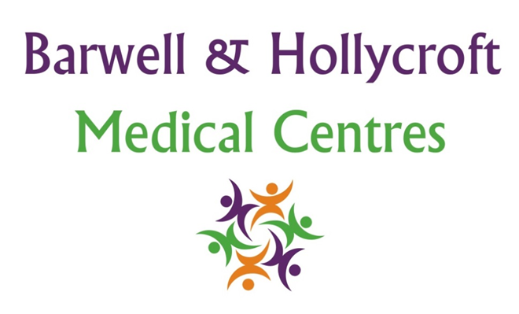
Access to Interpreters and Translation Services
at Barwell & Hollycroft Medical Centres
(Website Version)

Creation and Implementation:
Version: | Created: | Created by: | Approved by: | Review date: | Comments:
1 | 29/01/25 | Rohitkumar Rajyaguru | The Partners | 31/01/2025

Review of Policy:
Version: | Review date: | Edited by: | Approved by: | Comments:

At Barwell & Hollycroft Medical Centres, we are committed to providing high-quality care to all our patients, regardless of their language or communication needs. This policy outlines the services available for patients who require assistance with language translation or interpretation during their appointments.
Availability of Translation or Interpretation Services
We understand that clear communication is essential for effective healthcare. Therefore, we offer access to professional interpreters and translation services to support patients who may not speak English as their first language or those who have hearing impairments.
How to Request an Interpreter for Appointments
If you need an interpreter for your appointment, we ask that you let us know in advance. You can request an interpreter by:
- Phone: Call us on 01455 849149 to inform us of your need for an interpreter.
- At Reception: When booking an appointment in person, please inform our reception team about your need for an interpreter.
We aim to arrange an interpreter for your appointment whenever possible. For language assistance, we provide telephone and face-to-face interpreters, depending on your needs and availability.
Available Languages and Access to Sign Language Services
We offer a wide range of interpretation services for many languages. If you require assistance in a language other than English, we will make every effort to arrange a qualified interpreter who speaks your preferred language. We also offer access to British Sign Language (BSL) interpreters for patients with hearing impairments but this does require at least 48 hours notice.
Patient Responsibilities to Request Services in Advance
To ensure that we can provide you with the best possible service, we ask that you request an interpreter or translation service as far in advance as possible. This allows us to secure the appropriate resources for your appointment. Ideally, please inform us at least 48 hours in advance of your appointment so we can arrange for an interpreter to be available.
If you have a more urgent appointment and need language assistance, please still contact us, and we will do our best to arrange support for you.

Contact Us
If you need an interpreter or translation services, or if you have any questions regarding these services, please contact us at 01455 849149 or by email at Barwell.MC@nhs.net. We are happy to assist and will work with you to ensure that communication during your appointment is clear and effective.
Thank you for choosing Barwell & Hollycroft Medical Centres. We are committed to making sure all our patients receive the best care, regardless of language or communication barriers.

