PRG MEETING – THURSDAY 11th September 2025 AT 1PM BROADWAY MEDICAL CENTRE

Attendees: Lauren Smith (Locality Manager), Kenneth Rhodes, Poonam Sakarsudha, Kerry Rhodes, Viv Westhead.
Welcome and Introductions were made along with apologies
Operational Update
Looking back at the minutes in June from Kerry (Previous Locality Manager) I can see she noted our new phone system was in process of being installed. I can confirm this month our new phones will be going live. Which will be a big improvement for us. The new system will show us how many callers are in the queue, there will also be a call back system where you can ask that you get call back without losing your place in the queue should you wish to rather than holding on the phone.
Staffing Update
Sadly, Kerry Blakemore has now resigned (Previous Locality Manager). Amanda Green (Receptionist) has resigned due to ill health. And lastly our clinical letter summariser, Dakshaben Pandya has also resigned.
New Locality Manager Lauren Smith has taken over the post to manage Broadway Medical Centre. We are looking at advertising to cover hours lost in reception.
Patient Feedback
Friends and Family Feedback for July were fed back to the group. (As Augusts data at the time wasn’t available)
92% of patients said our services were good or very good. Up 3% from the figures from the last meeting in June.
The group would like to know the response rate of all patients who are sent the text compared the number of patients that actually reply and give feedback. Lauren will ask the question.
Committee Elections, Terms of Reference and AGM
13 shortlisted applications were received for the Position of PRG Chair. In the email sent to the PRG members with these minutes- it also includes all applications which Lauren has asked for votes to be made and sent back into her by Friday 10th October. The successful candidate will then be contacted and invited in to discuss a new terms of reference and the creation of a new Agenda for the next PRG meeting on Thursday 13/11/25 1pm-2pm.

Missed Appointments
Lauren gave a spreadsheet out which shows the DNA’s each month (Did not attend appointment). The spreadsheet is broken down into Drs, Advance Nurse Practitioners and Pharmacists, Practice Nurse and Health Care Assistants and Physiotherapist. GP appointments 51 missed appointments in June it was 40 missed. Pharmacists and Nurse Practitioners were 30 missed in June it was 34. Nurse and Healthcare assistant appointments missed was 80. In June it was 67. So overall July has been a worse off month for patients not attending appointments.
Volunteers for promoting PRG, PRG Local Surveys (150 Needed) during Flu Season;
During the Flu/COVID season –October we will be starting to hand out our local Survey’s. Where we ask each year for patient feedback on our services. PRG members were asked if they have any free time during October where they could come in and help get patients to fill in a survey. The new PRG chair will be in contact with them to organise once newly appointed. Any help would be greatly appreciated as we need 150 competed surveys.
Flu/COVID Update;
From 1st Sept – we offered Flu to Pregnant ladies and child nasals first. From the 1st Oct we will offer ‘Duel clinics’ of both Flu & COVID boosters. Which are now all bookable.
New chair PRG;
It was advised to the group we had 13 shortlisted applications which is a compliment to the Surgery to have so many patients interested in the role. Once voting has been completed. The new chair will be appointed in time for the next PRG meeting.
The new chairs responsibilities will include checking and updating our terms of reference for the group, helping with agenda and minutes to the meeting, newsletter updates, the organisation of reception display notice boards and organising staffing for the completion of patient surgery’s during October/November.
AOB –
We have a new social prescriber – Sharon Whitchurch. She has many years’ worth of experience so will be so valuable for us to use. If you or anyone you are aware of could benefit from Sharon’s input please spread the word and contact Receptionist for her to contact you.
Sharon can help individuals connect with community resources and services to address social, emotional, and practical needs that impact their health and well-being. And if they are generally struggling day to day I.e;
- Has one or more long-term conditions
- Who need support with their mental health
- Who are lonely or isolated
- Who have complex social needs which affect their wellbeing
- Bereavement
- Mental health
- Pain management
- Addiction
- Employment problems
- Disability
- Lifestyle choices
- Debt and benefit issues
- Carers
- Elderly patient struggling at home
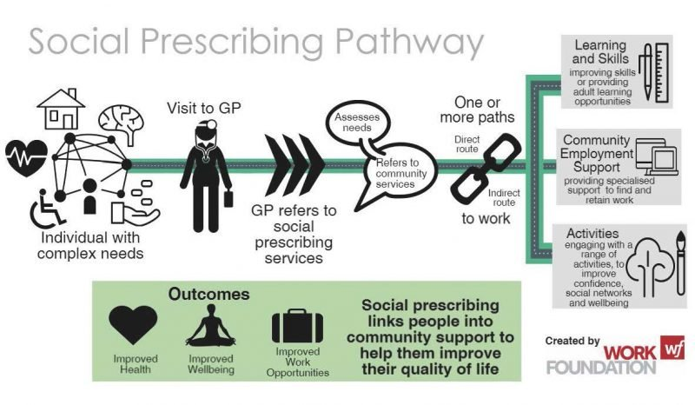

Next Meeting;
Thursday 13th November 2025 1-2pm

