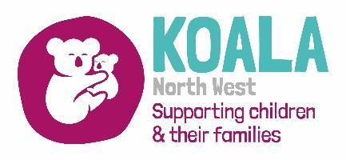
Koala NW Sleep Support Service Referral Form – Wirral & Cheshire

Effective Sleep Management Approach for Parents of CYP with Neurodevelopmental Needs (ASD / ADHD)

Thank you for your referral.

Referral Criteria:

The following criteria must be met in order to process the referral:
- Children aged between 2 and 11 years of age
- Diagnosed or on the pathway for Autism Spectrum Condition (ASC) or Attention Deficit Hyperactivity Disorder (ADHD)

Koala NW will discuss with parents which is the best option for them:

- 1:1 Intensive Support sessions over 6 weeks
- 6-week Koala Sleep Course

PARENT/CARER DETAILS

 | Parent/Carer 1 | Parent/Carer 2
Name
DOB
Ethnicity
Address
Contact Tel No:
Email Address:
Other professionals involved

CHILD DETAILS
Please complete the boxes which apply to all children in the household

Child FULL Name  (Eldest First) | DOB | Gender | Ethnicity | Diagnosis | Prescribed Melatonin | If yes, how many milligrams prescribed?
C1
C2
C3
C4

Any further details:
(please include diagnosis (or if on pathway), any previous sleep support, any other medication the child / young person is taking)

Date of referral:
Name of referrer:
Job Title:

Please email this referral to sleep@koalanw.co.uk

