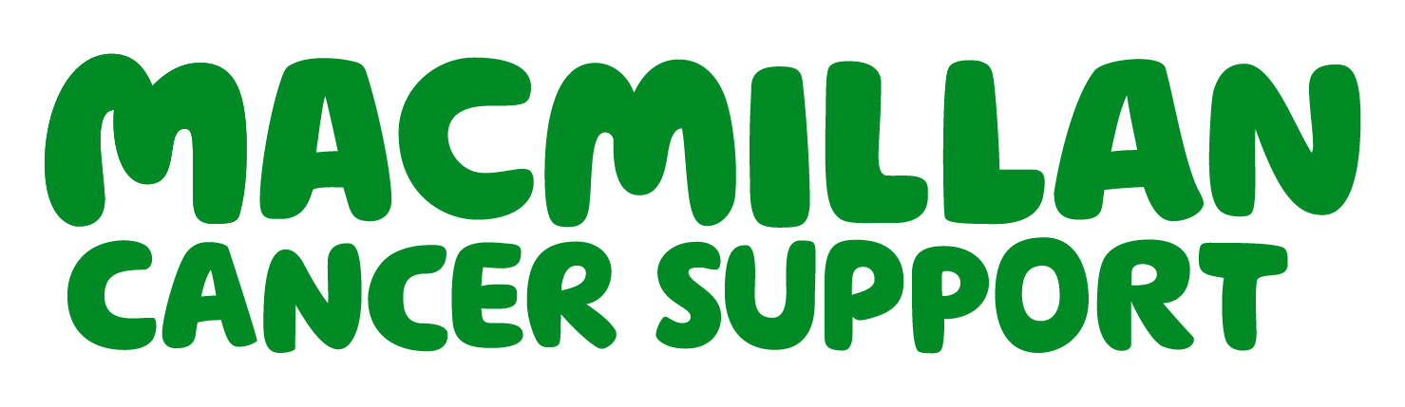
Macmillan Cancer Information and Support December 2025 Newsletter
  - Improved access to financial support for people affected by cancer

IMPROVED ACCESS TO FINANCIAL SUPPORT FOR PEOPLE AFFECTED BY CANCER
NEWARK YMCA UPDATE AND NEW DIRECT LINE
CANCER INFORMATION AND SUPPORT EVENTS – A SUCCESS
WHATS ON? OUR TIMETABLE
OTHER EXCITING NEWS

Thank you for supporting our YMCA Macmillan Coffee morning.
We raised £196
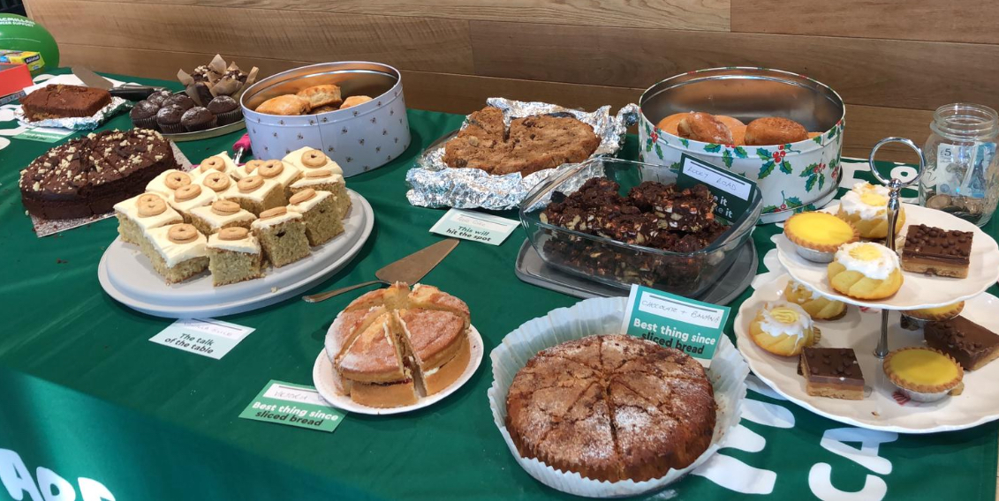

YMCA Macmillan Coffee Morning
We are delighted to announce that we have developed new links with the Department of Work and Pensions (DWP) Home Visiting Service. We, and our cancer nurse specialist colleagues, can directly refer people affected by cancer to the DWP Home Visiting service for benefits checks and support filling claim forms. This service gives patients choice about where they access the support needed, and it complements our existing relationships with Citizens Advice and other charitable organisations.
Newark YMCA Update
CONTACT US ON OUR NEW DIRECT LINE AT THE YMCA
01636 652532

Our YMCA Centre continues to attract more visitors and host more wellbeing events. Since opening our doors in June 2025, and we have welcomed and supported 434 people in the centre. We have also spoken with 670 people over the phone, email or text. We continue to work in our local community and with our partners to spread the word that we are open and supporting local people.
Relaunched Cancer Information and Support Events – A success.
“A good introduction into the world of cancer - a starting point of where to go for what”
This year we have worked with our partners, and people with lived experience of cancer, to relaunch our Cancer Information and Support Events at the hospital. Events are now more interactive and bring over 15 “market stall” holders into the room to showcase the range of support services available to local people affected by cancer.
Despite recruitment to the event being challenging, feedback has been very positive with all attendees rating the event as very good or good. For further information and booking contact us on 01623 672333 0r 01623 652532.
“Great event. It really helps to be introduced to the range of services that I was previously unaware of”.

What’s On?
Our Cancer Information Centres at KMH and YMCA are open for people to drop in’s Mon – Fri 8.30am – 4pm (excluding bank holidays). See timetable for sessions, events and groups that are happening.
Blue = KMH events Green = YMCA events R/AO = Referral / appointments only WkoM = Week of the month
 | Morning | Afternoon
Mon | Hair Loss Clinic  (Contact Aderans Trendco 0115 947 5316 to book)
Tues | Cancer Psychology (R/AO)  Beyond Diagnosis Wellbeing Clinic (R/AO)  Beyond Diagnosis Stepping Stones Bereavement Support Group (last Tues of the month) | Women’s Look Good Feel Better 1st WKoM (booking essential)  Cancer Support Walking Group 2nd / 4th WKoM  Cancer Psychology (R/AO)  Beyond Diagnosis Cancer Carers Support Group 1st WKoM
Wed | Cancer Psychology (R/AO)  Social Prescribing Clinic (R/AO) | Cancer Big Issues Support Group 2nd WKoM  Cancer Awareness and Promoting Health 4th WKoM  Hope & Glory Support Group (2nd WKoM – HOPE graduates only)
Thurs | Cancer Psychology (R/AO)  Hair Loss Clinic  (Contact Aderans Trendco: 0115 947 5316 to book)  Haematology direct referral pathway MCISS appointments (pilot project) | Cancer Psychology (R/AO)  Cancer Support Walking Group 1st / 3rd WKoM  Supporting Hard to Reach Community (2nd WKoM)  Women’s Look Good Feel Better 4th WKoM (booking essential)  Men’s Look Good Feel Better – Facing Cancer with confidence (4th WKoM quarterly, Booking essential)
Fri | Cancer Psychology (R/AO)  Craft & Chat Cancer Support Group (Monthly)  Cancer Psychology (R/AO) | Cancer Psychology (R/AO)  Cancer Psychology (R/AO)
Other Events
Cancer Information and Support Events (Booking essential) , HOPE - Living Beyond Cancer Programmes (Booking essential), Citizens Advice / DWP Home visiting Service appointments (Room booking on request)
Other exciting news …….
National Macmillan Cancer Support Conference
The team have been selected to deliver a seminar at the National Macmillan conference in April 2026 to showcase our unique Newark development. The session will be called “Working differently – successful partnerships serving our neighbourhoods.” We will also be taking a poster to facilitate discussions at the conference about using Apps, like our SFHT Cancer App, to expand the reach of information and support services.
Look Good Feel Better Sessions
We held our first Look Good Feel Better – Facing cancer with confidence session for men in November. The session was attended by 6 gentlemen who learned lots about skin care, shaving, personal styling and the imporance of diet and exercise when living with and beyond cancer. More sessions are scheduled next year.
Exploring new support networks
We ar working with Target Ovarian Cancer, Smell Taste, complimentray therapists, post surgery bra fitters, and the YMCA to bring new support to our areas - watch this space for updates.
Thank you
A special thank you to Ableworld for their donation of tea and coffee for our visitors. Thank you to Val Perrin for visiting us and reminding us about the fabulous voluntary work you do to support our patients to access essential equipment through a range of grants.
Thank you to Currys Repair Centre and Asda for hosting us – Helping us to spread the word that Cancer Information and Support is now in Newark
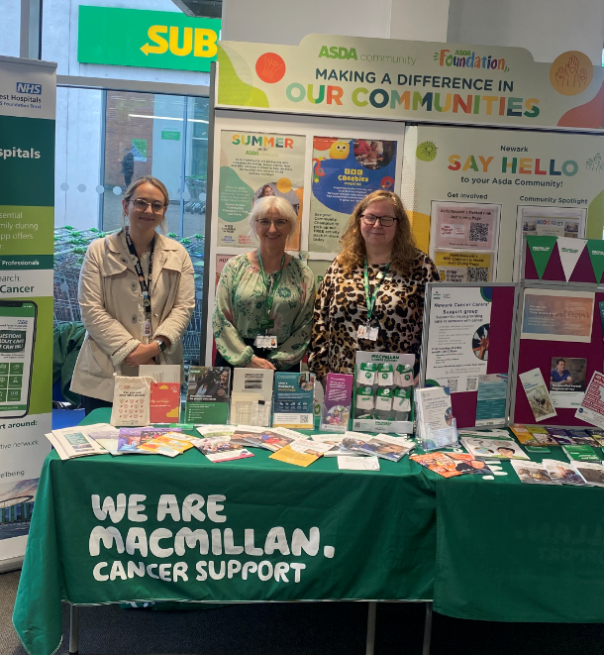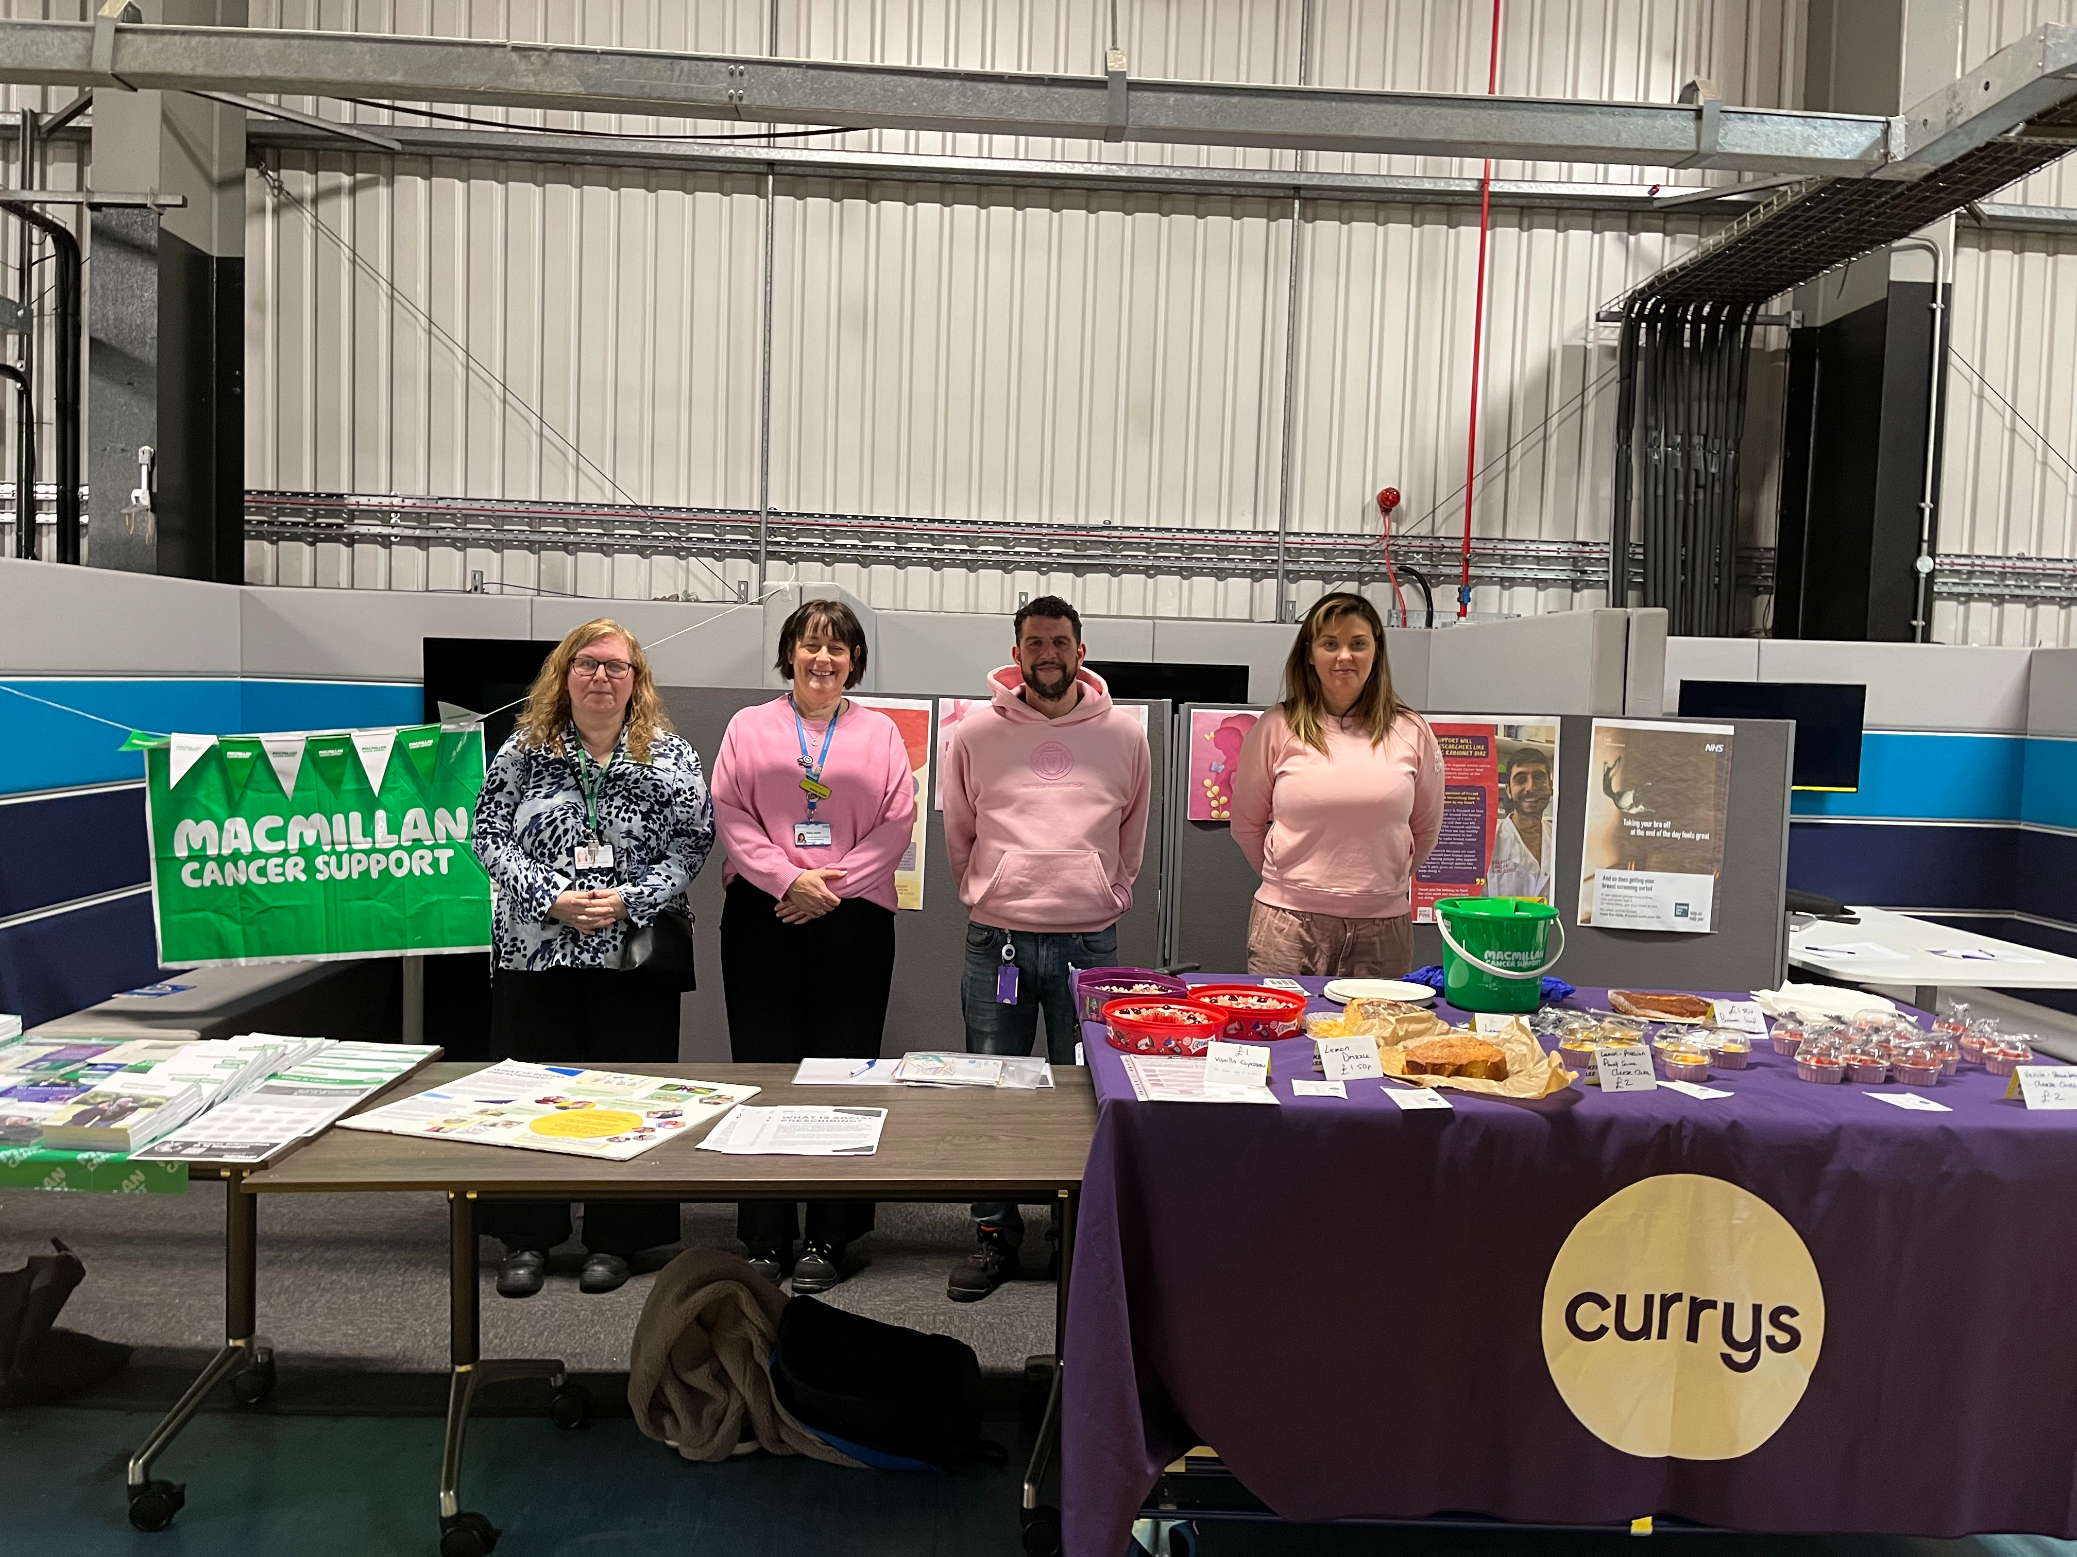

.
Contact us – 01623 672333 or 01636 652532
Sfh-tr.cancer.info@nhs.net
Download our Free Cancer App and Search “Sherwood Forest Hospitals Cancer App” Android iPhone  

If you have any comments about our newsletter, or if you do not wish to receive these regular newsletters, please email us. Thank you for your support.

