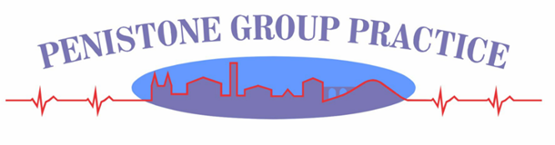
Summary of Complaints Procedure at Penistone Group Practice
The NHS advises that concerns are initially discussed with a relevant member of staff, as often things can be resolved quickly and effectively.

However, it is straightforward to make a formal complaint if you need to:

A formal complaint can be received in writing or verbally to the Business Manager.

In some circumstances the complaint can be resolved at the time, to the satisfaction of all involved. If this is not possible, or if further investigation is required, written acknowledgement of the complaint will be sent to the complainant within 3 working days.

A complaint investigation will then take place at the GP surgery.

The Lead Investigator of this complaint will usually be Donna Parker (Business Manager).

If the complaint relates to a matter requiring clinical knowledge or medical expertise, the Lead Investigator of the complaint will usually be Dr Jonathan Breeze (GP Partner and Clinical Complaints Lead GP), or alternatively another Senior GP.

An investigation would, as a minimum, usually involve discussion with the staff member(s) involved, and an assessment of the medical notes.

A written response will then be issued to the patient, with an explanation of what has happened. It may include an apology, learning points for the practice, or policy changes.

We follow the NHS complaints procedure, which obliges a response in writing within 6 months. However, even where significant investigation is required, the response time from our surgery is usually less than four weeks.

It is rare that this response does not satisfy the complainant, but at this stage the patient has the right to contact the Ombudsman for Health for an external evaluation of the issue, and our response will set this out in writing.

