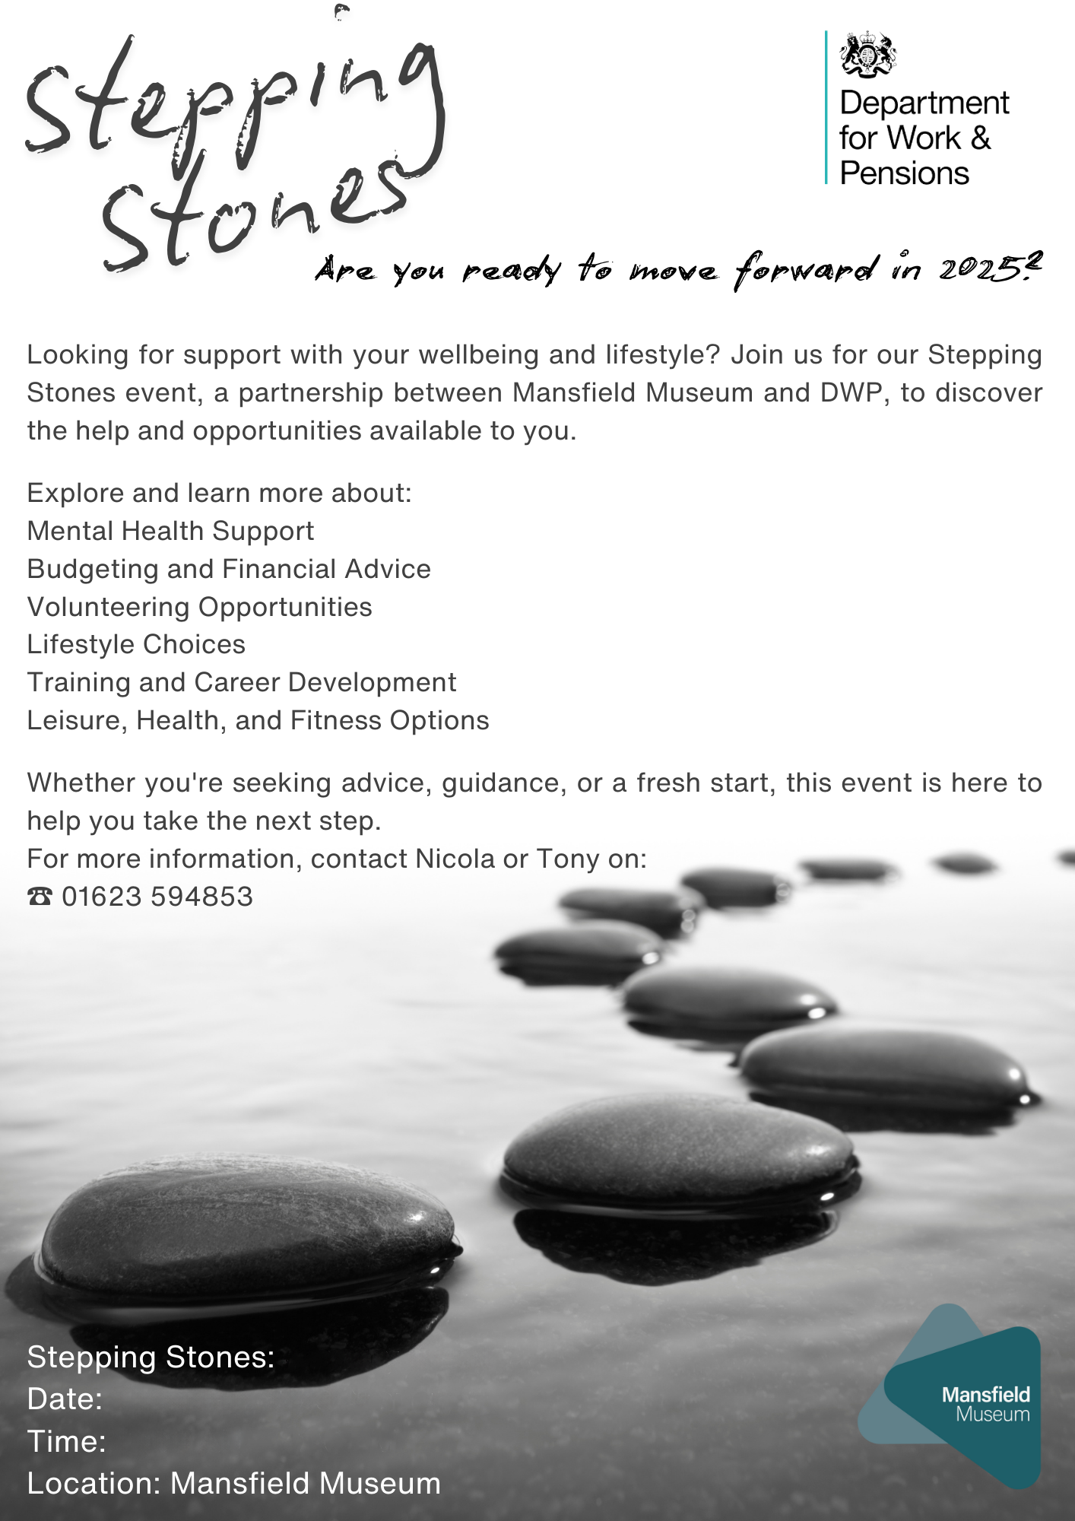
Summer Event
Thursday, 17th July 2025
11:00 AM - 1:00 PM

