GETTING VACCINATED
The NHS offers free vaccines to everyone in the UK at recommended ages. If you are unsure whether you or your child have received all routine vaccinations, contact your GP or click the link for more information. www.nhs.uk/conditions/vaccinations/
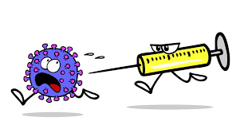

UPDATE YOUR DETAILS
Keep your contact details up to date so we can reach you with important information and reminders



PLEASE COMPLETE A Friends & Family SURVEY
We value your feedback to help improve our practice. Please share your views on how we’re doing by asking reception for a feedback slip.

WELCOME TO JOIN
PATIENT PARTICIPATION GROUP (PPG)
Alternately, have your say about the services provided. Please join our PPG group discussion




CQC Overall Rating GOOD
Awarded April 2024

All calls are triaged to ensure you are directed to the most appropriate healthcare professional, which may include a GP, Nurse, HCA, Community Pharmacist (CP) Specialist Practitioner (SPLW), Physio, Dietician or Mental health practitioner

EMERGENCY OUT OF HOURS:
1) For Advice Please Ring
NHS 111
2) In a Life Threating Emergency Call 999

DIGITAL INNOVATION
We are excited to announce that our practice is continuously improving its digital footprint!

PRACTICE IS GOING PAPERLESS PATIENT DATA ACCESS
Easily manage your health with the NHS App. Register today to:
Request prescriptions, view test results and access all your medical records.
Click here to register
https://www.nhs.uk/nhs-app/ 

TELEPHONY
We continue to improve our telephone access, patients can
use the call back service to skip long queues & cancel appointments quickly without speaking to staff and waiting in the queue.

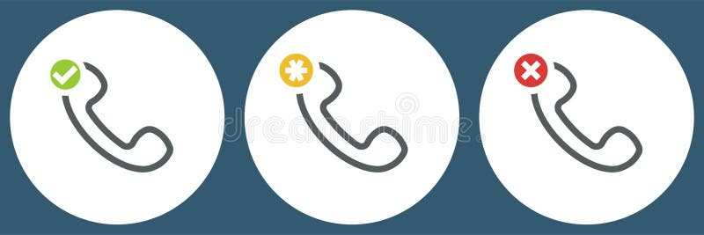

PATIENTS NEWS AND INFORMATION.

STAFF NEWS

Welcome back Ishka from maternity leave & Look forward to Mo returning in November.

Welcome to Nishi our new CP and Sheetal our new HCA.

Leavers: Krishna wishing her all the best,

CORE OPENING HOURS
Our core opening hours are now Mon–Fri, 8:00 am–6:30 pm for both doors and phone lines.

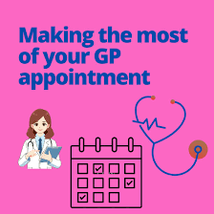

APPOINTMENT SYSTEM

Routine Appointments:
Routine appointments can be booked up to 2–3 weeks in advance.

For Same-Day / Emergency Appointments:

Our Care Coordinators will triage all requests and may offer:
- A face-to-face appointment with a clinician at the practice.
- A telephone consultation with a GP.
- Request completion of an online consultation.
- Referral to our Harness Hub service in and around Brent.

PRESTON HILL SURGERY BULLETIN Issue 3

Child Health Event Organised
By Dr BHACHU
We are delighted to share that our first Child Health Event was a great success! Families had the chance to hear from guest speakers across the Dental Team, Nutrition Team, Vaccine Team, Breastfeeding Team, and Brent Health Matters—all providing valuable advice and support for giving children the best start in life.

Here are some highlights we captured from the event.



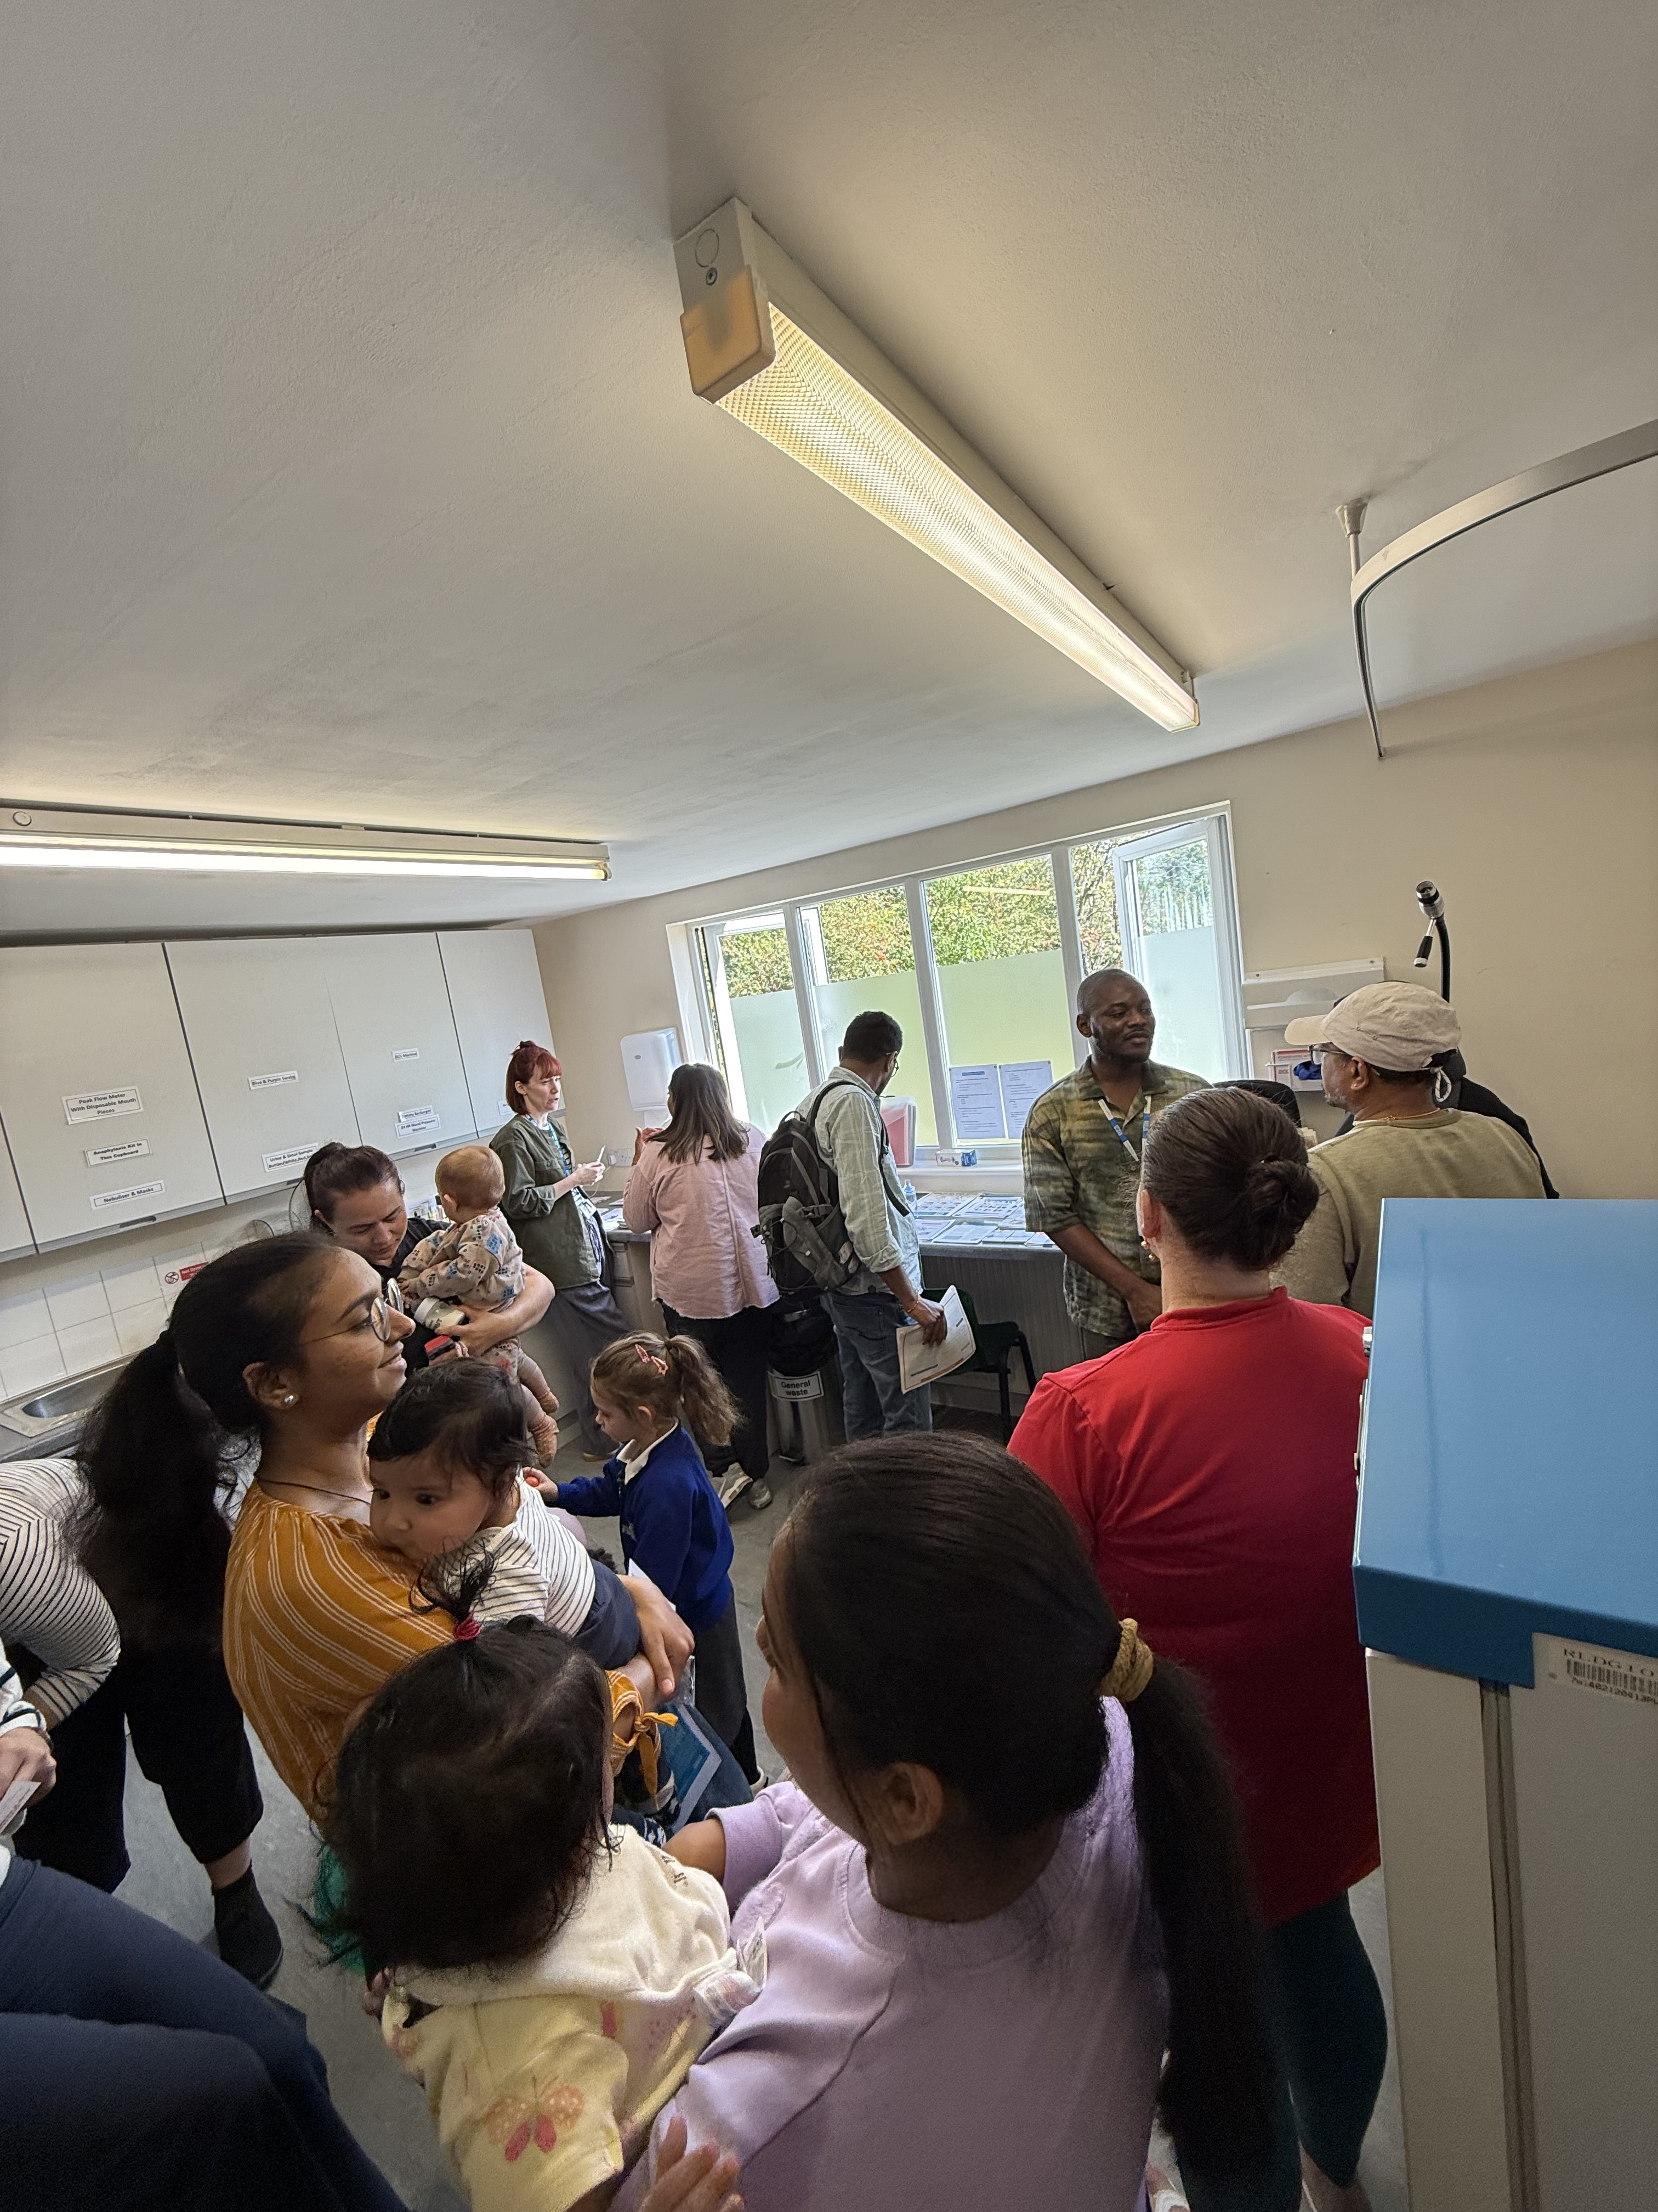

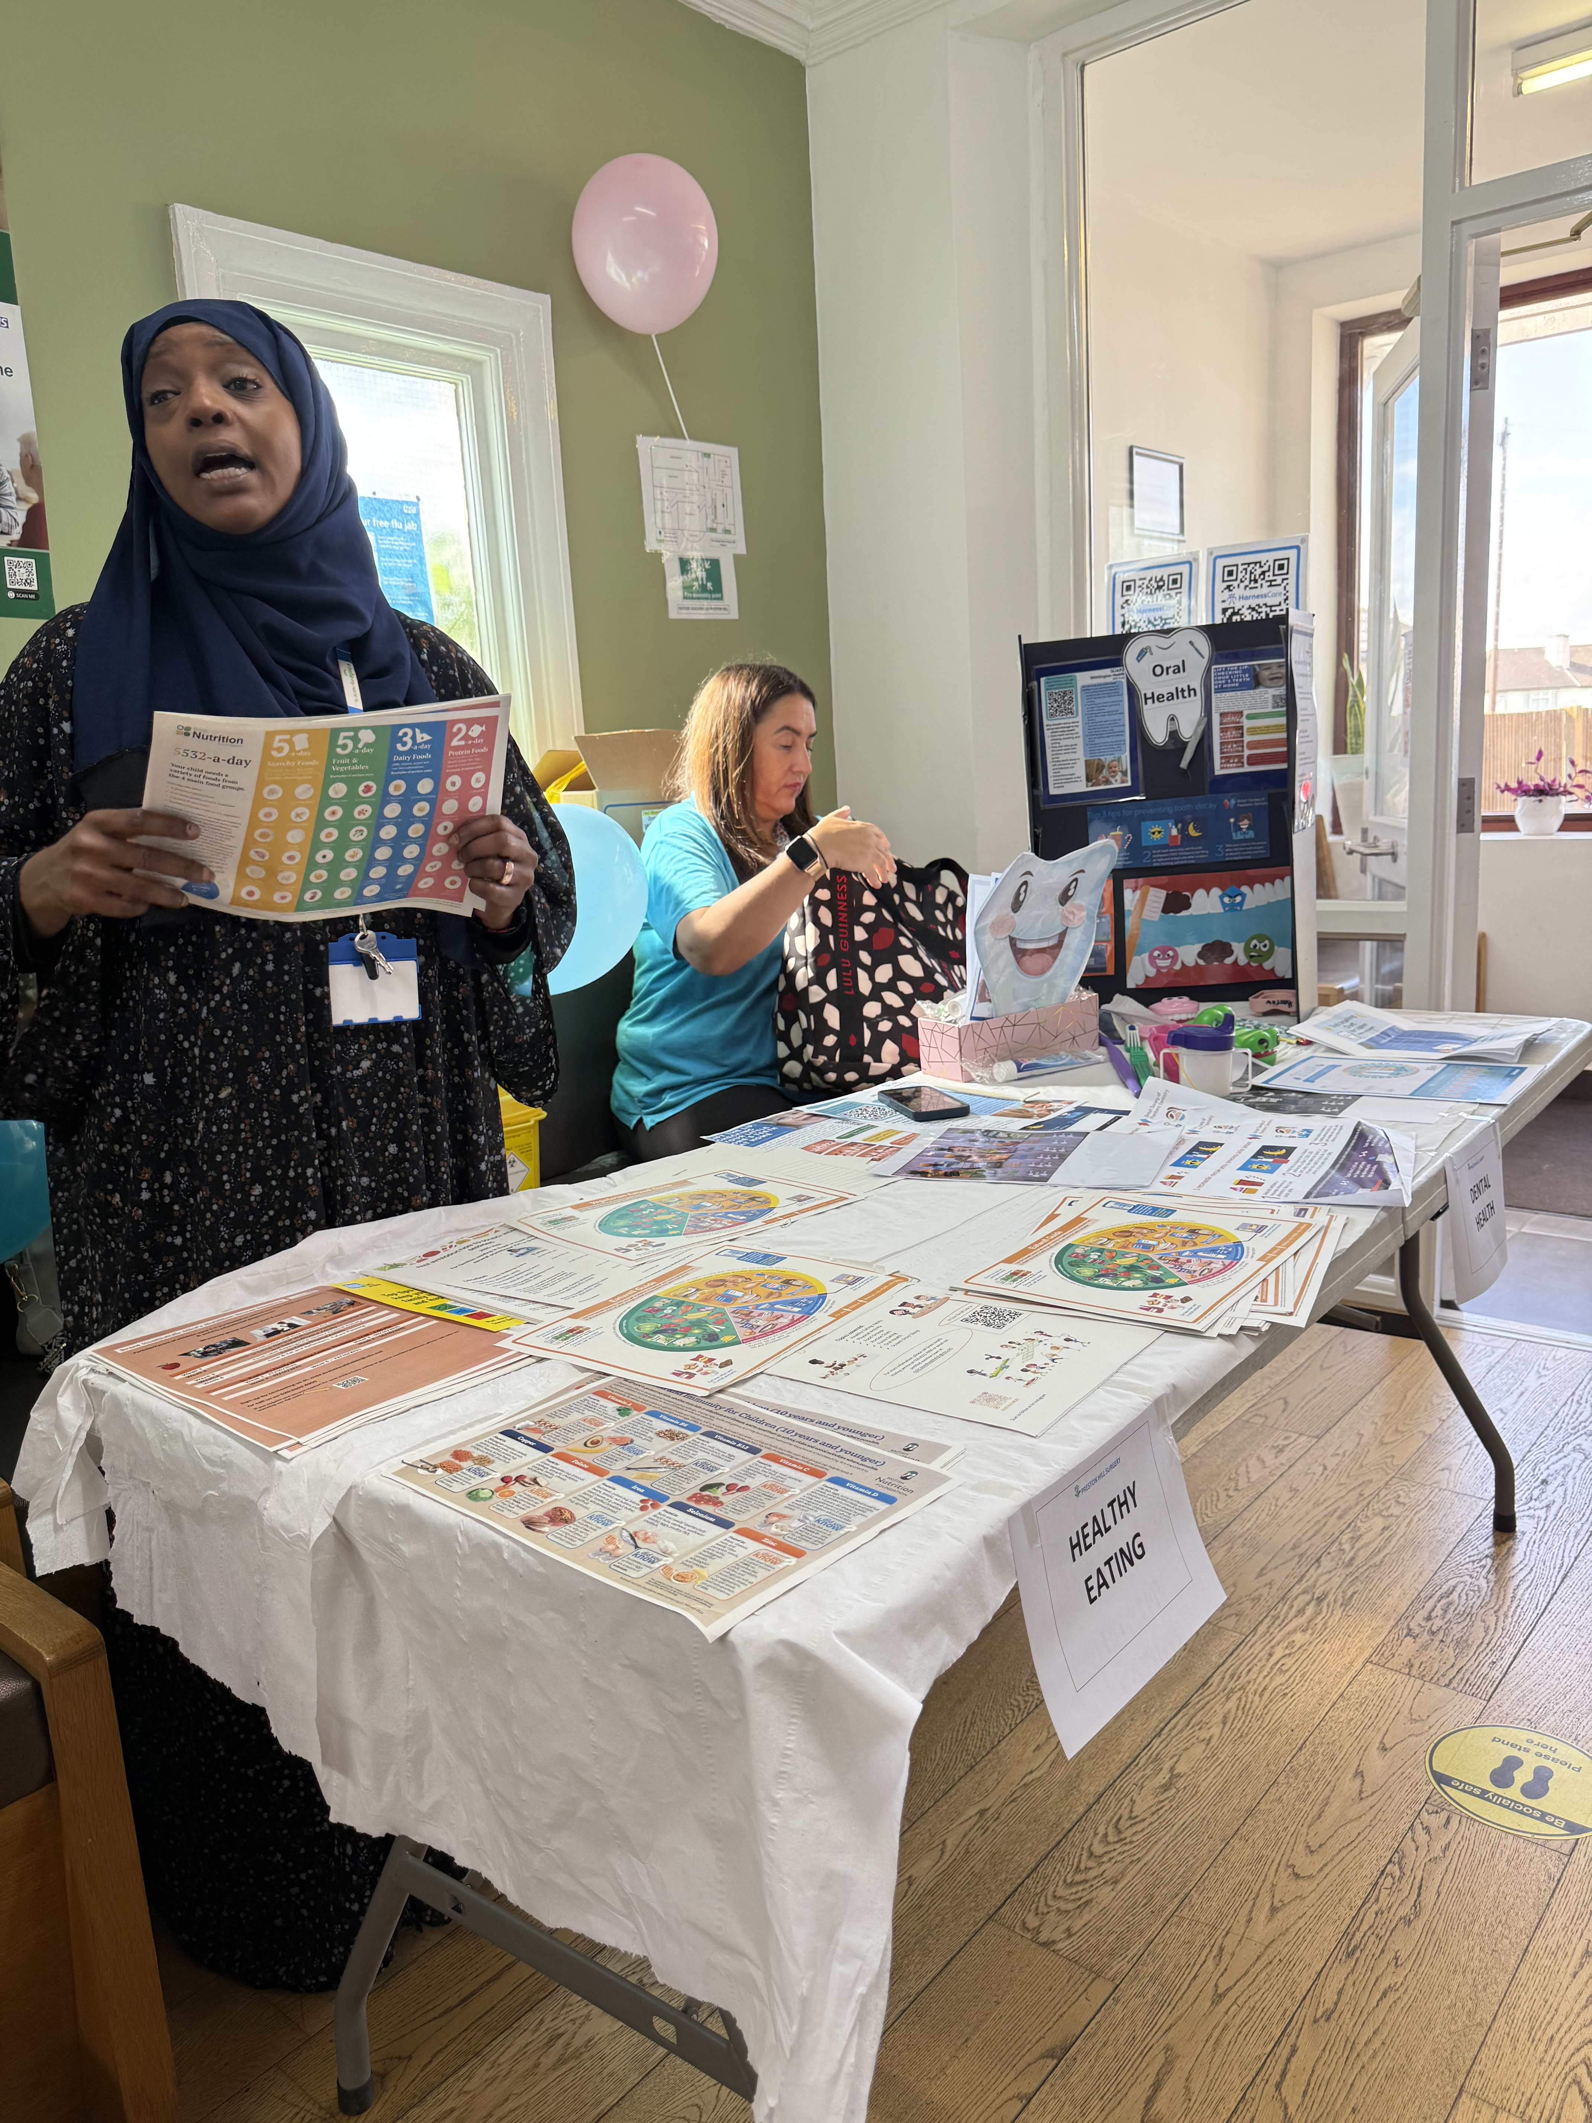

Protect Yourself with the Flu Vaccine. If you’re eligible, the flu vaccine is the best protection against serious illness.
It helps:
• Reduce severe symptoms, hospitalisation, and death
• Protect vulnerable individuals (elderly, long-term conditions)
• Reduce absences from work or school
❄️ Winter Support Services
• Winter Fuel Allowance
If you are struggling to keep warm, book an appointment with our Social Prescriber for help.
• Managing Cold Symptoms
Our Clinical Pharmacists can advise and signpost you to the right care.

OUR NEW BABY BANK
Lead By AMRAT
We are starting a new initiative for children age 0-5yrs. We are collecting donations for our Baby Bank to support local families. If you can, please donate baby essentials. See leaflet below.
Our surgery now has a Baby Bank where you can collect free baby essentials such as nappies, toys, beakers and more. Please speak to reception for more information.


Staying Well Over Winter

💡 TIPS to staying well this winter by Dr Syed

Colds are common in winter, but with the right care you can recover more quickly and avoid spreading them.
Symptoms
• Blocked or runny nose
• Sneezing
• Sore throat
• Cough
• Feeling tired or unwell
💡 Self-care tips:
- Rest as much as possible
- Drink plenty of fluids (especially water)
- Gargle salt water to ease a sore throat
- Ask your pharmacist about remedies such as paracetamol
- When to Contact Your GP
- Seek medical advice if you:
- Symptoms worsen
- Have a high temperature or feel shivery
- Experience chest pain or shortness of breath
- Are concerned about your child’s symptoms
- Still feel unwell after 10 days
- Have a cough lasting more than 3 weeks
🚫 Remember: Antibiotics don’t work for colds—they are caused by viruses, not bacteria.
🚫 How to Stop the Spread
Wash your hands often with warm water and soap
Catch coughs and sneezes in a tissue 🗑️ Bin tissues immediately after use.

PRESTON HILL SURGERY BULLETIN Issue 3

