Brand to Generic - Patient letter

Date 22/09/2025

IMPORTANT INFORMATION ABOUT YOUR MEDICINE
We are always trying to give our patients the most appropriate and most affordable medicines. Sometimes, we need to make small changes to your medicines so we can make the best use of NHS resources and follow local and national guidance.

Our records show that you are being prescribed Sukkarto SR 500mg or 1000mg tablets

The purpose of writing to you today is to inform you that we will be changing your prescription to metformin MR 500mg or 1000mg tablets. This is the “generic” name for the medicine. Please use up your current supply before starting the new one.
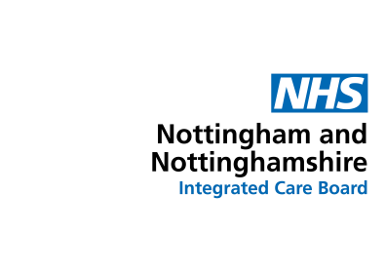
Please continue to take your medicine just as before. There has been no change in the active ingredients, dose or the way you take your medicine. You may also notice that the packaging and medicine looks a little different because the medicine may be made by a different manufacturer. However, despite these differences, the medicine works in the same way.

We hope that you will support us in making these small changes. We are confident that you will not experience any problems. However, prior to taking it, we do advise you to refer to the patient information leaflet that will be supplied to you with your new medicine, as this may contain additional information. If you notice any side effects or feel unwell after using the medicine, please speak to your doctor or pharmacist. If you have any known allergies or intolerances, always let your doctor or pharmacist know before starting a new medicine.

If you would like to leave feedback about the change, please email the ICB Patient Experience Team at nnicb-nn.patientexperience@nhs.net.

Thank you for helping the NHS to make the best use of its resources.

Yours sincerely
Castle Healthcare Practice

Brand to Generic – Patient letter
Author: Medicines Optimisation Team NNICB Version 1
Approved Date: 29 July 2025 Review Date: 29 July 2028

