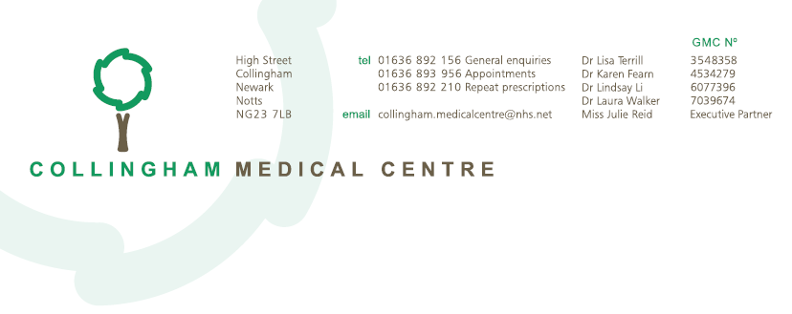

Fees and Charges

Not all services at the practice are available under the NHS. Where patients request non-NHS items or services, a private fee may be payable in accordance with British Medical Association (BMA) guidance and in line with charges applied by other General Practice surgeries. Fees and charges for these services are shown below which may be payable in advance.

Payment is by cash, card or cheque only (made payable to Collingham Medical Centre)

Fees payable by patients | Fee  (inc VAT if applicable)
Medical Examinations | Fee
Full medical examination and report (excluding employment)  Drivers or Pilots vocational licences (e.g. LGV, HGV, PCV, Taxi, Pilot etc)  Fitness to drive for insurance purposes (e.g. Elderly or racing driver)  Sports Fitness/Fitness to participate in event | £95 + £19 VAT (£114)
Medical for Employment or Pre-Employment (e.g. Army, Police) | £95
Accident and/or Sickness Insurance Medical Examination  Includes loan, income and mortgage protection | £95 + £19 VAT (£114)
Certificates, Forms and Reports
Private sick certificate for employer, college etc | £20
Health insurance forms (BUPA, PPP)  Complex Insurance form requiring extract from medical records | £50  £80
Shotgun certificate | £35 + £7 VAT (£42)
Accident and/or sickness forms (Loan, income and mortgage protection) | £50
Slimming club/Health club certificate/questionnaires | £50
Holiday insurance cancellation form – simple certificate  Complex Holiday cancellation letter requiring extracts from records | £30 + £6 VAT (£36)  £80 + £16 VAT (£96)
School fees insurance claim | £30 + £6 VAT (£36)
Copies of insurance medical reports – requested by patients | 40p per sheet
Miscellaneous
Private prescription for travel abroad (e.g. Malaria) | £15
Private prescription for other medication | Calculated by Pharmacy
Any simple letter to support non-NHS information  (e.g. Letter in support of, Fitness to fly, To whom it may concern, Housing, Social Services etc)  Complex letter requiring extracts from medical records | £30 + £6 VAT (£36)  £70 + 14 VAT (£84)
Capacity assessment with a GP | £50

Fees payable by patients – continued | Fee
Access to Medical Records
Access to medical records charge, whether copies are required or not  Viewing medical records only- no copies required:  Records held only on computer (via SystmOnline)  Records held part of computer and part manually (paper)  Records held manually (paper)  Copies of medical records required:  Records held only on computer (via SystmOnline)  Records held part on computer and part manually (paper)  Records held manually (paper) | £10  No charge  £10  £10 – unless records have been added to in the last 40 days, in which case viewing is free  No charge  40p per side to  £50 (max inc access) 40p per side to £50 (max inc access)
Private Consultations and Tests
Private appointment with doctor (10 mins) | £50
Private appointment with Nurse (10 mins) | £30
Private ECG with interpretation | £80
Private blood test | £18
Private travel immunisations | Listed separately

All services whose primary purpose is the protection, maintenance or restoration of the health of a person are exempt from VAT. Some services are eligible for VAT, and this has been applied in line with guidance from Moore and Smalley LLP (4 October 2016).

All fees are payable prior to work being completed where possible.

Fees payable by other Authority/Organisation | Fee
Insurance Medical Reports/DVLA
Insurance General Practitioners report | Set by company  (min £95) NO VAT
Insurance Company – Supplementary reports | Set by company  (min £28) NO VAT
DVLA Report (Series II pro-forma)  VOC Certificate  Copy of Visual Fields  VOC Resting ECG | Usually set by company  + VAT
Report for Criminal Injuries Compensation Authority (proforma) | Set by company
Solicitors – Forms and Reports/Copies of Medical Records
Copies of Medical records – as per Access to Medical Records | 40p per side to £60 (max inc access)
Letter providing information from patient’s records | £60 (minimum – depending on complexity of letter)
Local Authority
Adoption Medical e.g. prospective carer | £90 + £18 VAT (£108)
Department of Work and Pensions (DWP)
Disability Living Allowance forms | £33.50 + £6.70 VAT (£40.20)
DS1500 | £17 + £3.40 VAT (£20.40)

