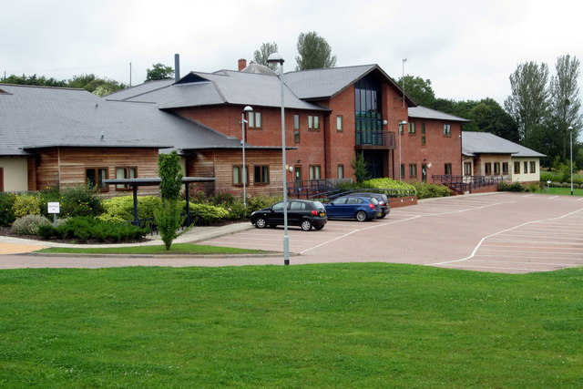

🌟 Join Our Award-Winning Team at Upton Surgery! 🌟
GP Partner Opportunity – Upton Surgery Worcestershire

About Us
Upton Surgery is a friendly, rural dispensing GP Practice serving around 12,300 patients in a beautiful riverside location. We are proud to be CQC Outstanding, winners of the 2025 Herefordshire & Worcestershire GP Practice of the Year Award, and consistently high QOF achievers.
We provide holistic, integrated care for a community that is weighted towards the frail and elderly, supported by an on-site multidisciplinary team including NHS Community and Social Care staff.
Following the retirement of our senior partner, Upton Surgery are seeking a GP Partner to join our friendly, forward-thinking partnership which is high- earning and provides an outstanding standard of care whilst maintaining a sensible work life balance. Varied duties to include triage, support GP for our trainees and employed staff during their sessions, duty, routine clinical sessions and special interest clinics depending on experience.
Drawings: To discuss further at interview.
Contract: Partnership
Annual Leave: 6 weeks plus 1 weeks study leave. A 6 week sabbatical every 6 years.
Our Team
We currently have:
⭐ 5 GP Partners
⭐ 4 Salaried GPs
⭐ 3 Trained & 2 Trainee ANPs
⭐ An established Management Team of 4
⭐An established Dispensing team
⭐ Strong Nursing team (including Practice Nurses, a specialist Frailty Nurse, HCAs, GPAs and a phlebotomist), Reception, Admin, and
⭐ 2 Pharmacy Technicians & 1 Clinical Pharmacist
We host several social events through the year for our team- annual Christmas Party, Summer Parties, charity team events. m
As part of our Primary Care Network, we work collaboratively with two other rural, dispensing practices in Pershore, who share similar patient demographics and healthcare needs.


Our Services
⭐ Minor Surgery in a designated minor surgery suite
⭐ Joint Injections
⭐ Ear Microsuction
⭐ Long-Acting Reversible Contraception (LARC)
⭐ Substance Misuse Shared Care
⭐ Care for residents in five local care homes
⭐RCGP Research Practice and are active with several trails currently.
⭐Dispensing Practice

Why Join Us?

✔ A thriving, supportive, and forward-thinking partnership
✔A training Practice- with 4 GP trainers- hosting Foundation doctors, ST1, ST2 and ST3 Registrars
✔ Excellent established practice team across clinical and non-clinical roles
✔ Strong links with Warwick & Three Counties Medical School
✔ A true sense of community in a scenic riverside town – Upton upon Severn is 10 minutes from the M50, with easy access to Worcester, Malvern, Tewkesbury, and Cheltenham.


Apply Now!
📅 Closing date: 30th November 2025
Interviews to be held from week commencing: 8th December 2025
📧To arrange a visit and / or request a practice profile pack please contact:
Ben Kent – Practice Manager, Upton Surgery

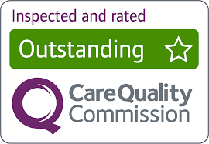
Tunnel Hill, Upton upon Severn. Worcestershire. WR8 0QL.

Tel: 01684 592696 Email: ben.kent@nhs.net Application by CV and personal statement.

