
Dr Emily Layden is back!
Dr Layden has returned to work after her recent maternity leave. Her days of work are Thursdays and Fridays.
Welcome to the February 2024 edition of our Patient Newsletter!
Please read on to keep informed about the latest news and developments at our Practice.
Chaperones
If you have a face-to-face appointment booked with a GP which may require an intimate examination, we are able to offer a trained chaperone to accompany you in the consultation. The chaperone is there to ensure the comfort and safety of both the patient and GP. If you would like a chaperone, please let a Receptionist know or ask the GP.

Childhood Immunisations

The Childhood immunisation programme begins when baby is 8 weeks old. The first vaccination appointment is booked alongside the postnatal check with a GP meaning you only have to attend the Practice once! Our care coordinator will be in touch to arrange the appointment.



This group is independent of the surgery but help us to get feedback on our patients’ experiences. They are our ‘critical friend’ and offer us practical support and advice with regular meetings with the practice team. If you do have ideas, questions or would like to know more about how to support both patients and the surgery, please feel free to email our Practice Manager Emma Rowe on nnicb-nn.manorsurgeryreceptionist@nhs.net.

Medical Exemption Certificates
Patients who suffer from long term conditions or take medication regularly for epilepsy, diabetes, thyroid, Addison’s or are undergoing treatment for cancer may be entitled to free prescriptions on the NHS. To obtain this, we ask that you fill out a FP92A form that we provide at reception, if you need further information, please contact 0300 330 1341.

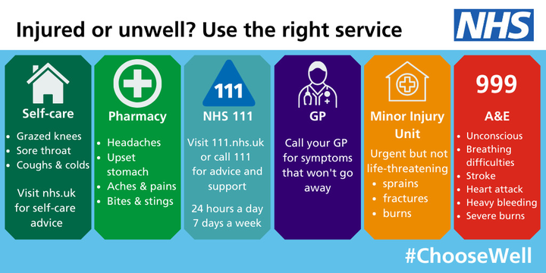

BP Machines
We are able to loan blood pressure monitors if the GP has asked for a week’s worth of readings. We ask for a £10 deposit which is then returned once you return the machine. Please enquire at reception for more details.

You said, we did….
“It used to be much easier to book an appointment with a specific doctor which was good for continuity of care - even publishing a weekly rota of who worked when would make it easier to make an appointment with the same doctor.”

Dr David Charles (GP): Thursday and Friday
Dr Christopher Evans-Hall (GP): Tuesday, Wednesday, and Friday
Dr Michael Mannion (GP): Monday, Wednesday, Thursday, and Friday
Dr Louis Mok (GP): Monday, Wednesday morning, Thursday, and Friday morning
Dr Sudam Prabhu (GP): Monday, Tuesday, Wednesday, and Friday
Dr James Read (GP): Tuesday, Wednesday morning and Friday
Dr Emma Shapiro (GP): Monday, Tuesday morning and Wednesday
Dr Anna Hewson (GP): Monday, Tuesday, Wednesday
Dr Emily Layden (GP): Thursday and Friday
Dr Alamgir Khan (Registrar): Monday, Tuesday, Thursday, and Friday
Dr Laura McCormick (Registrar): Thursday
Dr Ho (Registrar): Monday, Tuesday, Thursday, and Friday
Sean Massey (Physio): Tuesday and Thursday

MEASLES OUTBREAK
MMR is part of the NHS Routine Childhood Immunisation Programme – with one dose offered at one year and another second dose at 3 years 4 months. Parents whose infants missed out, or anyone of any age who has not yet had a vaccine, are urged to contact us on 0115 9076960 to book an appointment with the Practice Nurse.

Pharmacy Contact Details
Abbey Pharmacy: 0115 925 4522
Beeston Manor (old Boots): 0115 922 8291
Boots High Road: 0115 925 4464
Grewals Pharmacy: 0115 925 3034
Jardines Pharmacy: 0115 943 0487
Lloyds Pharmacy: 0115 939 2168
Tesco Pharmacy Beeston: 0115 827 1293
Ways Pharmacy: 0115 925 5584
Well Pharmacy: 0115 925 6607

Practice Closed
The practice will be closed from 12:00pm on the following dates:
February 22nd
March 21st



You said, we did….
“Not to have any music/radio in the waiting room. There is no need for it.”

We have had a period of having no music playing in the waiting room last year and it became apparent that patients were able to hear Receptionist’s telephone conversations and conversations between staff regarding patient matters. As we take patient confidentiality seriously, we have returned to playing music in the waiting room to help protect patient privacy.

Facebook Group
We have a Facebook account were surgery updates,
general health information and resources are shared.
The QR code will send you to our page for you to view.

Ear Syringing

We are currently limited with nurse appointments, therefore it will be another month before we can offer appointments for ear syringing.

We are able to add patients to a waiting list for contact when appointments are available or alternatively, you are invited to attend a private provider.

