
Welcome to the July 2024 edition of our Patient Newsletter!
Please read on to keep informed about the latest news and developments at your GP Practice.
PATHOLOGY SAMPLES

We would like to give a reminder to our patients that our samples go to the lab at 1:00pm every day. We therefore need any samples to be dropped in to Reception before 12pm so we can ensure they are checked and labelled correctly.

VETERAN FRIENDLY PRACTICE
We are happy to announce that we are now a veteran friendly practice. This means we have a dedicated clinician who has a specialist knowledge of military related health conditions and veteran specific health services. If you are ex-forces, please ensure you let us know so we can highlight this on your medical record.

HOSPITAL LETTERS
We get many queries regarding hospital letters and medication, and we thought it would be helpful for our patients to understand our process for checking the documents to ensure we are prescribing safely.

We can receive letters from the hospitals/community clinics electronically or by paper. The timing depends on how quickly the hospital secretary prepares the letters and the consultant signs off. We then add the document to your record and forward to the most appropriate clinician – eg, medication additions to Clinical Pharmacist, GP follow up to the GP who referred you.

We advise that our process can take up to ten working days as we allow for staff absence and awaiting the letter from the hospital. We understand that this may seem a long wait, but if you feel there is an urgency, please contact us and we will do our best to support your request.





This group is independent of the surgery but help us to get feedback on our patients’ experiences. They are our ‘critical friend’ and offer us practical support and advice with regular meetings with the practice team. If you do have ideas, questions or would like to know more about how to support both patients and the surgery, please feel free to email our Practice Manager Emma Rowe on nnicb-nn.manorsurgeryreceptionist@nhs.net.

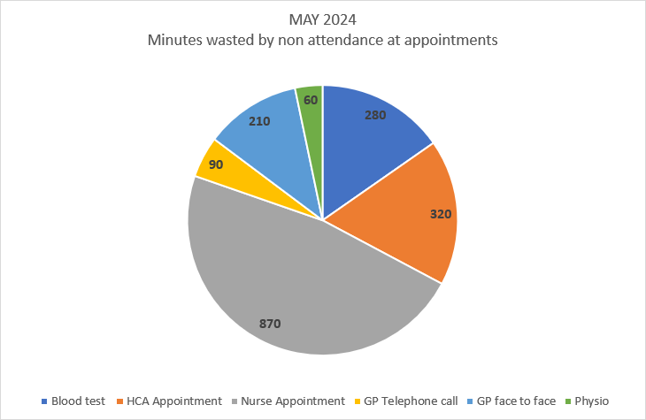
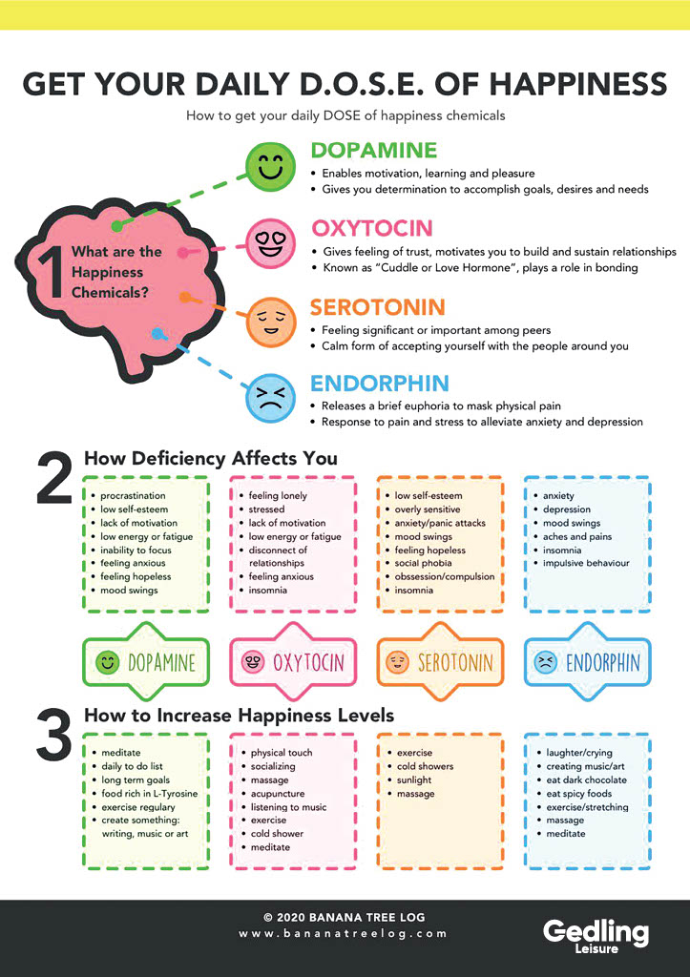
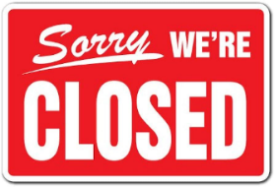


If you have a long-term condition such as asthma or diabetes, you will be asked to arrange an appointment with the appropriate clinician around your birthday month. We send out invites via text, email and letter. If you have any queries on your long-term condition, please do not hesitate to contact the reception team.

Important Dates
The practice will be closed for a meeting from 12:00pm on the following dates:

19th September 2024
17th October 2024

Our next Patient Participation Group meeting will be:
7th August at 6.30pm

MUSCULOSKELETAL SPECIALIST
Did you know we have a musculoskeletal specialist working at the practice? Sean Massey is trained to deal with all sorts of aches and pains and has face-to-face clinics at the Practice on a Tuesday and Thursday. He can also refer to specialists, issue short-term sick notes and arrange for medications with the help of a GP. If you have a physio related problem, please discuss with reception and we will happily book you in with Sean.



Facebook Group
We have a Facebook account were surgery updates,
general health information and resources are shared.
The QR code will send you to our page for you to view.

