
AUTISM / ADHD REFERRALS
We have implemented a change to imporve the process for referral for autism and ADHD assessmentsdiagnoses. If you are over the age of 18 years old, you are eligible for right to choose. Please go to the Health Information section on our website for more information and to access the forms that need to be completed and returned to us. The forms are also available from Reception.
Welcome to the May 2024 edition of our Patient Newsletter!
Please read on to keep informed about the latest news and developments at your Practice.
WISE MOVES – Exercise Class
Patients with mild fragility can self-refer to a postural stability class to help prevent falls. It will be held at the HOPE centre on Boundary Road, Beeston. You can self-refer by emailing WISEMOVES@LLEISURE.CO.UK

APPOINTMENTS
We offer pre-bookable telephone appointments for non-urgent concerns up to one week in advance. Pre-bookable appointments are also available to book online via the NHS APP.
Alternatively, you can call us on the day at 8am for an urgent same day telephone call.

This group is independent of the surgery and helps us to get feedback on our patients’ experiences. They are our ‘critical friend’ and offer us practical support and advice with regular meetings with the practice team. If you do have ideas or would like to know more about how to support both patients and the surgery, please feel free to email our Practice Manager Emma Rowe on nnicb-nn.manorsurgeryreceptionist@nhs.net.
Our next meeting will be at the Practice on:
Wednesday 8th May at 6.30pm



PRIVATE WORK
All paperwork requests that are not part of the NHS GP contract are classed as private work and are chargeable due to the GP having to complete in their own time. This includes completion of insurance forms, letters of support and medicals for work purposes.
Payment is required before the completed paperwork is released to the patient and we aim to complete the work within two weeks. If you have any questions regarding whether work is chargeable, please speak to a member of our reception team.

SOCIAL PRESCRIBER SELF-REFERRAL
We are happy to announce that the social prescribing team are now accepting self-referrals. If you or someone you know is needing support within the community, then they can fill out a form at Reception and one of the Social Prescribing team will be in touch. A social prescriber can help with physical health, mental health and wellbeing, social isolation, lifestyle changes, self-care and management of long-term conditions, benefits and financial advice, housing, employment and training and practical support.


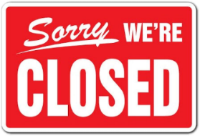
Important Dates
The practice will be closed for staff training from 12:00pm on the following dates:
16 May, 20 June, 18 July
We will reopen the following day at
8.00am. If you need a GP when we are
closed, please call 111.

COVID VACCINES
Please note that our surgery is not hosting any covid vaccination clinics for the Spring booster, to find your nearest clinic, please ring 119, visit www.nhs.uk or contact a local Pharmacy.
We have arranged for our housebound and care home patients to be vaccinated by the local nursing team. Please call us on 0115 9076960 if you have any queries.

PHARMACY FIRST
We can now refer patients for minor ailments that may require over the counter treatments or antibiotics. If you are unsure about your symptoms, you are more than welcome to speak to a receptionist, and they can advise. The following ailments are:
Acne and spots
Allergic reaction
Athlete’s foot
Blisters and cold sores
Cold and flu symptoms
Constipation
Cough
Diarrhea
Ear infection
Eyes
Hayfever
Impetigo
Insect bites and stings
Mouth ulcers
Shingles
Sinusitis
Sore throat or tonsilitis
Suspected UTI
Vomiting
Warts and verrucas

Pharmacy Contact Details
Abbey Pharmacy: 0115 925 4522
Beeston Manor (old Boots): 0115 922 8291
Boots High Road: 0115 925 4464
Grewals Pharmacy: 0115 925 3034
Jardines Pharmacy: 0115 943 0487
Lloyds Pharmacy: 0115 939 2168
Tesco Pharmacy Beeston: 0115 827 1293
Ways Pharmacy: 0115 925 5584
Well Pharmacy: 0115 925 6607

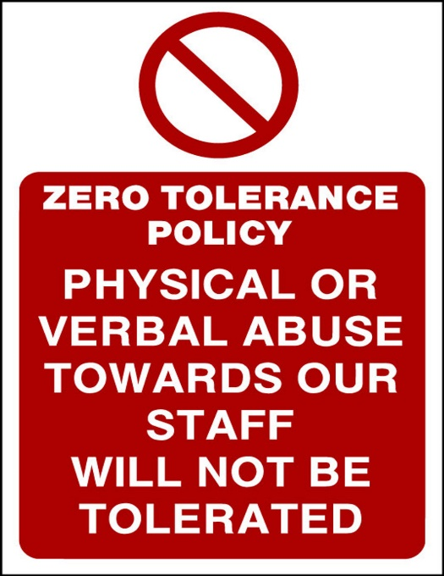

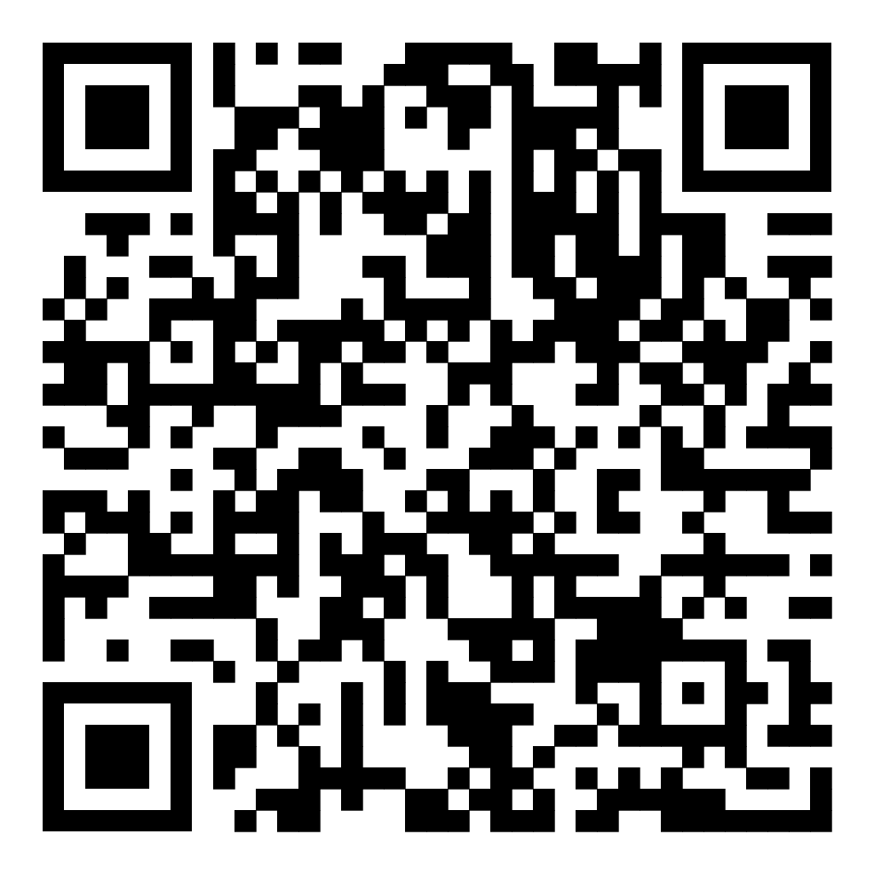

Facebook Group
We have a Facebook page for sharing surgery updates, general health information and
Local health groups and news. The QR code will send you to our page for you to follow us!

