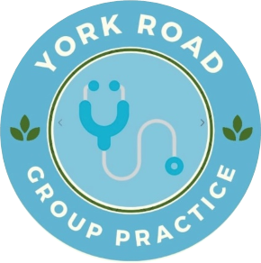
SAR Authorisation Form: Data Subject

Purpose of this form:
You can use this form to request access to personal data which York Road Group Practice holds about you. This right applies to:
- Patients
- Employees (current or former)
- Job applicants/interviewees
Please complete all relevant sections so we can process your request efficiently.

Your details
Full name
Date of birth
Address
Postcode
Contact number
Email

Your relationship to the practice (tick one)
☐ Patient
☐ Current employee
☐ Former employee
☐ Job applicant/interviewee

Details of the data you are requesting

Identification

Please attach proof of identity (eg driving licence or passport) and proof of address (eg recent utility bill).

Preferred format of information (tick one)

☐ Secure electronic format
☐ Printed copy (collection from practice)

Important information
Stop-the-clock: If we require clarification from you to identify the information requested, we may pause the one-month statutory time limit until you provide clarification.
Appropriate and proportionate searches: We will carry out reasonable and proportionate searches based on the information you provide. Giving specific details will help us locate your information more expediently.

Declaration

I confirm that the information provided in this form is correct and that I am the person to whom it relates.

Signature
Name
Date

Completed forms and ID should be presented to a member of the reception team.

Office use only:
Date form received
ID presented
Request handed to
Date complete

