HOW TO SUBMIT A TRIAGE REQUEST FOR YOUR CHILD

- In a web browser type in https://PATCHS.ai/login

- Select continue with PATCHS

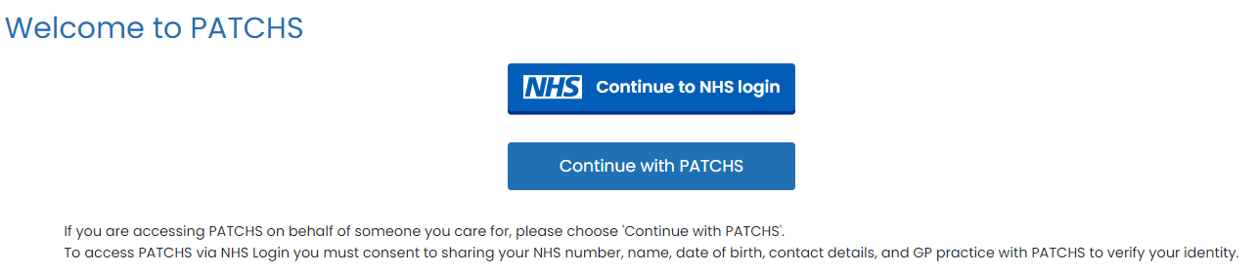

- You will be taken to the PATCHS login page, where you need to enter your email address and password that you used to register with PATCHS as a patient:

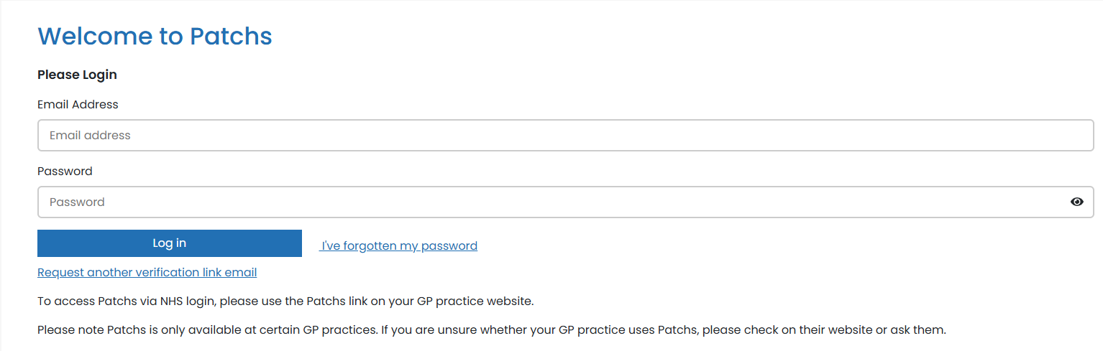

- If you are using a PC/laptop you will see this. Click Make a request and you will then see the triage request page.
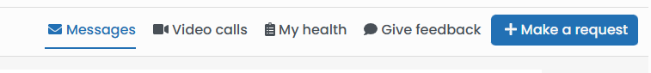

- If you are using a mobile device, you will automatically see the triage request page:

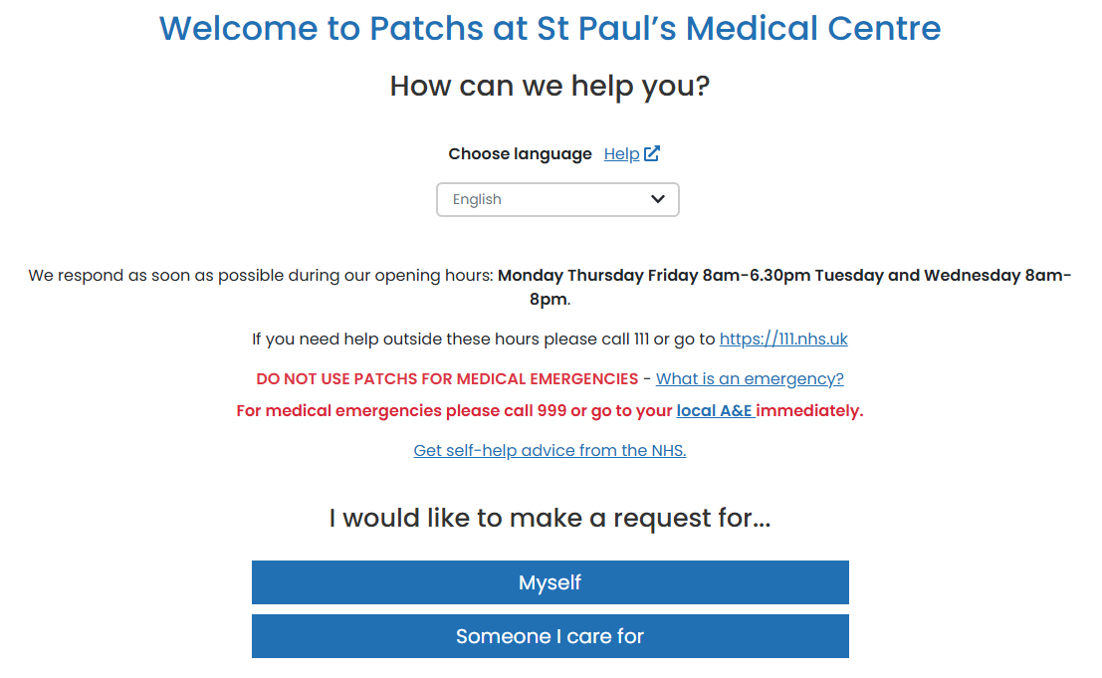

- If you are submitting a request for your child – click on ‘Someone I care for’

- If you have already added your children’s details, they will appear on this page

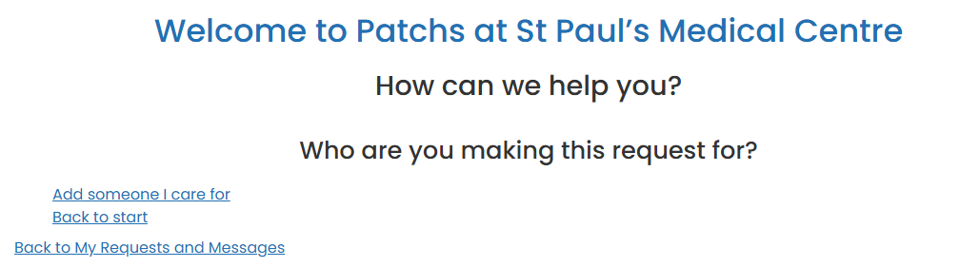

- If not please click on the link ‘Add someone I care for’.

- You will see this screen. Complete all the requested information.

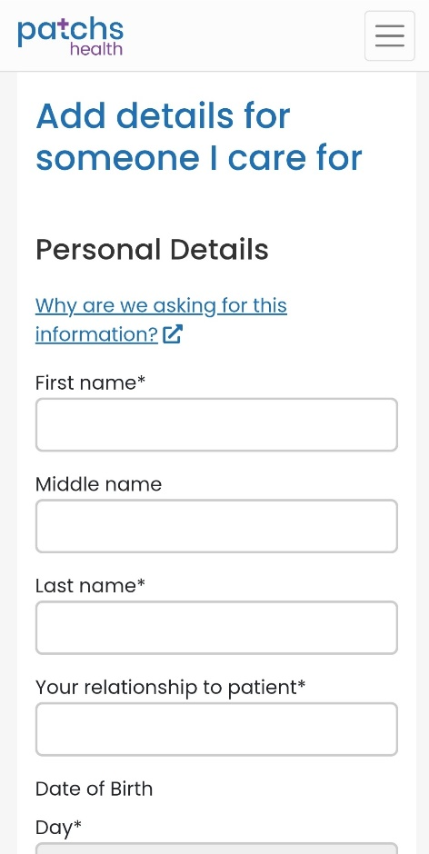

- You can then submit a request for your child, add another child or submit a request for yourself.

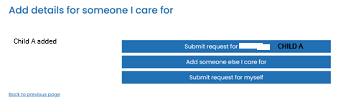

- By selecting one of the four options below.

