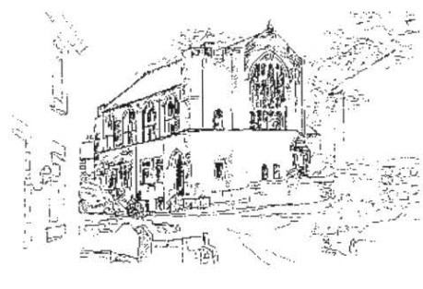
Fair Processing Notice

How we use your personal information

This fair processing notice explains why the practice collects information about you and how that information may be used.

The health care professionals who provide you with care maintain records about your health and any treatment or care you have received previously (e.g. Hospital, GP Surgery, Walk-in clinic, etc.). These records help to provide you with the best possible healthcare.

NHS health records may be electronic, on paper or a mixture of both, and we use a combination of working practices and technology to ensure that your information is kept confidential and secure. Records which this GP Practice hold about you may include the following information;

- Details about you, such as your address, legal representative, emergency contact details
- Any contact the surgery has had with you, such as appointments, clinic visits, emergency appointments, etc.
- Notes and reports about your health
- Details about your treatment and care
- Results of investigations such as laboratory tests, x-rays etc
- Relevant information from other health professionals, relatives or those who care for you

Your records will be retained in accordance with the NHS Code of Practice for Records Management
To ensure you receive the best possible care, your records are used to facilitate the care you receive. Information held about you may be used to help protect the health of the public and to help us manage the NHS. Information may be used within the GP practice for clinical audit to monitor the quality of the service provided.
Some of this information will be held centrally and used for statistical purposes. Where we do this, we take strict measures to ensure that individual patients cannot be identified.
Sometimes your information may be requested to be used for research purposes – the surgery will always gain your consent before releasing the information for this purpose.

How do we maintain the confidentiality of your records?
We are committed to protecting your privacy and will only use information collected lawfully in accordance with:

- Data Protection Act 1998
- Human Rights Act 1998
- Common Law Duty of Confidentiality
- Health and Social Care Act 2012
- NHS Codes of Confidentiality and Information Security
- Information: To Share or Not to Share Review (click here to read further information about this)

Every member of staff who works for the Practice or another NHS organisation has a legal obligation to keep information about you confidential.

We will only ever use or pass on information about you if others involved in your care have a genuine need for it. We will not disclose your information to any 3rd party without your permission unless there are exceptional circumstances (i.e. life or death situations), where the law requires information to be passed on for example Child/Adult Protection and Serious Criminal Activity.

Who are our partner organisations?
We may also have to share your information, subject to strict agreements on how it will be used, with the following organisations or receive information from the following organisations:-
- NHS Trusts / Foundation Trusts
- GP’s
- NHS Commissioning Support Units
- Independent Contractors such as dentists, opticians, pharmacists
- Private Sector Providers
- Voluntary Sector Providers
- Ambulance Trusts
- Clinical Commissioning Groups
- Social Care Services
- NHS Digital
- Local Authorities
- Education Services
- Fire and Rescue Services
- Police & Judicial Services
- Other ‘data processors’ which you will be informed of
You will be informed who your data will be shared with and in some cases asked for explicit consent for this happen when this is required.

We may also use external companies to process personal information, such as for archiving purposes. These companies are bound by contractual agreements to ensure information is kept confidential and secure.

Access to personal information

You have a right under the Data Protection Act to request access to view or to obtain copies of what information the surgery holds about you and to have it amended should it be inaccurate. In order to request this, you need to do the following:

- Your request must be made in writing to the GP - for information from the hospital you should write direct to them
- There may be a charge to have a printed copy of the information held about you
- We are required to respond to you within 40 days
- You will need to give adequate information (for example full name, address, date of birth, NHS number and details of your request) so that your identity can be verified and your records located

Objections / Complaints

Should you have any concerns about how your information is managed at the GP, please contact the Practice Manager. If you are still unhappy following a review by the GP practice,
you can then complain to the Information Commissioners Office (ICO) via their website (www.ico.org.uk).

Change of Details

It is important that you tell the person treating you if any of your details such as your name or address have changed or if any of your details such as date of birth is incorrect in order for this to be amended. You have a responsibility to inform us of any changes so our records are accurate and up to date for you.
Notification

The Data Protection Act 1998 requires organisations to register a notification with the Information Commissioner to describe the purposes for which they process personal and sensitive information.

This information is publicly available on the Information Commissioners Office website www.ico.org.uk

The practice is registered with the Information Commissioners Office (ICO).

Who is the Data Controller?

The Data Controller, responsible for keeping your information secure and confidential is:
Mrs Heather Underwood

Reviewed May 25
Review Date May 26
Signed off by ------------------------------------------------------------------------------------

