Danes Camp Medical Centre
Rowtree Road, East Hunsbury, Northampton NN4 0NY
Tel: 01604 709426
http://www.danescampmedicalcentre.nhs.uk

Danes Camp and Rillwood
Veterans Carers Pack



This pack contains the following:

- Carer’s Identification and Referral form
- Carer’s Information of records agreement form
- Veterans contact sheet
- Additional carer’s contact sheet
- Northamptonshire Carers Service explained
- Independent Living and handy man service
- Aged Veterans Counselling information – Listening is talking

We are trying to identify and support as many Carers as we can.

Danes Camp Medical Centre
Rowtree Road, East Hunsbury, Northampton NN4 0NY
Tel: 01604 709426
http://www.danescampmedicalcentre.nhs.uk

Carers Identification and Referral Form

Do you look after someone with a long-term illness, who is disabled, frail or suffers with dementia?

YOUR DETAILS:
Name
Date of Birth
Address
Postcode
Home Phone
Mobile Phone
Signature: |  | Date:

DETAILS OF THE PERSON YOU LOOK AFTER:
Name
Date of Birth
Address and Postcode
(if different from above)
Contact Telephone Number
(if different from above)
Relationship to me
Brief details of medical condition or reason you are providing care
Details of the GP practice where the person you care for is registered

We will refer you to the Carers Service for further information and support.
Please tick if you do NOT wish to be referred.

Danes Camp Medical Centre
Rowtree Road, East Hunsbury, Northampton NN4 0NY
Tel: 01604 709426
http://www.danescampmedicalcentre.nhs.uk

Agreement by a Patient to allow a Carer to have access to their Personal Details and / or Medical Records

Patient’s Name
Patient’s Address and Postcode
To: Danes Camp Medical Centre

I give permission for my Carer, (Carer’s full name: ……………………………………………………) to have access to my personal details and medical records held by the Practice.
(Details below)

Please tick which option is applicable below:

This permission relates to all my records.

This permission relates to part of my records.
Please specify the parts of the record to which access is allowed and any areas which are specifically excluded. | Medication Past and Present  All Investigations  Correspondence (Medical /social care)  All consultation records

This permission relates to a specific condition
Please specify the condition.

I understand that this permission will remain in force until cancelled by me in writing and that the doctor may override this authority at any time.

By signing below I consent to the above information being recorded on my medical record.

Print name: ___________________________ Signed Patient: ___________________________

Print carers name: ______________________ Signed by Carer: ________________________

Danes Camp Medical Centre
Rowtree Road, East Hunsbury, Northampton NN4 0NY
Tel: 01604 709426
http://www.danescampmedicalcentre.nhs.uk

Additional Veteran Carers Contact Sheet

RESOURCE | CONTACT NUMBER / DETAILS:
Emergency Medical Care | Tel: 999
Out of hours and Urgent Medical Care | Tel: 111
District Nurse Contact | Tel: 0300 777 0002
Emergency Dentist | Tel: 111
Northamptonshire Carers | 123 Midland Road  Wellingborough  NN8 1LU  Tel: 01933 677837  www.northamptonshire-carers.org
Alzheimer’s Society | Tel: 0300 222 1122  www.alzheimers.org.uk
Age UK (Northamptonshire) | Tel: 01604 611200  www.ageuk.org.uk/northamptonshire
Arthritis Care UK | Tel: 0300 790 0400  www.arthritiscare.org.uk
Mind | 6-7 Regent Square  Northampton  NN1 2NQ  Tel: 01604 634310  www.mind.org.uk  Mind Infoline 0300 123 3393
Citizens Advice Northampton | Tel: 0344 488 9629  Central and East Northants - https://www.citizensadvice.org.uk/  Adviceline (England): 0800 144 8848
Adult Social Care | www.northnorthants.gov.uk/adult-social-care

Other Useful Websites

- www.nhs.uk/carersdirect
- https://www.carersuk.org/

Our carers leads at Danes Camp Medical Centre are:-
Hannah Lindop Tel:- 01604 876314

Please contact your Carers Lead if you have any queries about our support for carers.

Carers Service Explained

- 1-1 Telephone Support – Listening and emotional support/information and advice in times of difficulty, usually for around 6 weeks to help Carer cope with a difficult period. Can be daily, weekly, monthly or as agreed with Carer and can be extended in response to Carers needs.
- Peer Support Workers – Trained members of staff who are or have been a Carer.
- Carers Sitting Service – Volunteers to sit with Carer on a regular basis, usually weekly for around 2 hours per session. Unable to provide personal care or lifting. On occasion recruitment may be necessary before a sitter is available.
- Health and Fitness – Carers can book and attend sessions at many gyms in Northamptonshire.
- Carers Choir and Ukulele Groups – Meet every week on Monday morning in Wellingborough. (Term Time Only)
- Carers Café Drop In Sessions – Take place in Northampton, Kettering, Wellingborough, Corby, Oundle and Daventry once a month. Carers can bring the person cared for to meet others, ask questions and relax supported by the group leader. Tea, coffee and cakes are provided.
- Carers Support Groups – Held in Denton, Kettering, Northampton, Rushden and Towcester. Parent Carer groups are also available in Northampton and Kettering. There is a Male Carer group in Northampton and a Ladies Carer Group at Prevasi Mandal in Northampton.
- Lunch Clubs – Informal lunch once a month in Northampton and Greens Norton (near Towcester) Cared for are also welcome, booking required, charge applicable.
- Trips Out and Activities – Advertised in Monthly Bulletin or at the groups.
- Support for Working Carers – Building links with local employers to improve support.
- Monthly News Bulletin – Sent by email to Carers and other organisations, also available at Carers Cafés, Support Groups and other events.
- Raising Carer Awareness of their rights - Contact carers support line 01933 677907

For more information

Support Line: 01933 677907 (Monday – Friday, 9.00am – 4.00pm). General Enquiries: 01933 677837 – a confidential service to support the needs of Adult and Young Carers, including Parent Carers. Can be accessed by Carers, professionals or anyone with a Carer related enquiry or issue.
Email: carers@northamptonshire-carers.org
Web: www.northamptonshire-carers.org

Independent Living and Handy Van Service

The Royal British Legion’s Independent Living Service covers England, Wales and Northern Ireland. We offer beneficiaries a high quality, friendly and professional service to live safe and well at home. The Independent Living Service comprises of two services; the Independent Living Advice Service and the Legion Handy Van Service.
We offer support face to face, over the telephone and email to help beneficiaries work towards goals that are important to them.
This means we could help with:
- Specialist Information and Advice-About Independent Living Options
- Aids and Adaptations
- Assistance with Disabled Facilities Grants and Challenges
- Small maintenance jobs
- Home safety checks
- Winter warmth checks
- Help and support to navigate social services
- Help and support to challenge decisions
- Help to address isolation and loneliness
- Information on local services
- Setting up your own social groups
- Help to understand your rights and speak up

Who can use this Service?
A beneficiary is anybody who has served, is currently serving in the armed forces or are a carer, dependent, spouse or partner of someone who is serving or has served.
Making Contact
Call our friendly contact centre on:
0808 802 8080- Open 8am-8pm- 7 days a week
Or visit one of our pop in centres:
http://www.britishlegion.org.uk/get-support/the-legion-near-you/


CRISIS CAFÉS

If you find yourself in crisis or need support with your mental health in the evening and/or at the weekend we are here to listen and help you in your time of need.

Mind Cafés have professional mental health workers who can offer you a safe space. Our aim is to support people to reduce any immediate crisis and to safety plan, drawing on strengths, resilience, and coping mechanisms to manage their mental health and wellbeing.

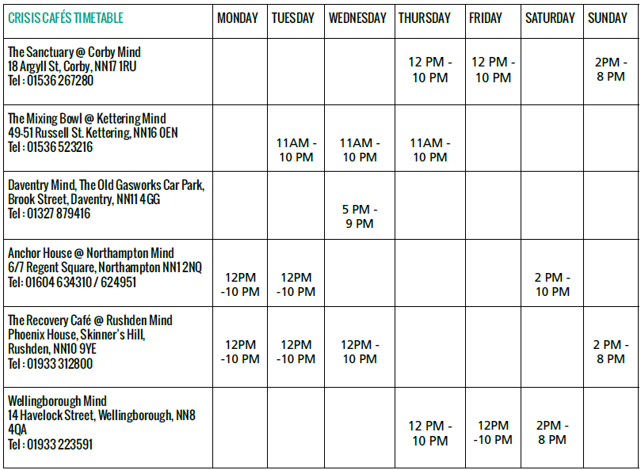
There is no need to call, just drop in to find a safe place with hope and comfort and find your pathway to recovery.

