Practice Leaflet
Modality Partnership

Modality Mid Sussex

Crawley Down Health Centre
Bowers Place
Crawley Down
Crawley
West Sussex RH10 4HY
01342 713 031

Park View Health Partnership
Sidney West Primary Care Centre
Leylands Road
Burgess Hill
West Sussex RH15 8HS
01444 244294

Judges Close
Judges Terrace
High Street
East Grinstead
West Sussex RH19 3AA
01342 317 820

Ship Street Surgery
Ship Street
East Grinstead
West Sussex RH19 4EE
01342 325 959

https://www.modalitymidsussex.co.uk/



About Our Practice

Welcome to Modality Mid Sussex

We are a group of general practitioners providing General Medical Services for primary care operating under a traditional partnership model. We are proud to have a highly skilled multi-disciplinary team providing care for our patients. As a training practice our health professionals are involved in the education of GP Registrars, administrative practice staff and other healthcare professionals.

The Practice is a member of East Grinstead Primary Care Network. This is a requirement of the contract under which we work to improve and build primary care services, and to meet the changing needs of the community.

The Practice is in the region of Sussex Health & Care Integrated Care Board. This is the statutory NHS organisation responsible for developing a plan for meeting the health needs of the local population, managing the NHS budget and arranging for the provision of health services in the Integrated Care System (ICS) area.

Integrated Care Board can be contacted at:
NHS Sussex, Wicker House, High Street, Worthing BN11 1DJ
Tel: 0300 140 9854
https://www.sussex.ics.nhs.uk/
sxicb.commsresponseteam@nhs

Meet our Team

Doctors
Dr Elinor Flatman BMBS, DFSRH, GCERT | GP Partner
Dr Sharon Pruden MBCHB MRCGP (2011) DFSRH | GP Partner
Dr Layo Osoba MBBS, RCGP, MRCP, DSFRH, McC Endocrinology and Diabetes, | GP Partner
Dr Ryszard Miarkowski BM | GP Partner
Dr Stephanie Cook MBE BM BCh MA MRCGP MRCS MFSEM DOHNS DRCOG DFSRH  Dr Holly Chouhan MBBS BSc (Hons) DRCOG MRCGP  Dr Tina Lee MBBCh BSc (Hons) DRCOG MRCGP (2017)  Dr Sally Doust BMBS BMedSci DRCOG MRCGP (2019  Dr Joseph Wilkinson MBBS, BSc Hons (Sports and Exercise Medicine), MRCGP  Dr Samantha Kerbey MB ChB, MRCGP, DRCOG, DFSRH, PgCert Med Ed  Dr Umar Malik Tabassum MBBS, MRCGP.  Dr Kamran Iqbal MD MPHARM MRCGP  Dr Aayesha Haleem MBBS MRCGP  Dr Twayyaba Yousaf MRCGP MBChB Bsc(Hons) Anatomy and Physiology  Dr Burhan Chaudhry MBBS, BSc, CCT (GP), MRCGP  Dr Dean Sharman BM BS (2017)  Dr Lauren Coupe - BMedSci, BMBS, MRCGP (2017)  Dr Matthew Whitehouse - MRCGP, MRCEM, MBBS  Dr Reem Koko | GP Partner  GP Partner  Salaried GP  Salaried GP  Salaried GP  Salaried GP  Salaried GP  Salaried GP  Salaried GP  Salaried GP  Salaried GP  Salaried GP  Salaried GP  Salaried GP

Remote Salaried GPs
Dr A Noorani MBBS, BSc, MRCGP
Dr A Cutts MBBS DCH DRCOG MRCGP
Dr Salihah Mughal MBChB, BSC (Hons), MRCGP (2015)

Nursing & Health Care Team
Alison Lawson | Practice Nurse RGN
Lisa Down | Practice Nurse RGN
Helen Grigor  Frances Bath  Deborah  Sarah K  Deborah  Brittany  Sarah L | Practice Nurse RGN  Practice Nurse BSc adult nursing  Health Care Assistant  Health Care Assistant  Health Care Assistant  Health Care Assistant  Health Care Assistant

Pharmacy  Rachel Luker  Natasha Newton  Razmin Begum  Reza Madeehah  Samina Idris  Sammie Ghafoor  Eleni Kitrilaki  Chloe Wallingford  Fariba Tajerianpour  Zoey Felton  Allied Health Professionals | Pharmacist Partner MPharm, PGDip Clinical Pharmacy, IP, GPhC  Senior Pharmacist BSC Hons Pharmacy, PGCert Clinical Pharmacy, IP, GPHc  Pharmacist MPharm GPhC  Pharmacist MPharm GPhC  Pharmacist MPharm GPhC  Pharmacist MPharm GPhC  Pharmacist MPharm GPhC  Lead Technician Pharmacy Technician- GPhC  Pharmacy Technician BTEC Level 3 GPhC  Pharmacy Technician BTEC Level 3 GPhC
Alison Woolley | ANP RN Msc
Paul West  Matt McAllister  Kelly McAllister | Paramedic IP, BSc (Hons), Dip PUC  Paramedic FdSc Paramedic Science  Paramedic FdSc Paramedic Science

Management
Jeanette Corps | Senior Divisional Support Manger
Beth Dyson  Chris Warren | Service Delivery Manager  Clinical Support Manager

Patient Services Team
Barbara – Patient Services Manager – Crawley Down
Natasha - Patient Services Manager – Burgess Hill
Ann Anderson – Patient Services Manager – East Grinstead

Core Opening Hours (Main Surgery)

Monday – Friday 08:00 – 18:30 (excluding Bank Holidays)

Extended hours

Enhanced access appointments are offered on a pre-booked basis outside of core hours during the week and at weekends. Please complete a Rapid Health request or contact reception for more information.

What to do if we are closed

When the surgery is closed, please call NHS 111

You can call 111 when you need medical help, but it is not a 999 emergency. NHS 111 is available 24 hours a day, 365 days a year. Calls are free from landlines and mobile phones.

You can also find help on the NHS website www.nhs.uk

Accessibility

If you need any help our team will be pleased to assist you. We have the following access for our disabled patients and visitors:

• Automatic front door access suitable for wheelchairs at Park View, Ship Street and Crawley Down locations
• Disabled car parking bays - all sites
• Wheelchair accessible toilets in the waiting area – all sites
• Hearing loop – all sites

Carers and Housebound Patients

If you look after somebody, are looked after by a carer or if you are housebound, please tell our reception team. It is important that we have this information on your medical records so that we can provide appropriate care and support.

Named Accountable GP

All registered patients have a named GP. This is the GP who will have overall responsibility for your care whilst you are registered with the Practice. If you wish to know the GP who has been allocated to you, please ask at reception.

Our doctors work as part of a multi-disciplinary team and you may wish to book an appointment with a practitioner of your choice. We will do our best to accommodate your request; however, as not all the practitioners in the practice provide all our services specific practitioners may not be immediately available. You may be asked to accept an alternative if, for example, your clinical need is urgent, or the service required is delivered by another member of the team.

Appointments

Appointments can be made by completing an online request using the Rapid Health triage system available from our website - https://www.modalitymidsussex.co.uk/
or by contacting the practice by telephone; our reception team can assist with the completion of the Rapid Triage questionnaire. The reception team are not able to book appointments without the triage form completion. There may be days when you are signposted to suitable alternative care provision should the medical concern be more appropriate for the hospital, or if appointment availability means we are unable to see you within a safe time period.

Patients may request a consultation if they have not attended a consultation or clinic provided by the Practice in the previous 3 years if aged 16-74 years, or in the previous 12 months if aged 75 years or over. Such consultations will be booked with an appropriate member of the clinical team, who will make enquires about the patient’s health and undertake any examinations considered to be clinically appropriate.

Chaperones

We respect the privacy, dignity, and cultural and religious beliefs of our patients. If you would like a chaperone during your consultation, please ask at reception or speak to your clinician.

Home Visits

Home visits can be requested for patients who are unable to unable to travel or be brought to the surgery because of serious illness and/or infirmity. If you need a home visit and are unable to attend the practice, please telephone the surgery before 11am if possible. We will ask for your contact details and the reason you require a home visit. A clinician may contact you before visiting to ensure that a visit is appropriate or whether the problem can be managed in a different way.

Interpreter Services

If English isn’t your first language, don’t worry we can help you by arranging an interpreter. If you need an interpreter, please let us know when booking your appointment. We will advise how long it will take for an interpreter to be arranged.

If you are unable to keep your appointment, please let us know as soon as possible so that the interpreter can be cancelled.

Cancellations and Lateness

If you cannot keep your appointment, please tell us so it can be made available for other patients.
You can complete in advance cancelations by cancelling using the automated telephone system, the NHS App or online Patient Access App.

Please note, if you arrive more than 10 minutes late we will make every effort to see you, however you may have to re-book your appointment.

Online Access

If you have access to the Internet, we recommend that you register for an NHS Account and/or download the NHS App for services such as ordering repeat medication, viewing test results and accessing your medical records. More details can be found at NHS App and your NHS account - NHS (www.nhs.uk)

Alternatively, you can register with the practice for online access to our clinical system.

List of Options to Leave Review

You can leave a rating and review of any NHS service on their profile page on the NHS website.
To do this:

- Click on the below link or scan the QR code to leave review https://www.nhs.uk/services/gp-surgery/mid-sussex-health-care/H82057/leave-a-review

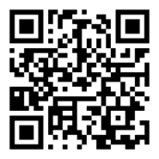

- open the service profile
- go to the 'leave a review' page
- use the online form to leave a rating and review of the service

Repeat Prescriptions
Repeat prescriptions are normally for patients on long- term medications. Most prescriptions are now processed electronically. Please let us know your preferred pharmacy, and your prescription will be sent there directly. You can change or cancel your choice of pharmacy at any time. Simply let us know before ordering your next prescription and allow time for the update to take place to avoid your next prescription being sent to the wrong place.
Paper prescriptions will continue to be available in special circumstances, but almost all prescriptions will be processed electronically.
Repeat prescriptions can be ordered:
- Online using Patient Access or NHS app
- Voice Connect Telephone order service
- Using the administration request on Rapid Health
- Email requests will only be accepted if online or telephone access is not appropriate

Please make sure you order your repeat medication at least 3 working days in advance. Please remember to make allowances for weekends and public holidays as they do not count towards the 3 working days processing time.
We review your medication periodically. When you order your prescription please ensure that you have not gone past your review date (stated on the right-hand side of your prescription). If your review date is overdue further prescriptions may not be issued until you have had a review appointment.

Test Results

We carry out a range of tests in our practice such as blood tests. If your test results are normal, we will not usually contact you. If you have an abnormal result or your test needs repeating you will be contacted with further details.

If you would like to know your test results you can find these on your NHS app, which is the quickest way to view the results, and any actions you need to take following the review of the results. If you are unable to use the NHS app or online access, you may contact our reception team, who can share comments made by the doctor on the test result. Results will only be given to you, the patient, unless prior arrangements are agreed for third party representation.

Sickness Certifications - Fit Notes

For the first week of illness, you may use a self-certification form which is available from your employer. Alternatively you can complete and download an online form at Ask your employer for Statutory Sick Pay - Ask your employer for Statutory Sick Pay - GOV.UK (tax.service.gov.uk)

If you are still ill after this time you will need to make an appointment with a clinician to discuss your illness and request a certification called a ‘Fit Note’ which tells your employer that you are unfit to work. Your fit note will be made available to you in an electronic manner – either by email or by SMS. In exceptional circumstances, if you are unable to access it these formats, we will be able to print this for you. If you require an extension to your fit note, you can contact the practice and we will arrange for a clinician to review your request.

If you have been under the care of a hospital doctor and admitted to hospital or have had a procedure, the duty to provide a fit note rests with the doctor who at the time has clinical responsibility for you. For guidance explaining how and when hospital doctors should use a fit note, please see Statement of fitness for work: a guide for hospital doctors - GOV.UK (www.gov.uk)

Hospital Transport

If you have been referred by our staff for onward care or treatment you will need to make your own arrangements with the hospital for your appointments. Should you need help with hospital transport please contact the hospital directly.

Non-NHS services

Some services provided are not covered under our contract with the NHS and therefore attract charges as private work. Examples include private sick notes, insurance reports, fitness to travel forms, holiday cancellation forms, private medical examinations, and some travel vaccinations that are not covered by the NHS.

Our reception team will be happy to advise you about the fees for these services, along with appointment availability if necessary. We will need sight of any forms in advance to enable us to advise on fees and assess any specific requirements.
Payment will be requested in advance and an approximate waiting time for the completion for these types of forms will be given. Please note that sometimes we may not be able complete a form or provide a service and may advise you accordingly.
These requests are considered clinically not urgent and cannot be completed during a routine consultation.
Change of Personal Details

To provide the best services to you, we need to ensure we have your correct details. If you have recently changed your address, phone number, email address or name please let us know:

- Via the NHS App
- In person - if you are unable to update your details online you can visit the surgery with any supporting documentation and out reception team will be pleased to help
- Using the administration feature on Rapid Health

Please note that if you change address, and no longer live within the practice boundary area, you will be asked to register with a GP surgery closer to your home.

Feedback, Complaints and Concerns

We aim to provide our patients with a caring, friendly, and professional service. We welcome all feedback so if you are not happy, please tell us.
We hope that we can sort out most problems easily and quickly. Often this will be at the time they arise and with the person concerned. Please tell them what is worrying you and they will do their best to resolve your concerns quickly and informally.
However, if they can’t or you wish to make a formal complaint, please let us know as soon as possible, and your complaint will be managed in line with our formal complaints process.
You can provide feedback our services or tell us about your concerns:
- In person or by telephone
- Online though our website
- In writing to the Service Delivery Manager by letter or completing a form available from reception

If you feel you cannot raise your complaint with us directly, and your complaint is about care you have received at the practice, then you can instead contact Integrated Care Board using the details included in this leaflet.

Confidentiality

We take confidentiality very seriously. The Practice is registered with the Information Commissioners Office (ICO). We comply with the Data Protection Act (2018) and GDPR. All staff recognise the importance of this. We ask you for personal information so that you can receive appropriate care and treatment. This information is recorded electronically and/or via manual medical records. For the effective functioning of a multi-disciplinary team this requires that medical information about you is shared between members of this practice and, on occasion with other health care professionals. We will not release any information about you to other third parties unless we have your consent to do so.

Our Privacy Notice describes how we collect, use, and process your personal data, and how, in doing so, we comply with our legal obligations to you. You can view a copy of our Privacy Notice on our website or by visiting the surgery.

Zero Tolerance for Violent or Abusive Patients

We are committed to taking all reasonable precautions necessary to ensure the health, safety, welfare and well-being of our employees, patients, and visitors. We endeavour to ensure that all employees are protected from physical and verbal abuse while they are working and strongly support NHS guidelines regarding zero tolerance.

We operate a Zero Tolerance Policy for patients. Anyone attending the surgery who is abusive, violent, aggressive be it verbally, physically or by acting in any threatening manner whatsoever to members of staff or other persons present on the practice premises, will risk removal from the practice list. In extreme cases we may contact the police to remove offenders from the practice premises.

Equality and Diversity

Modality Partnership is committed to eliminating individual and institutional discrimination, harassment and victimisation across all protected characteristics set out in the Equality Act 2010 relating to patients and employees which are: Race, Sex, Disability, Sexual Orientation, Religion or Belief, Gender Reassignment, Age, Marriage and Civil Partnership and Pregnancy and Maternity.
​
All Modality Partnership staff complete equality and diversity training

Patients’ Charter

Patients have the right to:

- Be seen by a doctor/healthcare professional for diagnosis and treatment of their medical condition. This is facilitated by making appointments from the range offered by the practice.
- Participate in public health programmes such as vaccinations.
- Not to be unlawfully discriminated against in the provision of NHS services including on grounds of gender, race, religion or belief, sexual orientation,
- disability (including learning disability or mental illness or age.
- Be treated with dignity and respect, in accordance with their human rights
- Accept or refuse treatment that is offered, and not to be given any physical examination or treatment unless valid consent has been given.
- Privacy and confidentiality and to expect the practice to keep their confidential information safe and secure.
- Access to their own health records.
- Choose their GP practice, and to be accepted by that Practice unless there are reasonable grounds to refuse, in which case they will be informed of those reasons.
- Express a preference for consulting with a particular doctor within their GP Practice.
- Have any complaint they make about the services we provide dealt with efficiently, to have it properly investigated, know the outcome and escalate the complaint to the independent Health Service Ombudsman.

Patients have the responsibility to:

- inform the surgery if they are unable to keep their appointment, thus making an appointment available for another patient.
- treat staff and other patients or visitors at the practice with respect and that causing a nuisance or disturbance on the premises is not acceptable

New Patients

All patients are required to be a resident within the practice boundary area below. You can either register online from our website or in person at reception. Please provide proof of identity including photographic identification and proof of address. We can still register you if you are unable to provide these documents.

If you are registering a child, please register in person and bring along your child’s red book.

For more information on how to register please contact us and we will be happy to advise you further on the process.

Crawley Down Health Centre
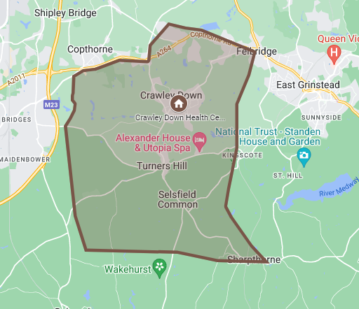

Park View Health Partnership
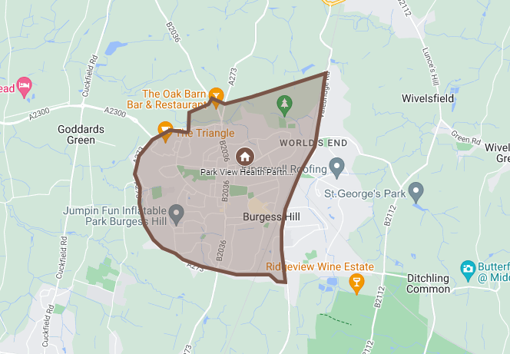

Judges Close Surgery
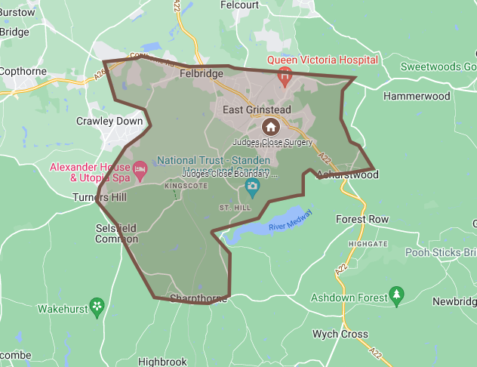

Ship Street Surgery
