 | Easy Read
 | NHS Nottingham and Nottinghamshire Integrated Care Board  They decide how to spend NHS money.  They plan how to improve people’s health, provide quality care and get better value for money.
 | Adult Pathway Review
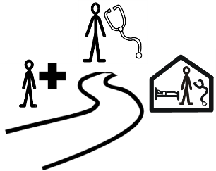 | The Learning Disability and Autism Team want to know how services for adults in Nottingham and Nottinghamshire are working.
 | These services help adults who are autistic, have a learning disability, or both.
We want to hear from you,

- If you use these services

- If you care for someone who does

 | What you tell us will help to make services better or create new ones.
 | Your answers will be private unless you choose to share your contact details.
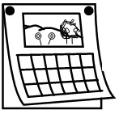 | The survey will close on Friday 18 July 2025.
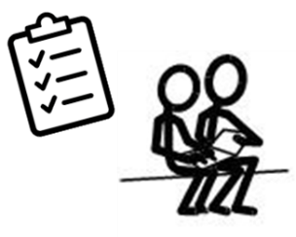 | There are a lot of questions, and you might want someone to help you to complete the survey.
 | If you have any questions or would like this survey in another language or format, please email  nnicb-nn.nottinghamshirelda@nhs.net.

 | Section 1
 | Pease tell us who you are by ticking 1 box.
 |  | I am completing this survey for myself.  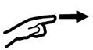  Go to section 1a
I am completing this survey on behalf of someone else.

Go to section 1b

Section 1a

I am completing the survey for myself

 |  | I have a diagnosis of:
Autism |  |  | A Learning Disability |  | ADHD
Other |  |  | Prefer not to say

 |  | I self-identify as:
Autistic |  |  | A person with a Learning Disability |  | Having ADHD
Other |  |  | Prefer not to say

 |  | I am waiting for a diagnosis of:
Autism |  |  | Learning Disability |  | ADHD
Other |  |  | Prefer not to say
 |  | Go to section 2

 |  | Section 1b  I am completing this survey on behalf of someone else.
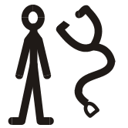 |  | They have a diagnosis of:
Autism |  |  | A person with a Learning Disability |  | ADHD
Other |  |  | Prefer not to say

 |  | They self-identify as:
Autistic |  |  | A person with a Learning Disability |  | Having ADHD
Other |  |  | Prefer not to say

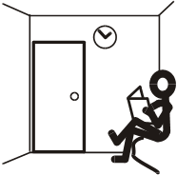 |  | They are waiting for a diagnosis of:
Autism |  |  | Learning Disability |  | ADHD
Other |  |  | Prefer not to say
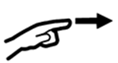 |  | Go to section 2

 | Section 2
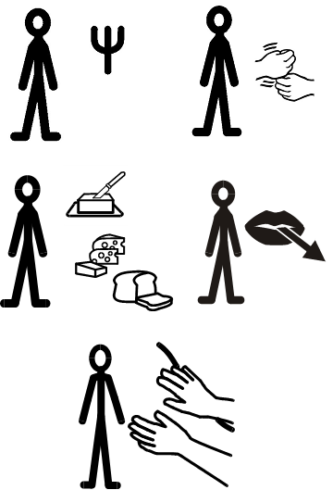 | - What health service/s are you  - using  - have used  - are waiting to use?  (tick all the boxes that apply)

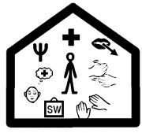 | Community Learning Disability Team (CLDT)  They have different people in the team including:
Psychology |  | Occupational Therapists | Psychiatry
Dietetics |  | Speech and Language Therapists | Learning Disability Nursing
Physiotherapy

Primary Care Liaison Nurses (PCLN)

Acute Care Liaison Nurses (ACLN)
 |  | GP Practices
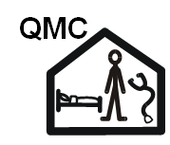 |  | Nottingham University Hospitals NHS Trust (City or Queens Medical Centre)
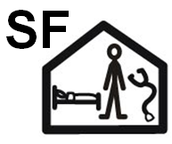 |  | Sherwood Forest Hospitals NHS Foundation Trust (King’s Mill)
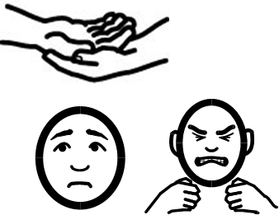 |  | Intensive Community Assessment and Treatment Team (ICATT)
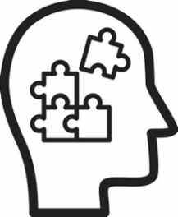 |  | Neurodevelopmental Specialist Service (NeSS)
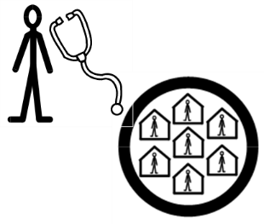 |  | Community Forensic Intellectual Disability (CFID)
 | Other |  |  |  | Prefer not to say

- What do you like about services you have used?

 |  | - What do you NOT like about the services you have used?

- What would you like the services you use to START doing?

- What would you like the services you use to STOP doing?

 | - What would you like the services you use to CONTINUE doing?

 |  | Section 3
 |  | - Are there any health issues that you are not getting support for?
Yes |  | No |  | Prefer not to say

- What health issues are you not getting support for?

 |  | - Does anyone else know about these health issues?
Yes |  | No |  | Prefer not to say

If YES - please tell us who knows

10. How long will you need to wait for support?

I expect to wait for:

 |  | Section 4
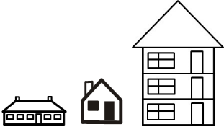 |  | - Where do you live?
Ashfield |  |  | Bassetlaw |  | Broxtowe
City |  |  | Gedling |  | Mansfield
Newark & Sherwood

Section 5
 |  |  |  |  | Would you be interested in helping us think about what we need to change?  Would you like to hear about what we did next?
Yes |  |  |  | I would like to be involved in helping think about and create a new pathway
Yes |  |  |  | I would like to hear about what you did next
  Tell us your email address or phone number and we will invite you to be involved, or tell you what we did next:

Thank you for completing this survey

