

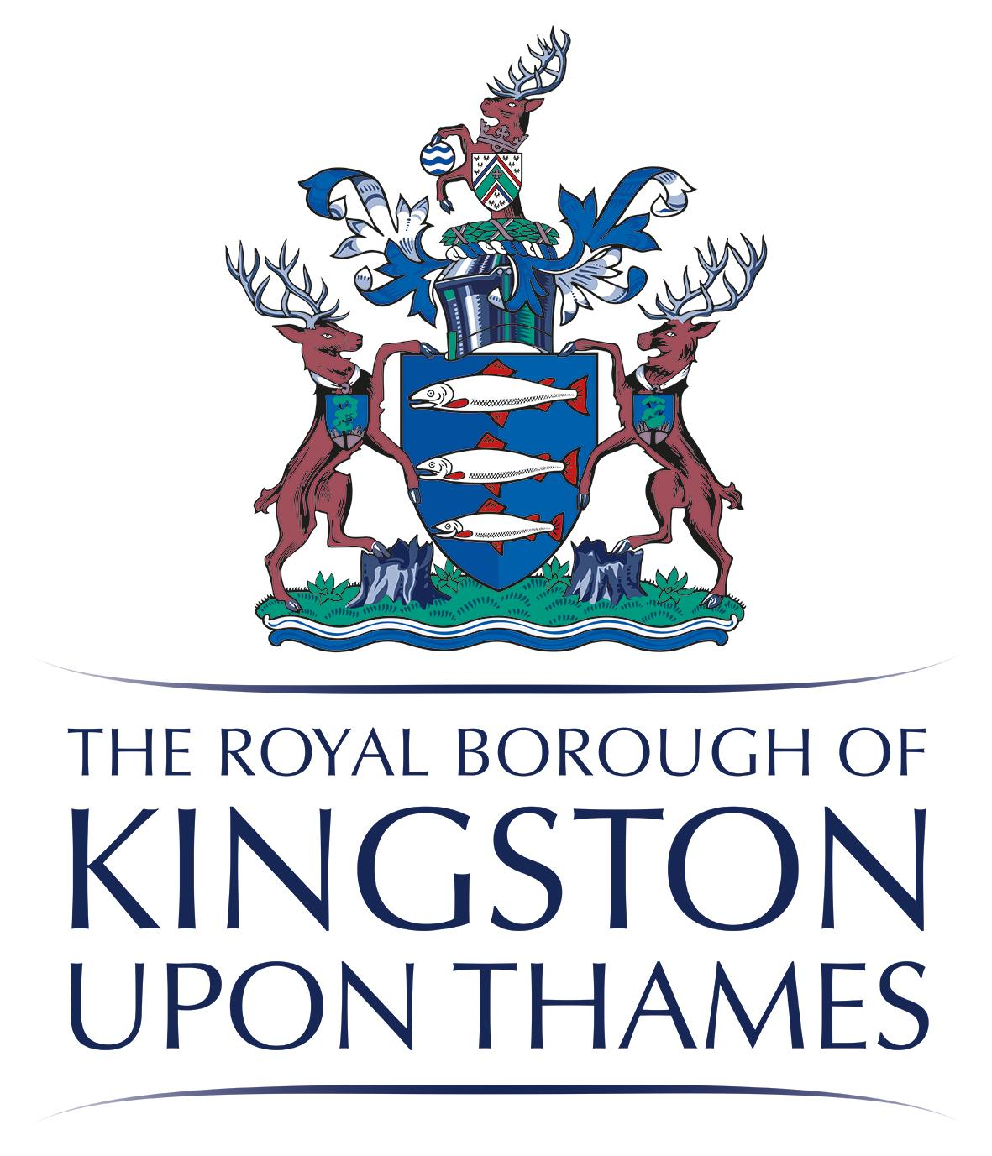
Exercise classes – Jan 26
(Free for people living, working or studying in Kingston or belong to Kingston GP Surgery)

Osteoarthritis Knee Class (12 weeks)
YMCA, 49 Victoria Road, Surbiton KT6 4NG
Starting 5 January, Mondays 13.45-14.45pm
Exercise and information sessions for people you have been diagnosed with knee osteoarthritis.

Osteoporosis Risk Class (Strength, Balance and bone health - 12 weeks)
Graham Spicer institute, 15 Dukes Ave, New Malden KT3 4HL
Starting 7 January, Wednesdays 10.30-11.30am
Balance, Bone and Muscle strength exercises for people who have been diagnosed with osteoporosis or osteopenia or at risk of developing them. Some risk factors include - A broken bone after a minor bump or fall, family history of hip fracture or osteoporosis, early menopause (before 45), rheumatoid arthritis, Cancer, regularly taking corticosteroid tablets, smoking, or consuming more than 3 units of alcohol per day.

Strength and Balance Class (10 weeks)
Surbiton Hill Methodist Church, 39 Ewell Road, Surbiton KT6 6AF
Starting 14 Jan, Wednesdays 13.15-14.15pm
Muscle strength and balance exercises for people with one or more long term health conditions.

Please let us know:
If you are unable to attend these sessions but interested in future sessions.

Places are limited. Please register by contacting us on
Tel: 0300 123 8086
Email: swlicb.betterbones@nhs.net

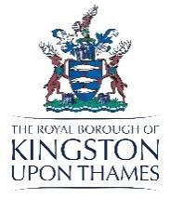

Information Sessions (Dec 25-Mar 26)
(free for anyone interested, out of borough clients, families and friends welcome)
No need for advance booking, just turn up on the day

Physical Activity: 6 Jan (13.00-14.30pm), Tolworth Library, 37-39 The Broadway, Surbiton KT6 7DJ

Learn about Physical activity and the type and amount of activities we need to do to maintain our health and wellbeing. Also learn about simple exercises to do at home

Bone Health: 8 Dec (13.00-14.30pm), Kingston Library, Fairfield Road, Kingston KT1 2PS and
3 Mar (13.00-14.30pm), Tolworth Library, 37-39 The Broadway, Surbiton KT6 7DJ

Learn about how to look after your bones. We will discuss diet, exercise and lifestyle factors that affects our bones and how to keep them healthy and strong.

Self Management in Osteoarthritis: 3 Feb (13.00-14.30pm), Tolworth Library, 37-39 The Broadway, Surbiton KT6 7DJ

Learn about osteoarthritis and how to look after your joints using lifestyle factors.

Osteoporosis and Bone Health: 4 Feb (9.30-11.30am), Graham Spicer Institute, 15 Dukes Ave, New Malden KT3 4HL

Learn about how to manage or prevent osteoporosis. We will discuss diet, exercise and lifestyle factors that affects our bones and how to keep them healthy and strong.

Please let us know (0300 123 8086 or swlicb.betterbones@nhs.net): If you are unable to attend these sessions but interested in future sessions.

