THE COTTONS MEDICAL CENTRE - PATIENT PARTICIPATION GROUP
Newsletter Summer 2025

ANIMA – HOW THE SYSTEM IS WORKING

This system has now been in use at The Cottons for approximately one month. It is a system that has been/is being introduced nationally by the NHS.

Many people who have used it are surprised at how quickly they are contacted back by The Cottons team, despite the fact that when a patient has completed the required forms and submitted their request ANIMA states “You may not receive a response for a number of working days”.
When your request is submitted it will, most importantly, initially be looked at by an appointed GP who will then ‘field’ problems to the relevant person/department and you will be contacted back almost certainly within the day and often, if it is thought that you need an appointment, within the hour.
We again remind you that if you do not have a smart phone or computer and are not able to use ANIMA, to telephone the surgery and a Care Navigator/Receptionist will complete the form with you and submit it on your behalf. The Care Navigator/Receptionist is UNABLE to make you an appointment if you telephone as all appointments have to go through ANIMA.
You may think that some of the questions you are asked are irrelevant to your problem and this is recognised by the Practice. It is hoped that problems will gradually be ironed out and alterations made nationally, but this will take time. Please remember that like you, the Staff are new to this system and learning all the time. They will do their upmost to help and as we have said you can contact them if you are struggling.
Repeat prescriptions should still be made through the NHS, SystmOnline or the AirMid apps, or you can physically go to the surgery and complete a Request Form and put it in the Prescription Box.

MISSED APPOINTMENTS

The level of missed appointments is still too high. Missed appointments also have an impact on patients who are needing appointments. Please help the surgery by responding to any text reminders by attending as notified or cancelling if your appointment is not needed. 139 patients did not turn up for appointments during the month of June 2025.
IF YOU NO LONGER NEED AN APPOINTMENT, PLEASE CANCEL IT!
This will free up appointments for other patients.

COPING WITH HOT WEATHER
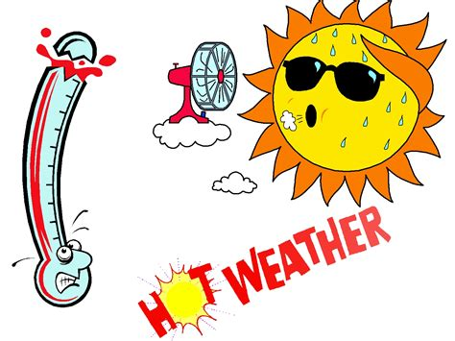
The NHS advises staying safe during hot weather by keeping out of the sun during peak hours (11am to 3pm), staying hydrated and checking on vulnerable individuals like the elderly and young children. It's also important to recognize the signs of heat exhaustion and heatstroke, which can include dizziness, excessive sweating, and confusion.
For more info visit the link below:-
https://www.nhs.uk/live-well/seasonal-health/heatwave-how-to-cope-in-hot-weather/

SUNGLASSES PROTECT YOUR EYES

Bright sunshine can increase your risk of cataracts and age-related macular degeneration, the most common cause of sight loss in older people. This is not only direct sunshine, but reflection of the sun, such as when we sit at white plastic tables or stainless steel or glass tables.
The skin of our eyelids is thin and prone to skin cancer if not protected. UK regulations are strict; sunglasses must block 99-100% of UV radiation. The same may not be true of shades bought abroad (or online), so be aware of copies.

OUT OF HOURS AND EMERGENCIES
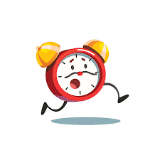
111 is the NHS non-emergency number. It’s fast, easy and free. Call 111 and speak to a highly trained adviser, supported by healthcare professionals. They will ask you a series of questions to assess your symptoms and immediately direct you to the best medical care for you.
NHS 111 is available 24 hours a day, 365 days a year. Calls are free from landlines and mobile phones.
IN CASE OF A LIFE-THREATENING EMERGENCY, PLEASE DIAL 999.

MMR JAB - MEASLES IS SPREADING
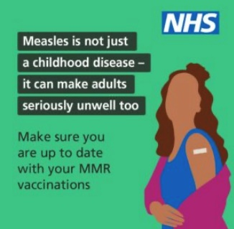
You have probably read or heard of the recent tragic event when a child died after contracting Measles. The NHS recommend that all children received the MMR vaccine to give them protection against Measles, Mumps and Rubella. More information can be found on the NHS website:- https://www.nhs.uk/vaccinations/mmr-vaccine/
However, Measles can also be dangerous for adults, especially those over 20 years old or with weakened immune systems, as they are at higher risk of severe complications like pneumonia and encephalitis. While most people recover, complications can lead to hospitalization and even death in some cases. If you have not or are unsure if you have been vaccinated please contact your GP.

JOIN THE COTTONS PPG!
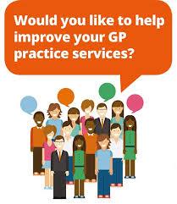
If you want to make your ideas and suggestions heard why not join our PPG. You can join as an Active member and come along to meetings which are held quarterly, or as a Virtual member and put your thoughts in writing to us and receive updates and minutes of meetings. We are looking for ‘new blood’ and would welcome all enquiries to: ppgcottons@gmail.com but please remember we are NOT a vehicle for complaints. These should be made to the Practice Management.
If you know anybody who is a patient at The Cottons, but not a member of the PPG, and who would like to receive the Newsletter, please ask them to send an email to this effect to ppgcottons@gmail.com and we will be pleased to add them to the circulation list.

USEFUL INFORMATION

Surgery Telephone No: 01933 623327
The Cottons Website: www.thecottonsmedicalcentre.co.uk
Repeat Prescriptions: NHS, Airmid or SystmOnline mobile phone apps
Life threatening conditions telephone 999

For urgent medical assistance telephone 111

To get mobile phone reminders: Register your number with reception.

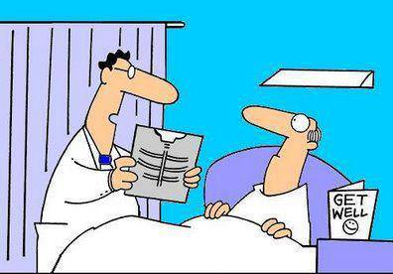 | Patient: Hi Doc – Wot’s the news?  Doctor: Your X Ray showed a broken rib, but we fixed it in Photoshop!

