***Social Prescribing in Mansfield North***

Social Prescribers in Mansfield North offer many resources to local Veterans, and we aim to ensure they receive the care, support and social interventions to connect with others who are serving personnel or are now Veterans.

Much of the work is around supporting their health and wellbeing and in collaboration with Age Uk, RBL and the local breakfast clubs but also by G.P. referrals.

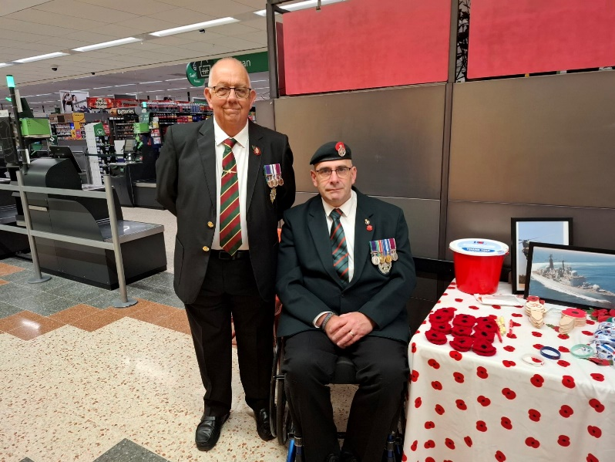  
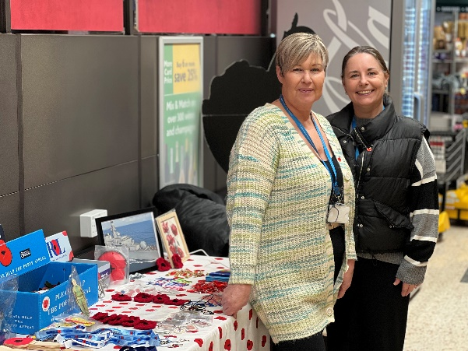

David Wilson (Worcestershire and Sherwood Foresters) and Steven Hughes (Royal Green Jackets) who supported the RBL Poppy Appeal in Mansfield.

We also give thanks to David who recently trained and became a Walk Leader with AGE UK to ensure the fortnightly walks go ahead at Mill Waters bi weekly.

Senior Social Prescriber Alison Foad and Kirsty Worboys recently helped out with poppy sales in Morrisons (Mansfield). They offered opportunities to the local community and chatted about the benefits of Social Prescribing to Veterans and Armed Forces Personnel.

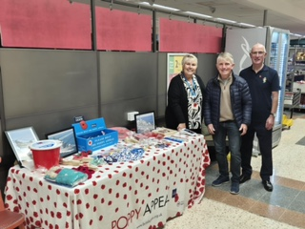

Senior Social Prescriber with Colin Ford (REME). Colin attends the Breakfast Club at the Bold Forester on Saturday mornings, offers guided walks, Volunteers with Ashfield District Council and assists at the Walk and Talk Group.

He is valued for his support in the community and came to know about Social Prescribers via his own personal experiences and a referral from his GP surgery.

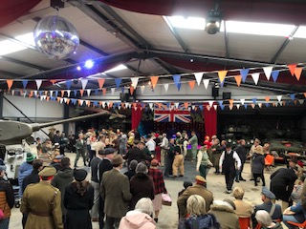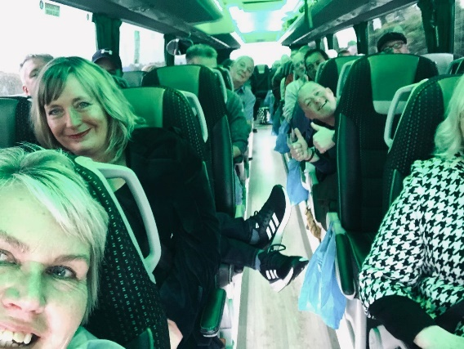

In October Rose Severn with the financial support of N.C.C and facilitated by Neil Bettison, took forty-two people from our Armed Forces Community in Mansfield to Eden Camp, a Modern History Museum in Malton, North Yorkshire.

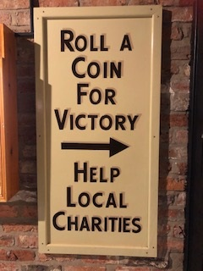

During the day, we were entertained by live performances, able to engage with actors, enjoyed the glamour and see all the fashion. We captured the full essence of the time. Restored vehicles from the 40’s, such as The Willys Jeep and a Sherman Tank, were on show.

*Eden Camp photos were shared by Melvyn Pearce who attends the sessions at Mill Waters.*

The camp hosted a 1940’S style event and allowed us to see the full spectacle of vehicles, singers, dancers and we were able to get into the full spirit of the event.

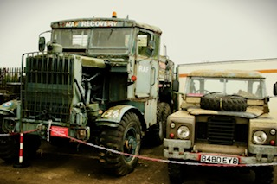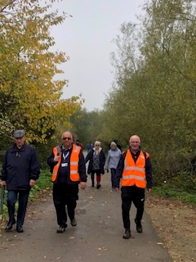

We are currently helping with plans for the Remembrance Parade on 10th November in the Warsop Parish. This is in collaboration with several agencies, the Poppy Gang and the Air Force Cadets and also organising a Christmas Lunch on the 10th December with the Veteran’s Walk and Talk Group.