In December of last year, we delivered nearly 70 Christmas presents that were kindly donated from our staff and patients. Derian House were extremely grateful for these lovely gifts for the children.
Thank you to everyone for donating
After 36 years, Dr Mark Savage retired in April from the practice. We wish him all the best in his retirement.
July
Second week of May: Mental Health Awareness Week
May 8th: World Ovarian Cancer Day
May 10th: World Lupus Day
May 19-25th, 2025: Dementia Action Week
Third week of May: National Epilepsy Week
Last week of May: Deaf Awareness Week
May 31st: World No Tobacco Day
Download the NHS App on your smartphone or tablet via the Google play or App store to Request repeat prescriptions, check their status, see your appointments and access your medical records.

Our news is not all medical, and we welcome suggestions and ideas for any future editions!
On the 4th March we trialled Group Respiratory Consultation.
We invited eligible patients to join us at the practice for one hour.
The evening was hosted by our Clinical Prescribing Pharmacist.
At Easter we ran a colouring competition for 2 age groups. Thank you to all who took part, we hope you enjoyed your prizes.
At the start of April, we welcomed Michelle who has joined our musculoskeletal team
We are currently accepting new patients, you can now register via the online GP registration service.

Please ensure you keep us updated of any changes in your contact details
Thank you to everyone who has taken the time to complete our monthly family and friends feedback form. We are required as a practice to collect patient feedback.
Please can we politely ask, if you are unable to attend an appointment, please call us to cancel it so the slot can be given to another patient.
To cancel appointments please call the surgery, send us an email, or cancel via the NHS app

Welcome to our April 2025 Newsletter

To provide professional, accessible, and comprehensive healthcare in a friendly environment with our patients at the centre of the service
Staffing and Service Updates

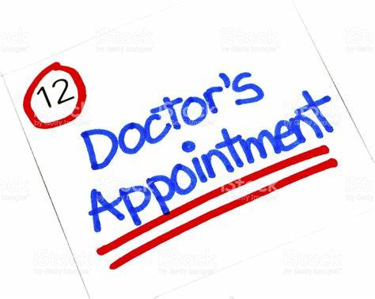

Your Feedback is important to us!

CONTACT US AT REGENT HOUSE SURGERY
01257 442628
Email: Lscicb-csr.regenthousesurgery@nhs.net
Website: www.regenthousesurgery@nhs.net
Regent House Surgery – Facebook/Instagram

Practice News
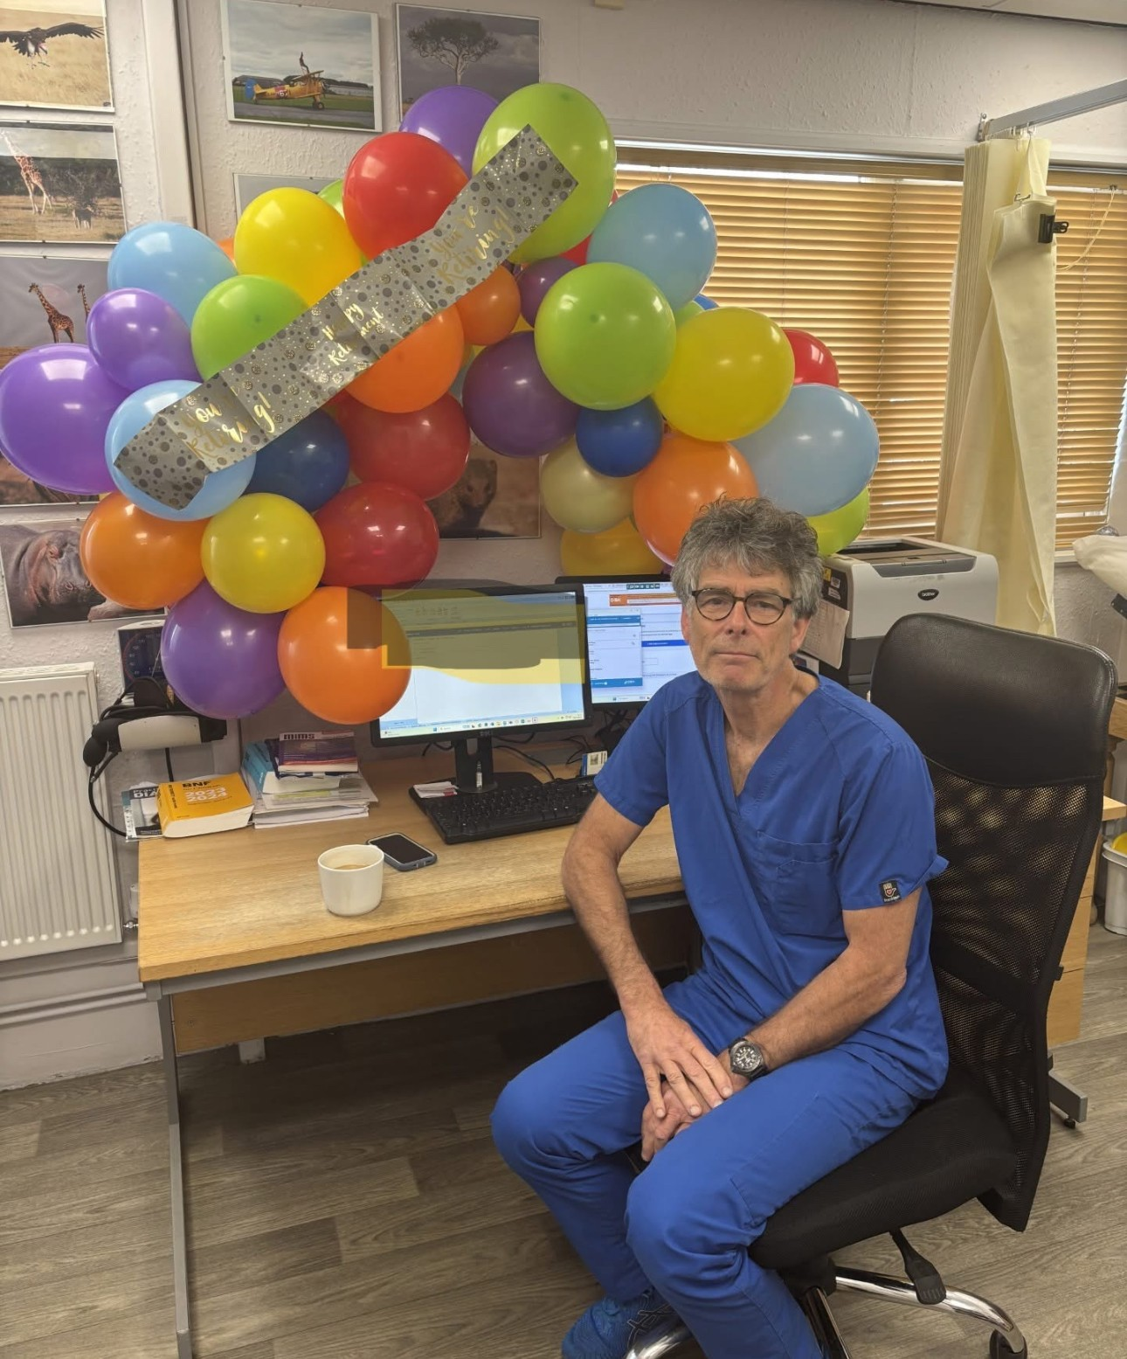


Upcoming Health Campaigns

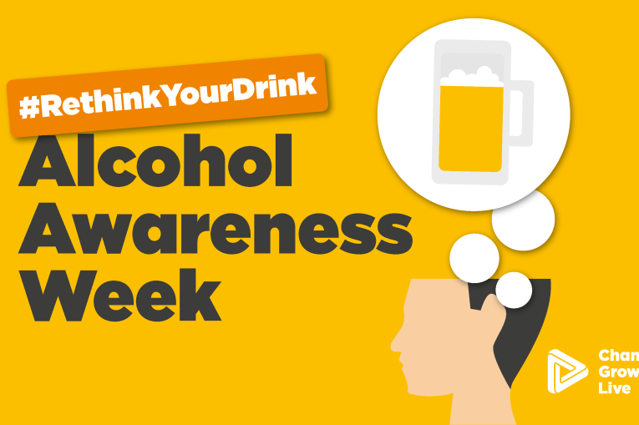
General News



