Appointments
The practice operates an appointment system, we offer both Face to Face and Telephone appointments during normal surgery hours.
- Same Day appointments are released at 8am
- Routine appointments can be booked at anytime

Appointments can be booked by telephone, online, at reception or via the NHS App
Please remember it is unrealistic to manage multiple problems in one appointment. If you have multiple issues to discuss, you may need to book a further review.
Please note that if you arrive more than 10 minutes late for an appointment, you will be asked to re-book for another day.
Our clinicians work to BMA safe working practices. Once all of our appointments are booked patients may be signposted to an alternative provider

Home Visits
Home visits are reserved for those patients who are housebound. In some cases, a GP may speak to the patient or a relative to discuss the need for a visit.
If possible, please try to telephone your request for a visit before 12:00 am to help the doctors to organise their day.

Cancellations
If you cannot attend your appointment, please inform us as soon as possible so we can offer it to another patient

Repeat Prescriptions

Repeat prescriptions can be ordered in the following ways:
- In person – By ticking the required medications on your prescription and placing it in the dedicated box, located by the front door
- NHS App
- Online – Please log in and order via our website
regenthousesurgery.co.uk

Electronic Prescribing Service (EPS) - The practice offers the EPS service which allows your prescriptions to be sent electronically to the pharmacy of your choice.

Please allow 48 working hours for collection. Ordering over a weekend and bank holidays may take longer.

Practice Location

The Practice is located in the centre of Chorley, where we have onsite parking available.
By Bus
The 118 and 362 buses stop close to the practice
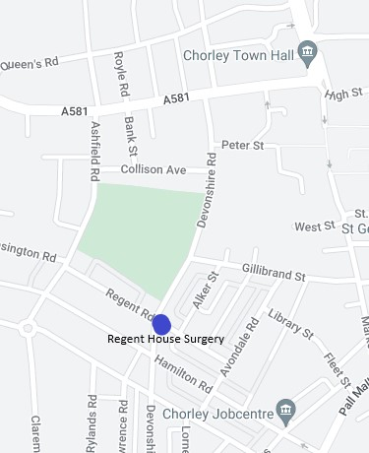
Accessibility

There is easy access to the surgery. Disabled parking and toilet facilities are available. We have a lift to the first floor and a portable induction loop available from reception. Access to language line can be arranged prior to appointment via reception

Patient Data
All clinical and administrative staff have an ethical as well as a legal duty to protect patient information from unauthorised disclosure and in accordance with UK GDPR.
The patient privacy notice is available on the practice website.

NHS England Contact
Regent House Surgery provides NHS services on behalf of NHS England, PO Box 16738, Redditch, B97 9PT.
Telephone: 0300 311 2233
Email: england.contactus@nhs.net

When we are closed
When the practice is closed, if you urgently need medical help or advice and it is life threatening, dial 999.
If it is not life -threatening, contact NHS 111 by calling 111 or accessing via www.nhs.uk
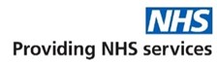
Lancashire and South Cumbria
Integrated Care Board (ICB)

21 Regent Road, Chorley, PR7 2DH

Telephone: 01257 442628
Email: lscicb-csr.regenthousesurgery@nhs.net
Website regenthousesurgery.co.uk

Opening Hours Monday—Friday 8:00am – 6:30pm
Regent House Surgery is a partnership providing NHS Services under an NHS England General Medical Services Contract.

Your health is important to us .

Our team will ensure they deliver high quality health care for you, in an environment of continual improvement, involving and respecting you at all stages.

New Patients are welcome to register with us.
To register, you will need to fill in a New Patient Registration form which is available from reception or can be download from our website.

We are proud to be a teaching practice, training fully qualified doctors who are in their final year of GP training and medical students.

GP services are provided to the following area
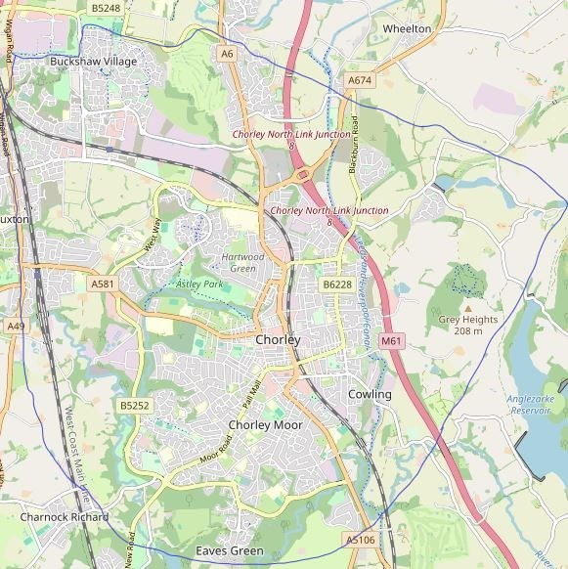
The practice website contains all the relevant information that you are likely to require. It is the quickest way to access the services you may need.

Practice Team

GP Partners

Dr Karen Marsden (f)
MBChB (Leeds 1995) MRCGP, DRCOG,
DFFP
Dr Gillian Brennan (f)
MBChB (Sheffield 2001) MRCGP, DRCOG,
DFFP
Dr Richard Brown (m)
MBChB (Leicester 1999) FRCGP, PGCert GP
Dr Sarah Richardson (f)
MBChB (Edinburgh 2011) MRCGP, DRCOG
Dr Diogo Costa (m)
Lic Med (Porto 2010) MRCGP

Practice Staff

Sinead Bretherton | Practice Manager
Jeanette Green | Asst. Practice Manager
Katie Newall | Nurse Practitioner
RGN 2016
Independent/Supplementary Prescriber 2021
A Nurse Practitioner can deal with many of the problems that a GP would normally see.

Nursing Team
Christine Shepherd | Practice Nurse
Joanne Hill | Practice Nurse
Nichola Arnott Assistant Practitioner

Secretarial and Admin
Jenny & Rachel Secretaries
Fran, Amy & Rachel Admin

The team provide support to the GP’s and practice Staff.

Reception
Caroline Supervisor
Janet, Jill, Paula, Jacci, Marita, Laura, Julie, Julia

All our receptionists are fully trained, competent and caring, and are bound by the same rules of confidentiality as the doctors.

The practice works closely with a wider Healthcare Team, District Nurses, Midwives, Health Visitor's, Mental Health practitioner, physiotherapists providing professional, accessible, and comprehensive healthcare in a friendly environment.

Services we provide
Along with routine appointments, the practice offers the following services:

Family planning
All our GPs and the practice nurse offer a full range of family planning services

Immunisations
The nursing team administers vaccines for both adult and child immunisations. Child Health Surveillance
All new babies are invited for a check up with a doctor from 8 Weeks old.

Minor operations, cryotherapy, joint and soft tissue injections
Please discuss this with your GP who will decide whether this would be a suitable option for you.

Cervical smear testing
For women aged 25 – 65. These tests are undertaken by the nursing team.

Chronic disease management
We hold a range of clinics to help our patients to manage their long-term medical problems including asthma, diabetes, hypertension, kidney disease and heart disease.

Phlebotomy
We have two clinics every week where a qualified phlebotomist can take any blood tests you require.

Warfarin clinic
If you are taking warfarin and wish to attend our clinic please contact the practice for advice.

Podiatry
This service is just for diabetic patients who are due their annual foot check and risk assessment. This clinic does not provide routine foot care.

Other services
Post natal checks, ECG and health checks for adult patients.

We are part of the Chorley Central Primary Care Network and offer access to the following services
- Evening and weekend appointments,
- Social Prescribing (help people, and address their problems more effectively),
- Musculoskeletal Practitioner (muscle & joint pain),
- Associate Psychological Practitioner (mental health)

Details are available from reception and on the practice website.

Private Medicals
We carry out various private medical examinations for which a fee is charged. For example HGV, PSV & taxi licenses, pre-employment, life-assurance, fostering, and hazardous sports.

Patient Participation Group
We have an active Patient Participation Group (PPG), ensuring that our patients are involved in decisions about the services provided by the practice.
Further information about our PPG is available online at regenthousesurgery.co.uk

Comments, Suggestions and Complaints

We are very interested in your views of the service we are providing and would therefore welcome any constructive suggestions that may further improve the service we provide. Please talk to a member of staff or submit ideas in writing. We have a suggestion box which is located by the front door.

Complaints Procedure: We make every effort to give the best service possible to everyone who attends our practice.
However, we are aware that things can go wrong resulting in a patient feeling that they have a genuine cause for complaint. If this is so, we would aim for the matter being settled as quickly, and as amicably, as possible.
If you would like to make a formal complaint, you can do this in writing to the Practice Manager

Patient Confidentiality

We respect your right to privacy and keep all your health information confidential and secure. It is important that the NHS keeps accurate and up-to-date records about your health and treatment so that those treating you can give you the best possible care.

All patient information will be treated in strict confidence. Access to all records will be limited to the people caring for the patient, including practice staff. Sometimes other professionals involved in patient care will need access to the notes, but this will only be done with the express permission of the doctor.

We fully abide by GDPR/DPA and Caldicott Principles in the use of information.
Patient Rights and Responsibilities Patients will be treated with courtesy and respect as individuals and partners in their healthcare.

We operate a zero tolerance policy for both physical and/or verbal abuse against all staff and patients.

