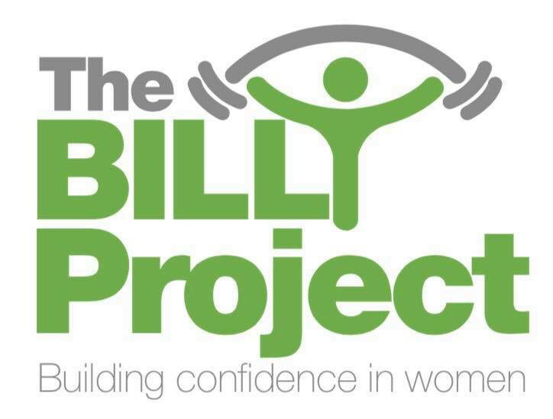
The Billy Project Referral Form

Date:
Client Name:
DOB:
Contact Number:
The Billy Project to contact client: Y/N
Key Workers name:
Key Workers attending session: Y/N
Details (health issues, medication, etc):

Referred by:

Please return completed form to
Sammi Yates sammi@thebillyproject.co.uk
Alternatively, hand in or post to Unit 2 Fitness for Women, Albert Street, Mill Hill Blackburn, BB2 4BL.

Telephone contact details:
Sammi 07960643154

