Kingstone Surgery Dec/ Jan newsletter (scribed Nov)

Another mixture of sublime and the serious this month.

**First: the sublime**. Kingstone were delighted to have been involved in a successful pan-Herefordshire bid for Arts Council funding for Arts-health projects this year https://meadowarts.org/2024/08/05/herefordshire-cultural-partnership-announcement/.

The first of these kicked off this month with Artist Cordelia Cembrowiz using a room in the surgery for her project focussing on the community of the Golden Valley and Kingstone areas. We hope you enjoyed posing and performing with her, and we look forward to the photographic outcomes. Here is our Dr Icey taking part in a lunch break:

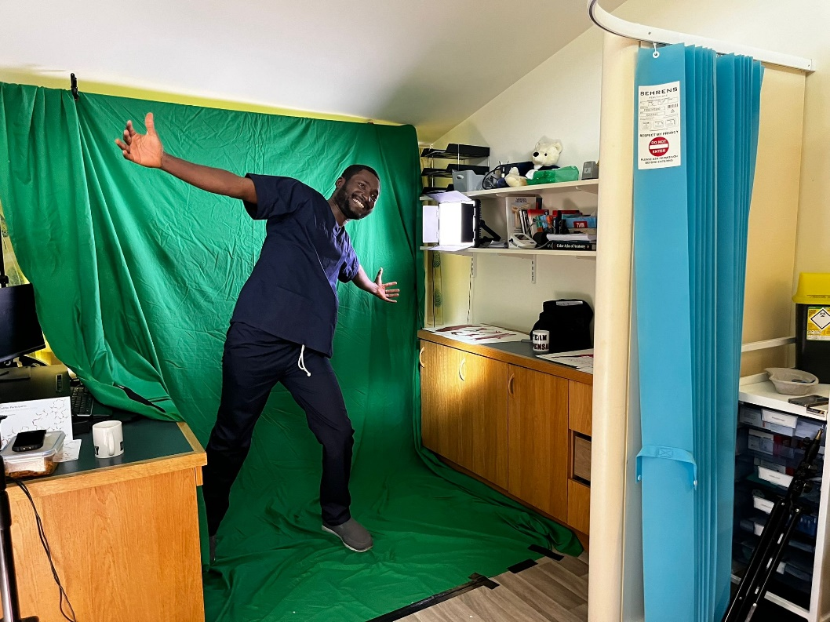

As you are aware, Kingstone has recently become a GP training practice. This means we contribute to the development of GPs for Herefordshire, and the retention of doctors in the county. Dr Icey has finished his 4 month rotation with us (moving on to work in Hereford County Hospital), and we welcome Dr Naja Khan in December.

**Now for the serious**. As with many of you, Kingstone surgery are reeling from the news that the employer NI contributions are going to be going up next year. Unless the government changes its funding structure, this is going to have an impact on the service we can provide.

We hope you will continue to support us in having to roll back on providing services that are not funded by the NHS so we can continue to provide our core services. Unfortunately, we have already made the decision we will no longer be able to do post-operative dressings. This is currently not funded by the Herefordshire Integrated Care Board (ICB) although we have always done it anyway. It is taking up increasing amounts of nursing time (20- 33 hours a month on our recent audit). We have given the ICB 3 months notice so that they can either chose to fund us to do it in primary care, or they may decide to set up an in-hospital dressing service. We are really sorry about this, because we feel it is something that benefits all patients being able to have this done locally, in an environment you are comfortable in.

Finally, a Christmas message for your friendly **Kingstone Dispensary:**

The dispensary will be closed on the 25th & 26th December 2024. Please continue to order your monthly repeat prescription as you would normally and do not order early. If you would be due to pick up on either of those days then your medication will be ready on the 24th December 2024. The dispensary will also be closed for one day only on Wednesday 1 January 2025, if you would be due to pick up on this day then your medication will be ready on Tuesday 31 December 2024. To help with this extremely busy period of the year, if you have enough medication to leave collection until after the festive period then please do so but do not go without medication. The dispensary girls will ensure you get whatever medication you need but please be patient if you have to wait a few minutes.

The whole Kingstone Surgery team wish you all a very Merry Christmas and a happy New Year