Kingtsone surgery newsletter June 2025

Thank you to the many who have voted (both in-surgery via QR code, and on our website) for the image that will go on the shipping container in our car park. This was made by artist Cordelia Cembrowitz, as part of a Meadow Arts Art-Health project, and many of you participated in the day she took your photos. Participants are portrayed as molecules which include Oxytocin for love, Serotonin for happiness and three variations of Adrenalin- for action.

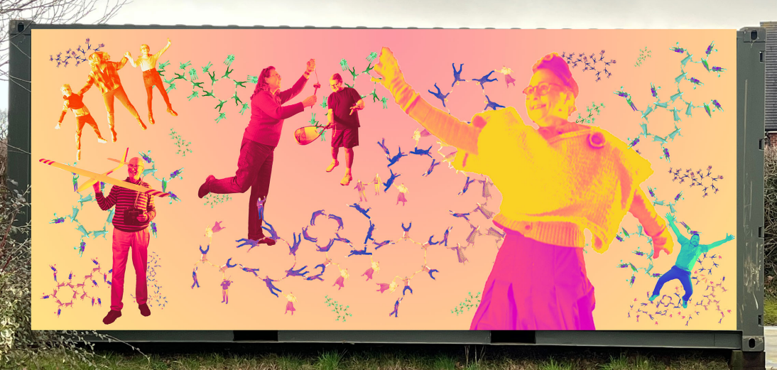

Sneak preview here, but we cannot wait to see it in situ- large, bold and beautiful.

On a more prosaic note, measles is on the rise again in London. The capital may feel far away, but we often follow its infectious disease trends. The UKHSA (FIVE letter acronym this time- whatever next?!. It stands for the catchy 'UK Health Security Agency) has written to remind us that all patients with suspected measles (rash and fever) should be isolated immediately on arrival to protect other patients. As you are aware, we have no isolation room and if you present with a fever and a rash will ask you to wait in the car before we call you through. Thank you for your patience when we ask you to do this. If you are at all concerned about your measles vaccination status PLEASE check your NHS app to see your immunisation record. Anyone who is missing documentation is welcome to have the two- dose MMR vaccine. Anyone on our records aged <26 years who does not seem to have had the vaccinations will be actively invited in via text message in the next few weeks.

Some of you have chosen to buy GLP-1 agonists (injections for weight loss) privately as the NHS has been slow to fund the roll out. We are getting MHRA alerts ('Medicines Health Regulation Authority'- a mere four letters this time) about caution with it affecting the absorption (and efficacy) of HRT and oral contraception. This may mean you need extra protection. Please contact us or your private providers of the medication if you have questions.

Finally, we are hoping for our TV in the waiting room to be up and running soon. If you run any local community groups you would like to be shared, please send in PowerPoint slides to Kingtsone.surgery@nhs.net. We may be able to include them when we get the TV active. Otherwise, the slide show will mainly contain my favourite surgery statistics..... (like the fact our patient population has grown 20% in 5 years, and 9% of patients have no mobile phone number on record...).

