Kingstone Surgery, October newsletter
First off: Flu vaccinations! We hope most of you have now booked your flu vaccinations with us in preparation for the winter ahead. We have been grateful for your treats to keep us going during these clinics: including some delicious apples, chocolate cupcakes and some marmalade cake! If not yet booked- please do so. We will put on clinics for as long as we have requests coming in.
There are, as usual, lots of new changes going on this autumn.
Next up is a scheme to help people back into work when they are ready. WorkWell is a free service, which provides help tailored for you whilst you're in work, off sick or out-of-work. They can support your employment difficulties, help you to move towards your goals and connect you with services for your wellbeing and health. Want to know more? Visit https://www.herefordshiregeneralpractice.co.uk/health-and-wellbeing/workwell or refer yourself directly by calling 01432 262668.
We also have a new exciting Tuesday ‘Winter Wellbeing Circle’ to be held at Kingstone village hall from 11.30-13.30 starting from November. See our Wellbeing Practitioner Jolanta Seavor’s poster below. It looks like an excellent addition to our local services. I am a particular fan of the chair-yoga! Please help make it a success by getting involved. Either simply turn up, or email thl.wellbeing.swherefordshirepcn@nhs.net for more information.
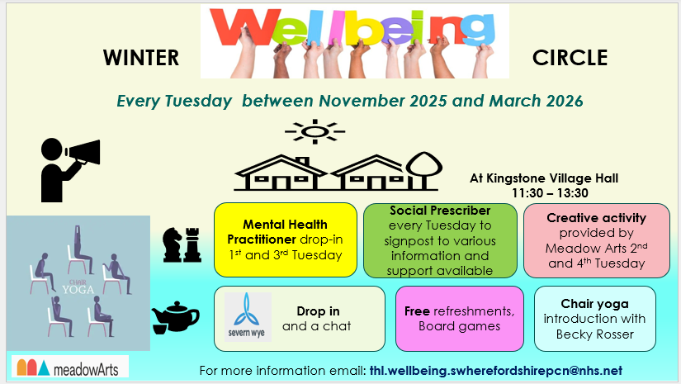
We are also delighted to let you know that we have secured some funding to help us build a new consultation room by converting our shed. This will mean we can try to serve our growing population by training more local GPs and putting on more doctor and phlebotomy appointments. We are hoping that in combination with the Kingstone Surgery Charitable Trust’s incredible fundraising for the external dispensing machine we will be able to keep the queues down and the appointments up. I was particularly sorry not to be able to make the KSCT awesome looking ‘Boogey in the Barn’. Those who did, please fill me in!

