Benign Growths and Alternatives to Liquid Nitrogen (Cryotherapy) Freezing

There are many other options instead of liquid nitrogen to treat many of these skin conditions.

Warts and verrucas:
These are thickenings of the skin, causing excess dead skin (keratin) to form. Sometimes you can see the dead blood vessels inside them as tiny black dots (which is characteristic). There should be no ‘meaty’ skin thickening under the keratin layer.

Warts are not dangerous and as long as you are otherwise well, do not signify any other illnesses. They may well disappear on their own within 2 years with no treatment. Treatments aim to thin the skin and irritate it to improve blood supply which aids the body’s own attack on the virus.

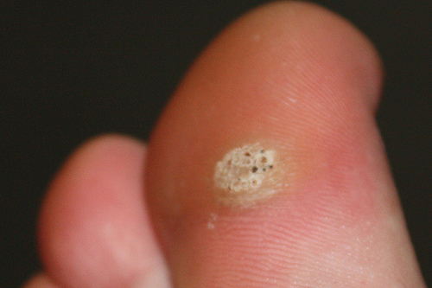

Overall, Liquid Nitrogen is no more effective than salicylic acid and may need repeated painful treatments. The evidence shows that after 3 months of treatment, liquid nitrogen does not seem better than other options.

Treatment options to try include:
- Salicylic acid:
- Remove excess dead skin with a corn and callous blade, emery board or pumice stone
- Protect normal skin around warts with petroleum jelly (Vaseline) or corn plasters
- Apply salicylic acid gel or liquid to the thickened skin daily
- Pare back the dead skin weekly after soaking
- Continue for 3 months

- Duct Tape or Blister plasters – the evidence for this treatment is not clear however some podiatrists feel this can work: Apply for 6 days at a time, wash, leave overnight and repeat regularly for 2 months

Seborrhoeic Keratoses (“senile warts”)

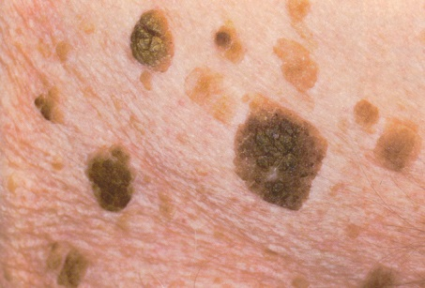
These are often brown or black crusty patches that appear after about the age of 35-40, mostly on the back, face, scalp or trunk (but do occur on the arms and legs too). They are unusually numerous and all look fairly similar. They have a characteristic ‘stuck on’ appearance with a side light. Almost all older adults will have some of these.

This is usually a cosmetic issue and only needs treatment if they get in the way of a function such as vision, or repeatedly bleed or get infected. Cosmetic conditions are not covered on the NHS other than in exceptional situations. Liquid nitrogen may not the best treatment as it can leave some of the keratosis behind.
Sun damaged skin (Actinic or Solar Keratoses):

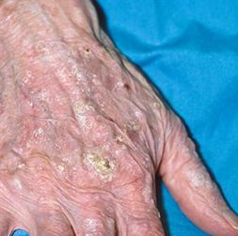
These are small patches of sun damaged crust with no ‘meaty’ thickening of skin under them. They can be picked off but are quite adherent and may bleed when picked off. They are often found on the face, scalp and back of hands where they might have a ‘sand-paper’ like texture. If there is swelling of the skin which is enlarging, under the crusty areas, please see a GP as they could represent a skin cancer.

Better options other than cryotherapy include an anti-cancer cream called ‘Efudix’ (5-Fluorouracil), it is best for numerous patches of sun damage which can be treated in sections at a time. This is prescription only and you will need a GP appointment to diagnose them unless you have seen a GP regarding these previously. Often this treatment will be much more effective than liquid nitrogen for multiple areas and can prevent a skin cancer developing.

For more information, please see the links below:

Verrucas:
https://cdn.bad.org.uk/uploads/2021/12/20153807/Plantar-warts-Update-Jun-2022-Lay-Review-Jun-2022-FINAL.pdf

Seborrhoeic Keratoses:
https://cdn.bad.org.uk/uploads/2021/12/06105630/Seborrhoeic-keratosis-PIL-Oct-2022.pdf

Actinic (or Solar) Keratoses:
https://cdn.bad.org.uk/uploads/2021/11/01100722/Actinic-keratoses-PIL-Jan-2024.pdf

Dr Simon De Vos
GP, Corbett Medical Practice and Associate Specialist skin cancer, Oxford.
Review date March 2025

