Pan-Cheshire
Please Use Resources Below to Promote:
ICON WEEK 22-26 SEPTEMBER 2025

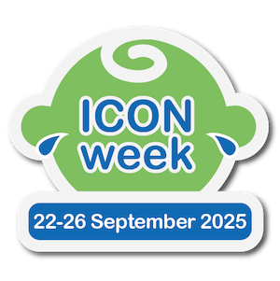
Right click on above, click on object,
Click on open. This allows you to click on file and print. (7 slides)
Copy the above for your signature list.
Please use the embedded Communications Toolkit below.
The embedded power point above has social media schedule with posters to print for sharing information which includes:
Day 1 Monday Launch: What ICON standards for.
Day 2 Tuesday Support & Mental Health: 5 Tips to help soothe a crying baby.
Day 3 Wednesday Friends and Family Support: Information on shaking or losing your temper with a baby.
Day 4 Thursday Coping Strategies: Website for help and advice.
Day 5 Friday Reminder and Call to Action: Information on babies who start to cry more frequently at about two weeks of age.
Different poster: with what ICON stands for.
MS Teams: background.

