PPG Meeting Minutes – 08 October 2024
Flixton Road Medical Centre Patient Participation Group (PPG) minutes
Tuesday 08 October 2024, venue Flixton Road Medical Centre
Attendees:
- Dr M A Khan (Chair),
- Dee Radcliffe (Assistant Practice Manager)
- Sandra Everett
- Sue Ralph,
- Lesley Culf
- Karen Lynes and Martha McCann
Apologies
- Marcelle Holt, Sarah Fraser & Representative from Ann Challis

Subject | Description | Raised by | Action by
1. Welcome, Introductions | The Chair Dr Khan welcomed everyone to the meeting.
2. Apologies | As noted, above.
3. Minutes & actions arising from the last meeting. | The draft minutes of the meeting held on the 28 May 2024, had previously been circulated, to all members.  The minutes were accepted by members as a true and accurate record of the meeting.
4. Matters arising | Noted  There were no matters arising.
5. Resignation Jilly Trout | Noted  A letter was received from our PPG member Jilly Trout, who has offered her resignation.  Discussed  A response letter was prepared and sent to member, on the 25 June 2024, thanking her for her contribution to the PPG.
6. Through the front door- early detection | Noted  Lung health appointment campaign  Dr Hadeer Dawood, is the face of the campaign for our practice FRMC.  Inaugural Strategy Meeting Wednesday 25 September 2024,  A joint venture with Davyhulme Practice- invite members of the TTFD group to our next meeting to discuss strategies.  Wendy McDonagh Davyhulme and Naadiea Ikram Primrose agreed to attend the next meeting.  Purpose of the meeting  The members believe that collaborating on this initiative would greatly benefit our communities and enhance our efforts to promote lung health. We are eager to discuss how we can work together to make this campaign a success.  Achievements – updates from Practices FRMC  Member Michael Dockery gave members an update of the flyers he had personally  delivered.  Malcolm’s pharmacy, Flixton Road, Boots Eden Square, Urmston Pharmacy, Stretford Road, Reed’s Pharmacy, Church Road, Davyhulme Pharmacy, Canterbury Road, and Allied Pharmacy Broadway.  The campaign has been posted on the practice website https://www.flixtonroadmedicalcentre.nhs.uk/  Banner/leaflets/pens promoted in reception area, also promotion at the flu clinic on the 5 & 6 October 2024  Davyhulme  · Two lung health awareness meeting have been held, cohorts of 50+ patients have been invited.  Merchandise (Water bottles and tote bags) have been ordered by Davyhulme to share with FRMC/Primrose (Costs to be shared)  Primrose Surgery  · Wish to join the project, attending the meeting for more information.  · Merchandise shared with PM Naadiea Ikram  Discussed  A discussion ensued around ideas of joint working in promoting the campaign.  · Trafford football club/Public health/cricket club/Andy man club – explore having a stall or leaving leaflets.  · Foodbanks can include leaflets in parcels.  · Macmillan volunteers- help with distribution & promotion  · Monthly updates on own websites with photos  · AGM WI- Adrian to prepare a brief for member LG.  · Copper hatch ladies’ group -LG to discuss and feedback.  · Additional pharmacies in the area  · Churches/keep fit /walking groups.  · Invite Urmston Group Practice to our next meeting.  It was noted that a Dr Sam & Dr Andre, 2 Trafford Road, Alderley edge are offering treatment (private clinic) for detecting cancer early, there is a cost of £1,250 for the blood test. Leaflets are being distributed to pharmacies.  Post Meeting note- Charlotte Potts PM at UGP has declined the invitation.
7. Charities- donations | Noted  We are delighted to announce that, thanks to the incredible generosity of our staff, community, and everyone who attended our Open Day on July 7, 2024, the staff at Flixton Road Medical Centre have raised funds that have been donated to four wonderful local charities:  · Macmillan Wellbeing Centre £500  · Riff Raff Society £50.00  · The Official Fundraiser for The Christie – Wibbersley & Thorne Society £100  · The Toy House £50
8. Friends and family Test | Noted  Friends and Family test Sept 2024  Discussed  Members discussed the monthly report, which has been consistently good.  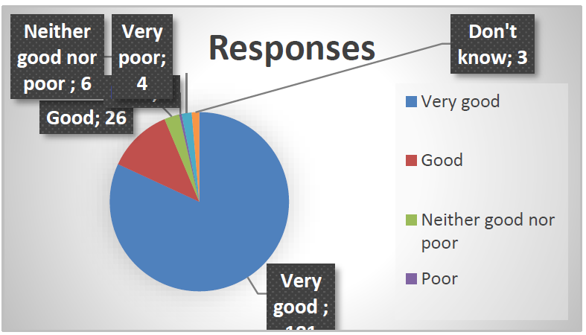  The practice has a good outcome- the poor comments will be analysed and added to our action plan – where appropriate  Agreed  An analysis to be prepared from Jan 24 – Sept 24 to evaluate the results. – DRR
9. PPG Chair | Noted  A Patient Participation Group (PPG) is a team of patients who work with their GP practice to improve services and promote better healthcare outcomes.  Discussed  The PPG does not have a designated chair, Dr Khan has undertaken the role, and given clinical expertise to the group. Dr Khan will remain on the panel in his advisory role when we have nominated a chair.  Agreed  A request for expression of interest in the position to be received by 1st November 2024
10. Christmas Appeal | Noted    Discussed  We have nominated three Charites for our Christmas appeal.  Christie’s /Toy House and cash for kids.  Agreed  We will begin the appeal in November 2024
11. Any other Business | Item submitted by Member.  Noted  Are our staff Iris- domestic violence trained, is there any reference on our website? https://www.ncdv.org.uk/agencies/irisi/  Discussed  Staff have been trained – although some time ago. Dr Gill is the lead for DV and safeguarding.  Agreed  Will research and update our staff and our website. Post meeting.  National Centre for Domestic Violence  Self-referral form on the website – Domestic Abuse and Violence Emergency Legal Protection https://www.ncdv.org.uk/  National Agencies  Refuge National Domestic Abuse Helpline – 0808 2000 247 – www.nationaldahelpline.org.uk Mankind Initiative – 01823 334 244 – www.mankind.org.uk  Men’s Advice Line UK – 0808 8010 327 – www.mensadviceline.org.uk LGBT Helpline – 0345 330 30 30 – www.lgbt.foundation  Karma Nirvana – 0800 5999 247 – www.karmanirvana.org.uk  No other business was discussed.  The chair deemed the meeting closed.
12. Date of next meeting | The date of the next meeting is scheduled for Tuesday 21 January 2025 at 12:30 pm  members are asked to confirm their attendance.
Read: PPG Agenda 20241008 Flixton Road M C PPG draft minutes
Read: PPG Agenda

