PPG Meeting Minutes – 28 May 2024
Flixton Road Medical Centre Patient Participation Group (PPG) minutes
Tuesday 28 May 2024
Venue – Flixton Road Medical Centre
Attendees:
- Dr M A Khan (Chair)
- Dee Radcliffe (Assistant Practice Manager)
- Jilly Trout
- Sandra Everett
- Anne Challis
- Sarah Fraser
- Lesley Culf
- Karen Lynes and Martha McCann.
Apologies: Marcelle Holt
Observer – Joyce Ward
Subject | Description | Raised by | Action by
1. Welcome, and Introductions | The Chair Dr Khan welcomed everyone to the meeting.
2. Apologies | As noted, above.
3. Minutes & actions arising from the last meeting. | The draft minutes of the meeting held on the 16 January 2024, had previously been circulated, to all members.  The minutes were accepted by members as a true and accurate record of the meeting.
4. Matters arising | Noted  There were no matters arising.
5. Resignation Justine Alderman | Noted  A letter was received from our PPG member Justine, who has offered her resignation.  Discussed  A response letter was prepared and sent to Ms Alderman, thanking her for her contribution to the PPG.  A copy of the letter will be circulated with the minutes.
6. CQC | Noted  The practice was inspected by the CQC on the 4 April 2024.  Discussed  The CQC quality statement covered how responsive the Practice is to our patients The inspection was via a team’s meeting.  Our evidence folder was submitted to the CQC inspector prior to the inspection.  Agreed  The Practice received the CQC overall rating of Good.
7. Through the front door- early detection | Noted  Trafford Local Care Organisation (TLCO) and partners have received innovation funding from Greater Manchester Cancer Alliance to help increase the number of cancers that are found and treated earlier. If we get more people with suspected cancer signs and  symptoms ‘Through the Front Door’ at the right time, then more cancers can be successfully treated, and more people will survive.  Discussed  There are three parts to the project:  1. Producing local campaigns.  When campaigns are localised, they are more likely to make a difference.  2. Work with Macmillan volunteers.  This project will support an already active Macmillan Health and Wellbeing Centre in Trafford, which has great volunteers ready and willing to promote our work. And will add messages about the importance of earlier detection to their work.  3. Work with FIVE Patient Participation Groups and General Practices.  Asking them to try different ways to raise the importance of earlier detection. Each Practice will receive a small pot of funding to help with this work.  Flixton Road Medical Centre is one of the participating practices.  Agreed  What does this mean for Flixton Medical Centre?  You could look at how you reach out to patients, run campaigns, work with reception staff (and others) to feel confident knowing what common signs and symptoms are, talk to family and friends, or promote your work in the community.  We will hold workshops so everyone can come together and find out how others have approached this opportunity. These are designed to give you confidence and fresh ideas.  Finally, we would like to use this work to recruit more people to your PPG.  Work to date  - The ‘Know4Sure’ marketing campaign to raise awareness of the four main signs and symptoms of cancer. (Unexplained blood, Unexplained pain, Unexplained weight loss, Unexplained lumps)  - Information shared on practice website and on messages to patients.  - Open meeting with around 55 patients who attended.  - In July we will move to a Lung Cancer Awareness campaign.  - A group of patients have been meeting as part of the campaign and they have:  - taken campaign materials to local businesses, friends and family.  We are planning cancer awareness as part of our open day celebration.
8. Practice open Day | Noted  Sunday 7 July 2024  The practice open day promises to be an informative and engaging event, featuring tours of our facilities, presentations on healthcare advancements, interactive workshops, and networking opportunities with fellow professionals and community members.  Discussed  Confirmed participating organisations and speakers.  Macmillan, Through the front door, early detection – find out about the Flixton Cancer Project: raising life-saving awareness of early detection of cancers. Dr Susan Ralph,  listening to women’s voices: using an adapted photovoice Methodology to access their emotional responses to diagnosis and treatment of breast cancer. LGBT foundation, Age UK, The Rif Raf society, DePaul charity, Capsule Clinic – Dr Simon Campbell, Endometriosis North awareness – Dr Amita Sharma, Physiotherapy – Mr Saad Khan, Dr Husain Mohammad (GP FRMC), Local Pharmacies – Pharmacy First, Safe Surgery,  Homeless friendly, CAHN, Veterans, Walking Group, Dev’s Ice Cream, Martin Green- hot food, Clint- Team/coffee, Homemade gifts and afternoon tea, raffle. Eleanor Bristow- Childrens dance teacher.  The practice needs volunteers, to promote the event and collect raffle prizes.  Agreed  The practice will source marquees for the stall in the car park.  The timing of the talks to be confirmed and circulated. – Action Dee
9. Friends and family Test | Noted  Friends and Family test April 2024  Discussed  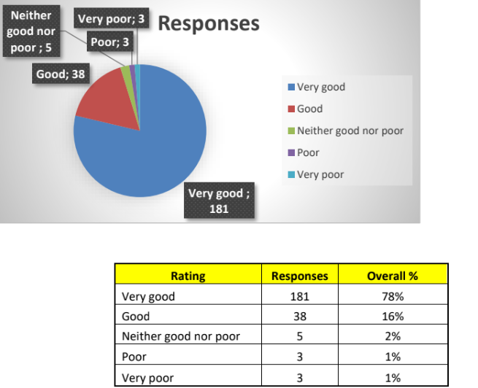  Agreed  The practice has a good outcome- the poor comments will be analysed and added to our action plan – where appropriate
10. Patient Survey | Noted  Patient Survey 2023-24 ● Responses received 1,248.  Discussed  Question Overall, how would you rate your experience with the practice?
No of responses Rating 1206
4.21 Average Rating
Agreed
The practice has a good outcome- the poor comments will be analysed and added to our action plan – where appropriate
11. NHS App | Noted  The practice is promoting the NHS App on the website, in practice, QR code.  Discussed  The assistant practice manager has held 121 appointments for patients who need help with the app.  Agreed  Another series of clinics will be organised in the next few weeks. There will be an option at the open day for patients to leave their contact details if they wish to make an appointment.
12. Safe Surgery | Noted  The practice is registered ‘Safe Surgery’ for everyone in our community.  Everyone in the UK has the right to free care from a GP. The prospective patient does not need to have proof of ID or address, they can register. Immigration status or nationality don’t matter -reception won’t ask for immigration documents and won’t share the information with the Home Office unless serious crime is involved.  Discussed  This means that we are committed to providing equal access to our services for everyone in our practice area, regardless of their immigration status.  This is in line with our duties under NHS England guidelines for GP registration. and informed by our knowledge of the barriers to healthcare faced by migrants in vulnerable circumstances. Reception staff will use the following five guidelines.  in mind when migrant patients seek to register with our practice.  - Everyone in England has the right to be registered and consult with GP, without charge, regardless of their immigration status.  - If a patient doesn’t have proof of address or ID but say they are living in our catchment area, they should still be registered. There are many reasons why a patient, particularly those in vulnerable situations, might not have access to these documents.  - If a patient has difficulty communicating in English, use a telephone interpreter.  Google Translate might also be useful for basic non-clinical information.  - Don’t ask about a patient’s immigration status, or to see proof of it. This information is not needed for registration and asking for it might.  intimidate some patients. • The GMS1 form includes ‘supplementary questions’ about immigration status, however patients don’t have to complete this section if they don’t want to.  - If a patient is worried about giving a home address, you can also reassure them that their information is safe and won’t be used to trace them because of their immigration status. • If needed, you can also use the address of the practice or another place where post could reach them (like a mosque, church, or community centre).  Agreed  The Practice is proud to be a safe surgery, the assistant practice manager has completed the relevant training.
13. Any other Business | Question submitted by PPG member –  AccuRx Messages  1. AccuRx texts sent from surgery – why do we send them after the surgery has closed.  Discussed  AccuRx texts are sent during 8:00 am to 6:30 pm- If a text is sent to all patients with general information, these are scheduled to go after surgery, so the system isn’t overloaded.  Post meeting note  Checked the patients notes the accuRx message was scheduled at 7:51 am for delivery at 8:00am  Gentle reminder  Members were reminded that personal issues/PID should not be discussed at the meeting, if there is an issue a meeting can be arranged with the APM.  2. NHS Health Check Appointments Discussed  We again reminded members that we can not discuss personal issues or identify patients at a group meeting.  The question of NHS Health Checks appointments has been addressed previously. Minute from 7 February 2023  Background  NHS Health Check for 40- to 74-year-olds, are patients currently being invited for this, as a patient in this age group I don’t remember having had a recent invitation, was this put- on hold during Covid and if so when will they be re-introduced.  Discussed  It was noted that the NHS health checks were restarted in April 2022, the practice invite a minimum of 10% of our patients for a health check. The check is designed for any patient without other underlying problems.  3. Confidentiality  It is imperative that members do not disclose person identifiable information at our meeting the PPG meeting.  The patient Participation Group is a forum where patients can contribute their perspectives and insights to help shape the delivery of healthcare services within our practice. It provides an opportunity for open discussions and collaborative efforts between the practice staff and patients to enhance the overall patient experience.  Purpose of the Patient Participation Group:  The primary goal of the PPG is to foster effective communication and partnership between the practice and its patients. By participating in the group, you will have the chance to share your experience, suggestions, and any ideas that can influence positive changes in the services we provide.  Terms Of Reference (TOR):  The Terms of Reference outline the purpose, structure, and operation of the PPG. They serve as a guide to ensure that the group functions effectively and in alignment with its objectives. If you are interested, we can provide you with a copy of the TOR for your perusal.  General Queries/Concerns:  It is important to note that the PPG is specifically focused on matters related to the patient experience and service improvement. General queries or concerns not related to the PPG, can be directed to the Assistant Practice Manager, Mrs Dee Radcliffe at dee.radcliffe@nhs.net or sent to the practice address, who will be more than happy to assist you.  No other business was discussed.  The chair deemed the meeting closed.
14. Date of next meeting | The date of the next meeting is scheduled for Tuesday 03 September 2024 at 12:30 pm  members are asked to confirm their attendance.
Download: 20240528 Flixton Road M C PPG draft minutes
Download: 1.a 20240528 PPG Agenda

