
Opening hours
Monday | 8:00 am | 7:30 pm
Tuesday | 8.00 am | 7:00 pm
Wednesday | 8.00 am | 7:00 pm
Thursday | 8.00 am | 6:30 pm
Friday | 8:00 am | 7:30 pm
Saturday | CLOSED | CLOSED
Sunday | CLOSED | CLOSED

Branch surgery Colyers Lane

Monday | 8:00 am | 6:00 pm
Tuesday | 8.00 am | 6:00 pm
Wednesday | 8.00 am | 6:00 pm
Thursday | 8.00 am | 12:00 pm
Friday | 8:00 am | 6:00 pm
Saturday | CLOSED | CLOSED
Sunday | CLOSED | CLOSED
Extended hours
Monday and Fridays at Slade Green Medical Centre 18:30-19:30
Services we provide
Along with routine appointments, the practice offers the following services:

- Family planning – All our GPs and the practice nurse offer a full range of family planning services
- Immunisations – The nursing team administers vaccines for both adult and child immunisations.
- Minor surgery – Your GP will advise on minor operations
- Cervical smear testing – For women aged 25 – 65. These tests are undertaken by the nursing team.
- Chronic disease management – We hold a range of clinics to help our patients to manage their long-term medical problems including asthma, diabetes, hypertension, kidney disease and heart disease.
- Other services – Health checks for adult patients aged 16 to 74 years and 75 years and over are also available especially for those who have not seen a clinician at this practice. Details are available from reception and on the practice website.

We also offer the following clinics and checks: antenatal, baby, post-natal, smoking cessation, travel advice and vaccinations

From time to time, other services may be available such as raising awareness of a particular disease or condition. We will advertise this information on our website and within the practice.

Teaching practice

The practice is a teaching practice and occasionally trainee GPs may, as part of their training, be required to sit in with their trainer GP during consultations with patients.

You will always be asked if you consent to this prior to your consultation. If you do not consent, the trainee GP will not sit in on your consultation.

How to register at the practice
The quickest way to register at the practice is to use the practice website. You must live within the practice area which is shown on the website. If you are unable to use the website, please contact the practice for information about how to register.

Patients’ rights and responsibilities
When registering, you have a right to express a preference to be seen by a particular GP. This will be recorded on our clinical system and, where possible, you will be allocated appointments with that clinician. All patients will be assigned an accountable GP.

You will also be offered a health check when you join the practice for the first time (see the practice website for a full list of your rights and responsibilities).

Patient Information Leaflet

Slade Green Medical Centre is a partnership providing NHS Services under an NHS England Medical Services Contract.

156 Bridge Road, Slade Green, DA8 2HS
Telephone No. 01322334884
&
90 Colyers Lane, Erith, DA8 3NZ
Telephone No. 01322342457

Email address: sladegreen.medicalcentre@nhs.net
Website: www.sladegreenmedicalcentre.com

GP services are provided
to the following areas:

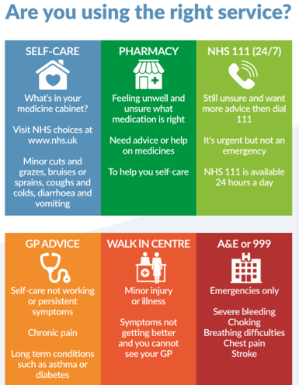

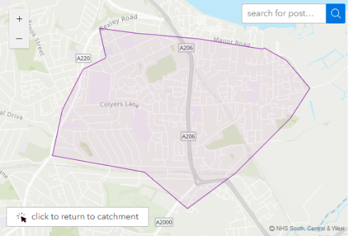

Further information can be sought from www.nhs.uk

Comments, suggestions and complaints

If you would like more information about any of the services we provide, please ask a member of staff, telephone or log into the practice website. Details are shown on the front of this leaflet.

Our aim is to give the highest possible standard of service. We would like you to tell us what you think about the service we provide.

Home visits
Home visits are at the discretion of the GPs and are usually for those patients who are housebound or have significant health issues. Should you require a home visit, please use the practice website to request one or contact reception requesting a call-back after logging a call. A clinician will then telephone you to discuss your request.

When we are closed
When the practice is closed, if you urgently need medical help or advice and it is life threatening, dial 999. If it is not life-threatening, contact NHS 111 by calling 111 or accessing via www.nhs.uk

Patient Participation Group
We have an active Patient Participation Group (PPG), ensuring that our patients are involved in decisions about the services provided by the practice.

Further information about our PPG is available online at www.sladegreenmedicalcentre.com

Alternatively, you could send an email to sladegreen.medicalcentre@nhs.net to express an interest.

Updated 14/10/2025
The practice team
This practice operates under a partnership agreement and provide services on behalf of the NHS.
Partners
Dr Surinder Nehru
Dr S Nehru is qualified surgical specialist. He is also accredited as GPwSI in minor surgery and vasectomy. He is also a GP trainer and has an interest in teaching.
Dr Jayprakash Sharma
Dr J Sharma has a special interest in complicated medical conditions like coronary heart disease, metabolic disorders and diabetes.
Dr Nyooti Nehru
Dr N Nehru has a special interest in women’s health, menopause and HRT. She is also a GP trainer and has an interest in teaching.
Salaried GPs
Dr Lan Dai
Locum GP’s
Dr Sophia Sureshkumar
Dr Stanley Izuebe
Dr Eugene Boules
Dr Jenani Jegatheeswaran
Dr Opeyemi Ajiboye
Nurses
Marian Salami-Prah
Sukhpreet Kaur

Other healthcare staff
Michael Quilter (HCA)
Ola George (Clinical Pharmacist)
Rowena Calderwood (Pharmacy Tech)

Practice Manager
Sarah-Louise Branch

Assistant Practice Manager
Stacy Haxell
Appointments and accessing practice services
To make an appointment to see your GP or any member of our healthcare staff or to access any other of our practice services, please log on to the practice website at www.sladegreenmedicalcentre.com to submit an online request. Should you be unable to access the website, please ring 01322 334 884 and a member of our administrative staff will be able to assist you.

Online access to your online records
In line with NHS England requirements, Slade Green Medical Centre provides patients with online access to their prospective medical records. This means you can view new information added to your record from the date you register for online access, including test results, consultations, and medication history.
You can access your records securely via the NHS App or our online services. If you wish to register for online access, please visit our website or speak to our reception team for guidance. If you do not wish to have online access, or if you have concerns about confidentiality, please let us know so we can discuss your options.
Proxy access is also available for carers or family members, subject to appropriate consent and safeguarding checks. More information is available on our website and from NHS England
Disabled access
Step-free access to the building
Disabled parking spaces available on site
Accessible toilet facilities
Assistance available for patients with mobility or sensory impairments

If you have specific accessibility needs, please contact our reception team in advance so we can make suitable arrangements for your visit.

Patient data
All clinical and administrative staff have an ethical as well as a legal duty to protect patient information from unauthorised

The patient privacy notice is available on the practice website.

disclosure and in accordance with UK GDPR.

NHS England Contact
Slade Green Medical Centre provides NHS services on behalf of NHS England, PO Box 16738, Redditch, B97 9PT.

Telephone: 0300 311 2233
Email: england.contactus@nhs.net

We also offer the following clinics and checks: antenatal, baby, post-natal, smoking cessation, contraception

From time to time, other services may be available such as raising awareness of a particular disease or condition. We will advertise this information on our website and within the practice.

Prescriptions/repeat prescriptions
Your GP will initiate any prescription that they determine you require. Repeat prescriptions can be ordered in the following ways:

- Via your nominated pharmacy – Your pharmacy will request on your behalf
- Via email – please email sladegreen.prescriptions@nhs.net
- NHS App – Please log in and order via the NHS app
Please allow 72 hours for collection (excluding weekends and bank holidays) when ordering repeat prescriptions.
Threats of violence or abuse of our staff
Our staff work hard to provide you with the best possible service. Please treat them with the courtesy and respect they deserve. We operate a zero-tolerance policy and may refuse to provide services to individuals or those accompanying individuals who are violent, threaten violence, commit or threaten to commit a criminal offence.

