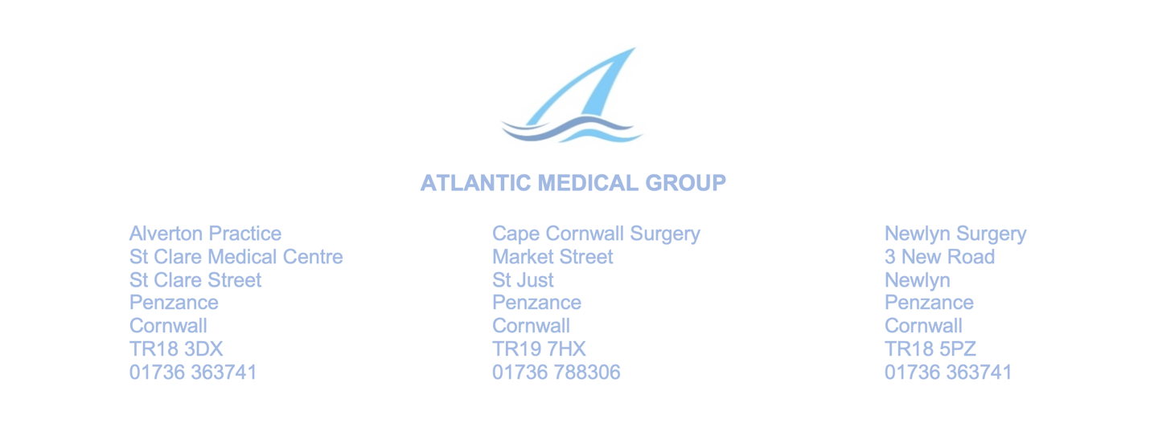
PATIENT PARTICIPATION GROUP MEETING, 24th June 2025, 5.30pm
ST CLARE, PENZANCE

Present: Dr Tom Graver, Dr Marlen Jackman, Liz Burns, Marna Blundy
Apologies: Ian Cary and Eliabeth Thomas, No other apologies were received.
- Minutes of the previous meeting None had been circulated, so Marna’s notes from that meeting are appended to these minutes, to maintain PPG records.

- Clinical Research
Dr Ryan has been engaged in clinical research for years. Dr Graver and Dr Dewdney are now also engaged in this too. They understand that Atlantic Medical Group is one of the most active practices in the south-west for clinical research. This is good news for the practice and for patients. Dr Graver detailed four of their current research projects, which enable patients to receive treatments they could otherwise not receive on the NHS:
(i) Weight loss injections – patients getting treatments
(ii) Back pain
(iii) Cholesterol
(iv) Difficult to manage asthma

- Can the PPG support expert outpatient services closer to Penzance?
Liz reported on her good cataract treatment at Probus, but wondered why she had to travel so far. The doctors present described several new local services which benefits patients:
(i) Cardiology ultrasound at Atlantic
(ii) Some surgery at Atlantic
(iii) COVID service at Atlantic
(iv) Mental health hub at Lescudjack Centre; also at Cape Cornwall Surgery once a
week, with a clinician (patients can book an appointment for this)
(v) Photography clinics at both WCH and SMH for dermatology
There was further discussion about the aim of ‘care close to home’ which was the aspiration of both medics and patients. It was felt that patients should be asking for outpatient clinics close to home whenever they make or receive outpatient appointments for Treliske, Probus, Bodmin, and other places where independent providers are funded by the NHS across the county.
- Access, Triage and Appointment System
Dr Graver outlined the changes to appointments which is planned, due to the GP contract being changed. The practice must now provide opportunity for online contact throughout the day. It is proposed that patients should fill in a form online, or over the phone with a receptionist, or at the front desk, in order to make an appointment. Then doctors will prioritise the appointments. There is fine tuning to be done on this, but the hope is to introduce the new system before the autumn, which will make it more equitable.
- Ear wax removal
The Royal National Institute for the Deaf has produced a report (attached) highlighting the problems caused to patients by the removal of ear wax removal services from the NHS. Dr Jackman highlighted an example where a patient required treatment following surgery, which could not legally be delivered by private providers, but there was no NHS treatment to be given. Marna wondered if, going forward, the Penwith practices between them could consider delivering a service in the locality for their patients.
- Issues for carers
Marna reflected on two neighbours, both caring for their husbands who have dementia, and who seem to have slipped through the net where support was concerned. They would be encouraged to talk to their GP and look to the Memory Service DOPMH for support.

A date for the next meeting was not agreed.
There being no further business the meeting closed at 6.44pm.

