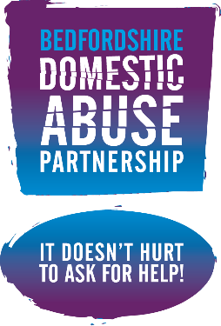
16 Days of Action against Gender Based Violence
What’s on for 2025?

The 16 Days of Activism against Gender-Based Violence is an annual international campaign that kicks off on 25 November, the International Day for the Elimination of Violence against Women, and runs until 10 December, Human Rights Day. In support of this initiative, the United Nations Secretary-General launched in 2008 the campaign UNITE by 2030 to End Violence against Women, which runs parallel to the 16 Days of Activism.

When? | Like to add your event to our calendar Send details to: jenny.bull@luton.gov.uk
25th November
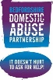 | BDAP Domestic Abuse Recognition Awards Scheme  Do you know an individual, team or service that really makes a difference to those affected by domestic abuse in Bedfordshire? Why not nominate them for a certificate of recognition. Send your nomination and their details (including an email address so we can get in touch with them) to:  Nominations to: bdap@centralbedfordshire.gov.uk  Scheme open for nominations until 31 Dec 25.  For more info go to www.bedsdv.org.uk
     | Orange the World Walk: Stop Violence Against Women  Join Stepping Stones, the Inner Wheel Club Luton North, Azalea and Women's Aid Luton on Tuesday 25th November, as we take to the streets for a short walk around central Luton to raise awareness of Gender-based violence.  Walk leaves Stepping Stones HQ at 3:30pm.  Sign up: https://www.tickettailor.com/events/steppingstonesluton/1867596  All are welcome to take part in this FREE event, expected to end around 5pm with light refreshments at Stepping Stones.  Don’t forget to wear something orange in solidarity with the UNiTE campaign to End Violence Against Women.
   | Luton Council and partners mark White Ribbon Day and the start of 16 Days of Action in a bid to end gender-based violence against women and girls  ‘It starts with men’, and the aim is to address the attitudes and behaviours that contribute to a fear of violence for women in their daily lives and to specifically encourage men to hold themselves accountable to women and to each other to affect positive change to transform harmful cultures.  Sign the promise anytime at: https://www.whiteribbon.org.uk/promise
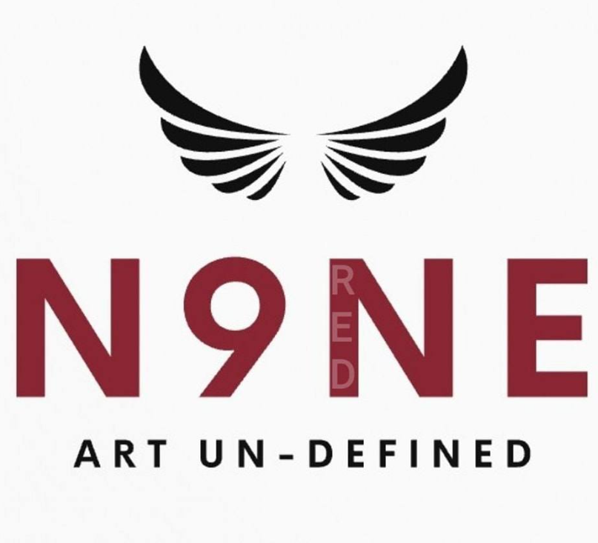 | “Our House” art installation will be on display at Wardown House Museum and Gallery throughout 16 Days.  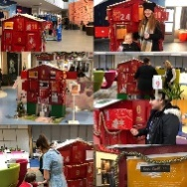  "Our House" was commissioned by the Bedfordshire Domestic Abuse Partnership in 2015. It features a giant ‘advent calendar’ house, with each window unveiling a positive survivor's story through poetry or art. This installation serves as a powerful engagement tool and has resonated deeply with audiences.
 | All the way through 16 days our Local Authorities and other partners will be sharing themed content across their social media platforms. Look out for their posts across your socials! @LutonCouncil @BedfordBoroughCouncil @bedsdv #NoExcuses #16daysofaction #EndVAWG #EndGBV #standwithus #reachout #survivorsvoice
26th November
 | ELFT Safeguarding Conference – Neglect and Domestic Abuse  We are pleased to invite everyone to the ELFT and Luton Adult Social Care Joint Safeguarding Level 3 Children and Adult Online Conference covering the following topics:  - What research tells us – How childhood maltreatment influences adult brain structure  - Neglect and domestic abuse lived experiences  - DHR and CSPR learnings  - DA Safety Planning  - Trauma informed practice  Attendance for the full day will automatically count as CPD for level three adult and children refresher L3 compliance for staff members of ELFT.  - Wednesday 26th November: 09:30 to 16:40hrs.  Book your place: https://ww.eventbrite.com/e/ELFT safeguarding conference  Please email - SOVABL (EAST LONDON NHS FOUNDATION TRUST) elft.sovabl@nhs.net for further details.
   | Luton Women’s Conference  Wednesday 26th November: 9:30 - 14:30hrs. Doors open at 9am  Grand Royale Banqueting, Crescent Road Luton LU2 0AH  Get ready to be inspired, empowered, and connect with amazing people at the Luton Women's Conference!  Book your place: https://www.eventbrite.co.uk/e/luton-womens-conference  Sold out but you can register for the waiting list!
 | Cake, Coffee & Chat Afternoons – Every Wednesday from 1pm to 3pm  Stepping Stones Luton, 9a George Street, LU1 2BJ.  A new weekly drop-in service for women.  Do you provide a service for women and would like to host an information table? Contact: Kathy.Doris@steppingstonesluton.org.uk.
27th November
   | MARAC Mini Roundtable  Thursday 27th November from 09:30 to 13:00hrs  An on-line event for anyone working with individuals or families impacted by domestic in Luton who wants to know more about how refer to our local Luton Multi Agency Risk Assessment Conference (MARAC). You will hear from local Police, Our MARAC Coordination team and Specialist IDVA services about their work and we will share our top tips and resources to help you with all aspects of the MARAC process.  Get in touch to book your place: chloe.king@luton.gov.uk
   | Authentic Voices workshop  27th November - 10:30 to 12:30 (on teams)  Authentic voice is an essential part of a high-quality response to domestic abuse. We welcome your participation in this workshop to look at the principles of authentic voice and how they can be embedded locally in Central Beds.  The contact for the Workshop is chloe.bird@safelives.org.uk
28th November
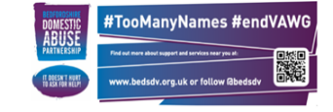 | #TooManyNames - Community Event  All welcome to join us for a short community event to raise awareness of the devastating impact of violence against women. Friday 28th Nov from 10:30 to 11:00hrs. Locations across Bedfordshire:  - Luton Point, Luton (inside The Atrium by Costa Coffee)  - Grove House Gardens, Dunstable Town Centre (outside by the bandstand)  - The Harpur Centre, Horne Lane, Bedford Town Centre (inside centre)  No need to book a place. Just turn up. All welcome.  #EndMVAWG #EndVAWG #EndGBV #TooManyNames
 | FaithOn4th 2025: Faith and Online Harms Against Women  🗓️ Friday 28 November 2025 | ⏰ 12:00–13:30 | 🌐 Online via Eventbrite  As digital spaces become more central to everyday life, online harms increasingly shape women’s safety, wellbeing, and participation in public life. Women of faith often face layered abuse that targets both gender and belief.  This year’s #FaithOn4th event explores how faith, gender, and technology intersect — and how faith can be a source of resilience and justice in creating safer online spaces.  Speakers include:  • Seyi Akiwowo – advisor, author, and founder helping brands, platforms, and policymakers build ethical and inclusive technology  • Mischa Gerrard – postgraduate student, activist, and independent researcher examining algorithmic bias, online misogyny, and radicalisation  • Emily Chebanu – from Illuminate Tech, whose mission is to build a safer, more trusted internet  • Imogene Resnick – Policy and Commissioning Manager at MOPAC, leading work on violence against women and girls across London  Part of our annual #FaithOn4th campaign, held on the 4th day of the 16 Days of Activism, highlighting the vital role of faith in ending violence against women and girls.  BOOK HERE
3rd December
Cake, Coffee & Chat Afternoons – Every Wednesday from 1pm to 3pm
Stepping Stones Luton, 9a George Street, LU1 2BJ.
A new weekly drop-in service for women.

Do you provide a service for women and would like to host an information table? Contact: Kathy.Doris@steppingstonesluton.org.uk.

4th December
 | ECP Pop up event - Central Family hub, 30 Allhallows, Bedford MK40 1LN on Thursday 4th December 13.00 – 15.30pm in partnership with the Community Safety Team.  Come along to talk to the team and some survivors of domestic abuse.  No need to book, just turn up.
5th December
  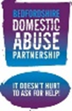     | Pan Bedfordshire Domestic Abuse Professional’s Networking Event on Friday, 5th December at Priory House, Shefford from 9.30am - 3.00pm. We would be delighted for you to join us and take part in what promises to be an insightful and inspiring event. With sessions from:  - Bedfordshire Wellbeing  - Beds Police - Raneem’s Law  - Chrysalis Centre - Intervention programme  - Embrace - DA and Children  - Victim Support Bedfordshire - Trauma Informed Practice  👉 To request an exhibitor table, please sign up HERE  👉 To confirm your attendance, please sign up HERE
7th December
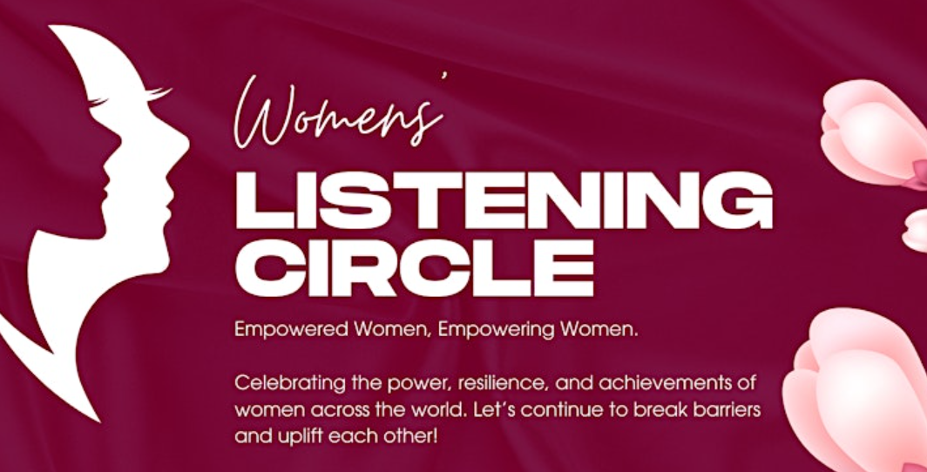 | The Women’s Listening Circle - are open to any women impacted by Domestic Abuse who wishes to attend. Join us on the first Sunday of every month to share experiences, connect deeply and uplift each other in a safe space.  At: Wardown House, Museum and Gallery, Old Bedford Road, Luton LU2 7HA  Sign up for these FREE sessions on 2 Nov or 7 Dec from 12pm.  https://www.eventbrite.co.uk/e/womens-listening-circle
10th December | Human Rights Day
Cake, Coffee & Chat Afternoons – Every Wednesday from 1pm to 3pm
Stepping Stones Luton, 9a George Street, LU1 2BJ.
A new weekly drop-in service for women.
Do you provide a service for women and would like to host an information table? Contact: Kathy.Doris@steppingstonesluton.org.uk.

#EndVAWG #EndFGM | Help Build Local Understanding of Female Genital Mutilation (FGM), Forced Marriage (FM) & Honour-Based Violence (HBV) in Luton and Bedfordshire.  Have your say and take our short 10-minute Survey  Scan the QR code or visit: https://forms.gle/qUCYAtduh8Tmw3Yh6
 | Human Rights Day is observed every year on 10 December and the international theme is Equality: Reducing Inequalities and Advancing Human Rights.  “Everyone deserves to live a life free from abuse.”  Join us again next year for 16 days 2026 to help us put an end to all forms of gender violence and abuse.  For more information about the services and support across Bedfordshire go to: www.bedsdv.org.uk

