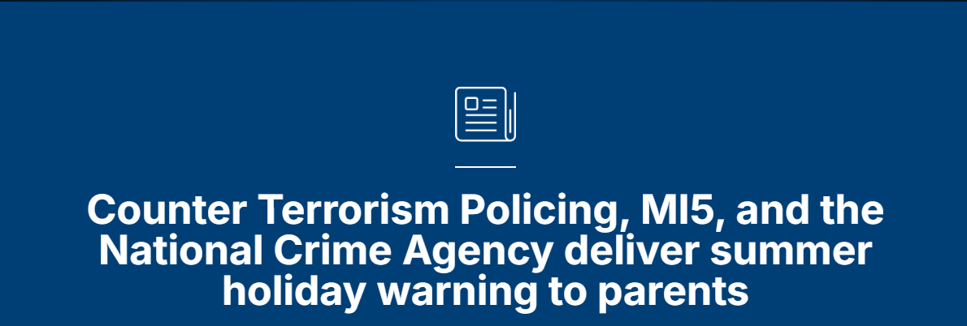

23 July 2025

For the first time, Counter Terrorism Policing (CTP), MI5, and the National Crime Agency (NCA) are jointly calling on parents and carers to support their children to be safer online during the summer break.
In an unprecedented move, the three agencies have delivered a public warning to parents that online offenders will exploit the school holidays to engage in criminal acts with young people when they know less support is readily available.

Counter Terrorism Policing’s Senior National Coordinator for Prevent and Pursue, Vicki Evans, said:
“We know parents care deeply about keeping their children safe online and given the ever-developing digital world it can feel like an uphill battle.
“We want parents to empower their children to know what to do if they come across inappropriate content online.
“We of course encourage parents to activate parental controls on routers, devices, and apps, but this should be alongside conversations that give young people the tools and strategies to make the right decisions when online.
“If you haven’t already, please start the conversation about online safety as soon as possible.”
Counter Terrorism Policing and the National Crime Agency are increasingly seeing children being routinely exposed to the most serious harmful online content.
This includes sexual violence; self-harm and suicide content; extreme gore; animal cruelty; indecent images of children; and terrorist content.
This bombardment of online harms can quickly become normalised. Worryingly, some of the children who come to the attention of CTP and the NCA are completely desensitised to extreme and obscene content.

The National Crime Agency’s Director of Threat Leadership, Alexander Murray, said:
“As outlined in our recent threat assessment, there is a fast-growing threat from sadistic and violent online gangs, made up predominantly of teenage boys, dedicated to inflicting harm and committing a range of criminality which includes fraud, cyber, child sexual abuse, violence and extremism/terror related offences.
“They are international and operate across multiple channels, including messaging apps, gaming platforms and other online forums.
“We are working closely with our partners in response to this complex threat, but we recommend that adults take time to understand the online lives of young people to help prevent them falling victim to these networks.”
Counter Terrorism Policing and MI5 are seeing high levels of young people in terrorism-related investigations and 2023 saw the highest numbers of terrorism arrests of young people since records began.
MI5’s Director General, Sir Ken McCallum said:
“In 2024 I said that 13% of all those investigated by MI5 for involvement in terrorism were under 18. That deeply concerning presence of young people in our casework continues to this day.
“In a few short clicks, young people can be speaking to dangerous radicalising terrorists online, consuming violent and extremist content. Terrorists who understand online culture are using slick propaganda to pull young people down a dangerous and potentially life-changing path.”
Of the 219 people arrested for terrorism-related offences in 2023, 42 were aged 17 or under, meaning one in five terrorism arrests involved a child or young person.
In 2024, this slightly decreased, with 39 young people aged 17 or under arrested for terrorism-related offences.

Deputy Assistant Commissioner Evans continued:
“Unfortunately, every year, we arrest children for terrorism offences, which tend to come about after they are led down the wrong path by extremists seeking to use the internet to target those whose age makes them vulnerable, or as a result of accessing harmful abhorrent content online.
“A significant proportion of their parents were unaware of their child’s online activity – who they talked to, the content they viewed, and the sites and platforms they used.
“With the summer holidays now under way and children spending more time online, we’re asking parents and carers to have conversations with the young people in their lives about what they are doing online and who they are speaking to.”
“None of my colleagues started working in counter terrorism thinking they would be investigating and arresting children as young as 12 for terrorism offences.
“The online environment can be a sanctuary for children to socialise and form strong bonds but for all the benefits it brings, the internet has also globalised extremism. It has accelerated the spread of hateful ideologies internationally and made it possible for anyone with an internet connection to reach into the lives of children halfway round the world.”
Last year, the leaders of counter terrorism for the ‘Five Eyes’ nations called for immediate international action to fight the growing threat to children posed by online extremism.
For the first time ever, the alliance published a public facing paper calling for collective action from the public, governments and the tech industry to tackle the problem. The paper highlighted that ‘once law enforcement and security agencies become involved it is often too late’.
Internet Matters provides practical advice to parents on how to help their children navigate the ever-changing digital landscape.
Parents and carers can access information and advice specific to their child’s age, the apps they use, or the issue they wish to address.
Anyone can report extremist or terrorist online content online at gov.uk/report-terrorism
If you’re concerned that someone might be taking a dangerous path, get advice and support via ACT Early.

