Patient and Participation Group (PPG) meeting minutes
Thursday 3rd July 12:30pm to 1:30pm

The Porch Surgery | Dr Tom Gamble (TG) GP Partner
 | Rhonda Ward (RW) Practice Manager - Chair
 | Becky Drennan (BD) Assistant to Practice Manager - Minutes
Guests: | Claire Bryant (CBr)
PPG Committee | Alan Brown (AB)
 | David Gilks (DG)
 | Yvonne Le Grys (YLG)
 | Terry O'Brien (TOB)
 | Pat Sharp (PS)
 | Susanne Dyke (SD)
 | David Wilson (DW)
Apologies: | Caroline Usher (CU)
 | Martyn Couzins (MC)
 | Steve Lumb (SL)

Welcome and apologies
Approval of the minutes of the previous meeting – DG and PS, thank you.
No outstanding actions

Update from The Living Well Team (LWT)

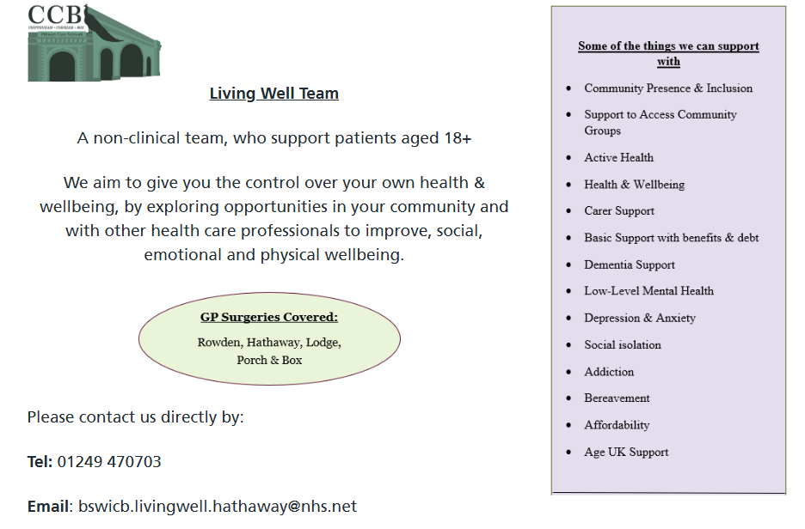
CBr gave an overview of what the team has been up to over the past few months.
From January to April 2025, the team had 2,600 encounters. Only 6 of these encounters were referred to the GP.

As a reminder, anyone can refer to the Living Well Team (LWT), they have their own number and email address so you can go direct to the team. Contact details in poster above.

Lesley Johnson from the LWT has been helping to set up Corsham Chronics after extensive research and working with patients this was identified as a need in the area. Lesley is looking to extend this group to the Chippenham area in the near future. At the last meeting in May, there were 15 people in attendance. There will be dates for the next meetings posted on the noticeboard downstairs in reception at The Porch. CBr to send these to BD, who will circulate. There are no geographical location restrictions to those that attend.

Next Corsham Chronics meeting – Tuesday 17th June 11am-1pm – Metheun Arms, Corsham

There are several other projects that the LWT are working on at the moment:

- Healthy Man Workshop
- Cancer screening awareness – to increase uptake of cervical, bowel and breast screening, by listening to patients who do not currently attend their invites to these and understanding the barriers that people may face in relation to this. Promoting awareness and the reasons for screenings.
- Pharmacy Hub – importance of the NHS App – the NHS are moving away from paper and printing as much as possible. More information to come on this in the near future.

Items raised from members:

(PS) The Government has said it's made major changes and invested much more into the NHS.
Has it filtered down to the Porch, in particular are there any more appointments than previously? Also are there any other effects?
- RW reported there is a change in the services we provide. The Physician Associate (PA’s) role that the PCN employed is no longer there. There is no PA’s working in any of the PCN surgeries.
- The focus as much as possible is on additional GPs. This does mean that where the PA’s were focusing on minor illness clinics, there will be more GP input into this moving forwards.
- There is a small monetary increase in contacts, however this doesn’t make up the lack of investment in the past 10-12 years in surgeries. This increase helps with staff costs, but beyond this it doesn’t give much more due to the increased cost of National Insurance contributions, heating, electricity costs etc.
- The Primary Care Network (PCN) have moved over to Springfield Community Campus; they were based in Chippenham before.

The group discussed local hubs where practitioners might be available to free up GPs. It was mentioned that this works well in cities and places with good transport links, however Bath, Swindon and Salisbury is a little too far for some people to travel. We want to be able to offer services within the Surgery.
HCRG has been confirmed as the new community provider in Wiltshire.

AB updated the group on two things that are out in the public already
1. The confirmation of the licence for the second pharmacy in Corsham after Boots closed last year – the initial application was turned down, but it was accepted upon appeal. The pharmacy will be taken over by Care Plus Pharmacies UK, which is licenced for the NHS. AB confirmed the Town Council are not sure when this will be opening or in which premises in Corsham.
2. The recent press release concerning the NHS and housing development in Corsham – AB confirmed this is regarding the land opposite the Church in Pickwick to build 150 houses. However, as the NHS can’t guarantee medical cover via The Porch/Box, they’re not quite sure what will happen. The Porch has not been contacted about this.

(TOB) On dialling the surgery main number the voice intro states that it does not facilitate a “walk-in or minor injuries service”. Chippenham hospital does offer this service to all surgeries. Maybe this fact could somehow be added to the intro? Not sure how but food for thought!
- RW reported that our welcome message is set by our phone company, but we can investigate this and make the change if possible. Information about minor injuries available locally is on our website.
- ACTION: RW to listen to phone message and see whether we can make this change.

Other questions or discussion points from members
TOB mentioned that he has been receiving calls from the practice displaying The Porch Surgery as calling. These calls have not had the phone number withheld. RW reported that some clinicians will remove the withheld number if previously agreed with the patient and this is noted on their record or if calling patients for the second time. However, all calls should be withheld due to safeguarding concerns, unless otherwise agreed.

Women’s Health: ‘Addressing Bladder Issues’ – 12.06.2025
The Women’s Health lunchtime talk took place in the waiting room – Claire Fitzpatrick from ‘Fitz and Physio’ was our guest speaker as well as one of our patients who spoke about her experience of living with bladder illness.

BD reported it being a successful event with a very good turnout of over 30 people.
DG reported it being useful to collect feedback from the events/talks to factor into future events.
The RUH article with our patient story in has been left in the waiting room for patients to look at.

The group discussed the potential to undertake another talk around prostate cancer for men. TG reported there being no screening for men however a physical exam and PSA blood test would take place if agreed with a GP.
RW asked that the group would help us deliver this next time – although Autumn 2025 was discussed in the meeting, DG has suggested early 2026 and he would be happy to help organise. AB also volunteered during the meeting to assist.

Surgery and staffing updates
- A new GP will be joining us from August. Dr Haskins will start with us as a 5 session GP. Some of you will know Dr Haskins as he was Registrar GP here up until the Summer of 2024.
- Nurse Emily left us in May to go and work as a diabetic specialist nurse in the community. She is coming in to help us out with the odd session whilst we recruit a Practice Nurse - we have an advert out at the moment.
- We are losing two of our trainees in August – Dr Waldock and Dr Bell but taking on two different trainees mid Aug – Dr Kendle and Dr Luxton.

PCN Patient Participation Feedback
- Next meeting has been scheduled for 09-09-25 at Springfield Community Campus.
Action: BD to add TOB to feedback at next meeting in November.

Non-Attenders - DNA results for June 2025
We had 77 DNAs from 4662 appointments

Phlebotomy/HCA Clinic | 32
Nurse Clinics | 20
GPA | 13
GP | 10
Immunisations | 2
TOTAL | 77

Family Friends Test (FFT) June 2025
Patients were asked ‘How likely would you recommend our GP Practice to Friends and Family if they needed similar care or treatment’.

We received 361 responses (342 electronic, 19 paper copies).

Very Good | 294
Good | 28
Neither Good nor poor | 6
Poor | 5
Very Poor | 8
Don’t know | 1

AOB

Next meeting – Thursday 27th November
sandwiches from 12 noon (meeting 12.30-13:30)

