Being Prepared …
Let’s Stop Winter Flu !

1 hour on line information session
for …
- People with Learning Disabilities
- People with Autism/Autistic People
- Family Members/Friends
To book your place click one
of the links below …

click
- Monday 6th October 2025
- 1.00pm – 2.00pm
https://stlukes.accessplanit.com/accessplan/checkout/AddItems?coursedateid=13362


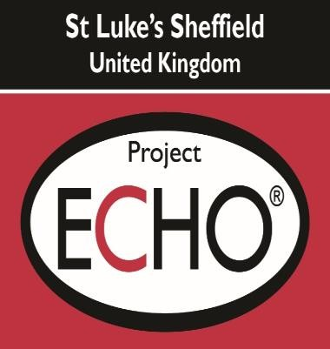
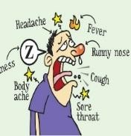









click
  - Monday 13th October 2025
  - 1.00pm – 2.00pm
https://stlukes.accessplanit.com/accessplan/checkout/AddItems?coursedateid=13363

