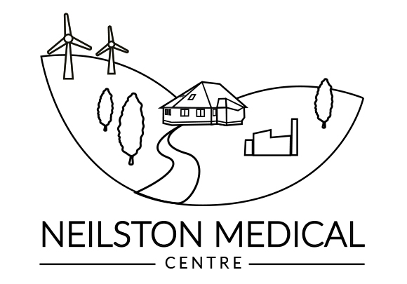

Neilston Medical Centre - Private Service Fees from 8th December 2025

We are an NHS practice but the NHS does not cover the services below. Please allow 10 working days for completion of any requested letters/ certificates.

Please note: these fees are for guidance, but may be subject to change at the discretion of the partners, depending on the amount of time and work involved.

Consultation Fees
Patient not eligible for NHS Care £90 per 15min
Examination and Report for Sickness or Accident Insurance Report £135
Examination and Report for Pre-Employment/ Travel/ Insurance Proposal £135
Examination and report for Voluntary work/ Higher Education £80
Examination and Report for Group 2/ PSV Licence £220
Power of Attorney Certification, Examination (30 mins) £220
Adoption (examination and form completion) £115 per person

Certificates/ Letters
Pre-employment/ voluntary or Higher Education Medical Report £70 / £35
Gun Licence report £90
Completion of Insurance medical report £90
Private Sick Note/ Fitness to work note £35
Written Immunisations History £30

Travel and Non-NHS Prescribing
All letters relating to fitness to travel/ medication arrangements/
transit arrangements/ travel cancellations £30/£45
Complex Pro forma cancellation Certificates £45
Administration of Non-NHS Vaccinations/ Immunisation £70 per injection
Private Prescription £25

Miscellaneous
Copy of medical records (Subject Access Request)
first copy-free, subsequent copies = £135 + £1.00 for each page printed

PLEASE NOTE THE FOLLOWING:

- We no longer provide travel vaccinations.

- Patients who wish to be assessed directly following a road traffic accident should telephone 111. This is not a service we would routinely provide, however, if we are requested to do so, a fee of £25.00 for the assessment consultation would apply.

