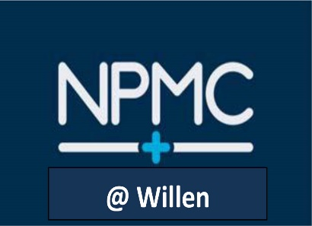

Patient Handbook

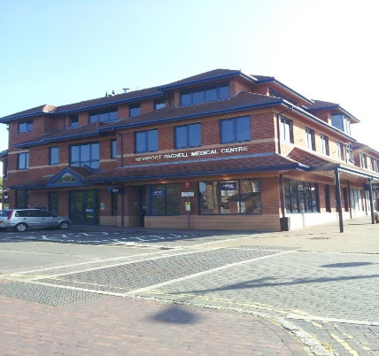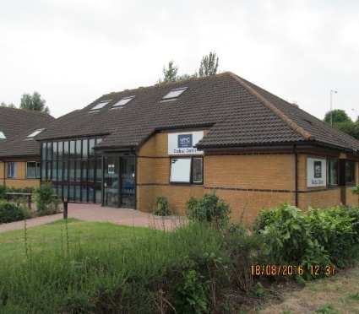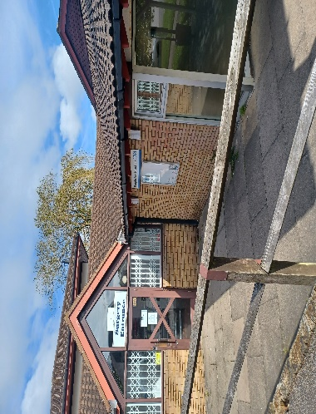

Practice Manager – Karen Hudson

Partners
Dr Asha Chandola (f)
MBBS, DCH, DRCOG, MRCGP

Dr Tayo Kufeji (m)
MBBS, MPH, MRCGP, DIP.MSK

Dr Fatima Mohri (f)
MBBS (London) 2002, MRCS, MRCGP, B.Sc Human Genetics

Dr Sharon Rocque (f)
BSc Biology MBBS, MRCGP

Dr Amit Karia (m)
MBBS (University of London) 2002 MRCGP 2007 Certificate in Diabetes Care 2013

Dr Raj Yuvaraj (m)
MB BS, DFSHRH, PGC Diabetes, MRCGP

Salaried GPs

Dr Vandya Shetty (f)

Dr Samarin Salman (f)

Dr Indra Sujatha (f)

Dr Nicola Abassah (f)
Dr Fatima Alkali (f)

Dr Ravi Agarwal (m)

Dr Ligia Costa Rocha (f)
Dr Moushumee Dey (f)
Dr Henry Onimisi-Smith (m)

TABLE OF CONTENTS:

Practice Values 3
Registration Process 3
Registration Doctor 4
Patient Rights and Responsibilities 4
Making an Appointment/AccuRx 4/5
Making an Appointmentfor the same day 6
Out of Hours 7
Repeat Prescriptions/SystmOnline 7
How We Can Help 8
Specialist Visiting Consultants 9
Teaching and Training Practice 10
The Buildings 10
Discrimination and/or Abusive Behaviour 10
Complaints & Comments 10
Care Quality Commission 11
Integrated Care Board 12
Patient Participation Group (PPG) 12
Patient Reference Group (PRG) 12
Useful Numbers & Websites 13

Self Help
Everyone experiences common illnesses like coughs, colds, fever or headaches from time to time.

You do not need a prescription for symptoms of common illnesses as they are rarely serious. Treating these illnesses yourself, or with advice and medicines from your local pharmacy, can often be the easiest and quickest way to help you back to health. If your problem is more serious and needs further attention, your pharmacist will recognise this and advise you to make an appointment to see your GP.

A minor illness guide for adults can be found on our website (http://www.npmc.nhs.uk) – many conditions can be treated with a well-stocked medicine cabinet.

Practice Values

We are a successful and innovative practice where all staff strive to provide excellent patient care now and in the everchanging future.

Our goal is to deliver excellence and innovation in healthcare whilst maintaining the health of the community by using our NHS resources effectively.

Registration Process

To register with us please come in and speak to one of our Patient Navigators.

We can only register patients who live in the following locations:

Postcode MK16 Blakelands Downhead Park Downs Barn Middleton
Red House Park Great Linford Neath Hill Broughton Brooklands
Giffard Park Oakridge Park Willen Woolstone Springfield
Bolbeck Park Pennylands Willen Park Oakgrove Monkston

A Department of Health registration form will need to be completed for each patient as well as a new patient questionnaire.

Having proof of where you live helps but, NHS guidelines make clear that it is not necessary for you to have a proof of address when registering with a GP. This also applies if you are an asylum seeker, refugee, a homeless patient or an overseas visitor, whether lawfully in the UK or not. Below is a list of documents that you can use as ID at a GP practice:

Passport
Birth certificate
Biometric residence permit
Travel document
HC2 certificate
ARC card
Utility bill

Alternatively, patients can register online via the NHS App.

Registration Doctor

We believe in providing continuity of care and therefore each patient has a named Usual GP who will provide the majority of the non-emergency care.
We will always try and accommodate a request for a change of named usual GP (list size permitting). If you wish to change your usual named GP, please make your request in writing to the Operations Manager. Once registered with the surgery, you will receive a text message informing you that your registration has been completed and confirming the name of your usual GP.

Patient Rights and Responsibilities

Patients have the right to:
- Be registered with a named usual GP.
- Change usual GP if desired.
- Receive a new patient health check if requested upon registering.
- Have a face-to-face appointment rather than a telephone appointment with the GP if they prefer.
- Receive urgent care at any time from the practice during our working hours 08:00 – 18:30.
- Receive appropriate drugs and medicines.
- Be referred for specialist or second opinion if they and the GP agree.
- Have the right to view their medical records, subject to the Acts and associated procedure, and to know that those working for the NHS are under legal obligation to keep the contents confidential.
- Receive interpretation or translation services if required.

Patient responsibilities:
- Courtesy to the staff at all times – remember sometimes they are working under doctor’s orders.
- Responding in a positive way to questions asked by the reception staff.
- To attend appointments on time or give the practice adequate notice that they wish to cancel. If you cannot make your appointment, please contact the practice and let us know so that we can offer your appointment to another patient.
- An appointment is for one issue only, patients should ask for a double appointment if they need more time to discuss more than one ailment.
- An appointment is for the treatment of one person only: however, a patient can be accompanied if they wish. Where another member of the family needs to be seen or discussed, another appointment should be made and the medical records made available.
- Patients should make every effort when consulting the surgery to make best use of nursing and medical time – home visits should be medically justifiable and not requested for social convenience.
- Advise the reception staff, when making an appointment, if a translator or interpretation service is required.
- Patients are asked to give 48 hours notice for repeat prescriptions. This is time we need to prepare and issue the prescription prior to sending it over to your chosen Pharmacy.
- To be available for an arranged telephone appointment or arranged home visit.

Making an Appointment

Making an Appointment
You can arrange an appointment with your doctor or the practice nurse:
- by using Accurx online – please visit our website to do so www.npmc.nhs.uk;
- in person at the Practice Reception desk, at NPMC or our branch surgeries at Willen or Kingfisher.
- by telephoning the appointment line on 01908 617111.
Accurx is our online system and can be accessed via our website. It is only available during our Practice opening hours and on occasion may be temporarily suspended if it becomes overloaded.

Opening Hours:

NPMC is open: NPMC @ Willen is open:
Monday – Friday 08:00 – 18:30 Monday – Friday 08:00-13:00 14:00-18:00
Saturday: *08:00 – 12:30 Phone lines available 08:00-18.30
*(Pre-bookable appointments only on Saturday)

NPMC @ Kingfisher is open:
Monday – Friday 08:00 – 18:30

Pre-bookable appointments are available Mon – Fri between: 08:05 – 11:00 and 14:00 – 17:45.

Saturday Consultations
These are available for pre-bookable appointments only – this will allow for those who find it difficult to visit their doctor during the week to access a GP at the weekend.

Home Visits
Home visits are only available to housebound patients who cannot be brought in by a relative or carer, or those too unwell to be leave their home. A home visit can be requested by request on Accurx. Please advise why the visit is necessary and whether the patient can be brought into the practice. The request for a visit will be passed to the Urgent Care Team who will assess/triage. Requests who require a visit will then be assigned by the team to the most appropriate clinician.
Patients MUST be available for any pre-arranged home visits.

Appointment System
Both our patients and our doctors value having a usual doctor for continuity of care. We will do our best to make an appointment with your own doctor, but unfortunately this is not always possible.

I need to:

Speak to a clinician about a query
e.g. about a blood test result or medication query
Book an appointment in advance

Go online via Accurx

If you are unable to access Accurx please telephone us on 01908 617111 and the patient navigator will take your information and complete the Accurx form on your behalf. You will either receive a telephone call from a clinician or a text or phone confirmation of an appointment.

Go online via Accurx

If you are unable to access Accurx please telephone us on 01908 617111 and the patient navigator will take your information and complete the Accurx form on your behalf. You will either receive a text or phone call with an appointment.

Appointment bookings

Online: www.npmc.nhs.uk (via Accurx)
Appointment line: 01908 617111

If you cannot keep your appointment please let us know in good time so it may be given to someone else.

If you feel you need to see a clinician on the same day for an urgent problem please refer to the following chart:

See a clinician in our Urgent Care Team
We understand that you want to see a clinician today, but we do have a huge demand and need to ensure we manage the Urgent Care Team caseload safely.

Once we receive your request via Accurx, it will be triaged by the urgent care team and a telephone consultation or appointment arranged.

If the clinician thinks your medical condition requires urgent care you will be asked to attend the practice for a consultation the same day and given a time to come in. Please only attend the surgery if you are invited.

Everyone who needs to be seen urgently will be seen.

This is what you should do:

Clinician gives advice over the telephone.
Telephone call from clinician
Telephone call from the Clinician, Doctor’s PA or a text to confirm an appointment.

Appointment with a clinician.
Urgent Care Team Assessment
The team determine which requests can be answered with a telephone call and which requests require a face to face consultation (based on medical needs).

Reception
If you are unable to access Accurx please telephone us and the patient navigator will take your information and complete the Accurx form on your behalf. This allows the Urgent Care Team to decide how they should help you. In some cases he/she will not need to speak to you in person.

Go online www.npmc.nhs.uk and visit Accurx.

Out of Hours

If you require medical assistance which cannot wait until the surgery re-opens please call 111. This is a free phone service
For more information please visit www.nhs.uk/111

Or alternatively go to:
The Walk-In Centre
Standing Way
Eaglestone
MK6 5NG
Tel: 01908 303030
Open 24 hours a day
Call 999 in an emergency
Chest pains and / or shortness of breath constitute an emergency.

Repeat Prescriptions/SystmOnline

A Parliamentary Accounts Committee has estimated something like £100 million a year is wasted on medicines that never get used.
In order to help reduce on-going wastage, since November 2013 the length of repeat prescriptions issued is limited to TWO MONTHS supply at a time only.

PLEASE REMEMBER:
- Unused medicines cannot be recycled. Even if you never open them, once medicines have left the pharmacy or dispensary they cannot be recycled or used by anyone else. Please check the prescription is correct before leaving the pharmacy.
- Unused medicines are a safety risk. Return out of date or unused medicines to a pharmacy for safe disposal. If your medicines change, return your old medicines to the pharmacy to avoid mixing them up with your new ones. Don’t stockpile medication, it is a safety risk for children and others who might take them. Store medicines in an appropriate place out of reach of children.
- How can you help? Only order what you need. Let your doctor or pharmacist know if you’ve stopped taking any of your medications. Check what medicines you still have at home before re-ordering. Think before ticking all of the boxes on your repeat prescription form and only tick those you really need. If you don’t need the medicine don’t order it! If you need the medicine in the future you can still request it.
- Did you know you can save money on your prescription charges? It may be cheaper to buy a prescription prepayment certificate (PPC) – effectively a prescription “season ticket”. A PPC covers you for all of your own NHS prescriptions, including dental prescriptions, no matter how many items you need.
- The current prescription cost is £9.90; the cost of a prescription prepayment certificate is £32.05 for 3 months and £114.50 for 12 months.
- PPCs offer savings for those needing 4 or more items in 3 months or 14 or more items in one year:
  - If you need two items each month you can save around £123 with a 12 month PPC.
  - If you need three items each month you can save around £242 with a 12 month PPC.
  - If you need four items each month you can save around £361 with a 12 month PPC.
  - Speak to your pharmacist about how you can apply for a certificate.
- In England, around 90 per cent of prescription items are dispensed free. To find out if you are eligible for free prescriptions please visit: http://www.nhs.uk/NHSEngland/Healthcosts/Pages/help-with-health-costs.aspx or ask your Pharmacist.

We offer the following options for ordering your repeat medication:

At our practices: Complete a repeat order form or put a tick against the medication you need on the tear off slip from your previous prescription and place it in the letterbox of the Queens Avenue door or drop at Willen or Kingfisher.

Via our website: To do this you will need to contact the Reception Team at the Medical Centre via Accurx or via telephone, and they will grant you access to "SystmOnline" and print you a username and password. Visit our website and click on the box “access to the appointment system” to log on. Once logged on you will be taken to your "home page" on SystmOnline which gives you the opportunity to order repeat medication.
Written request: Just send a note explaining your requirements (please post through Queens Avenue door letterbox or drop at Willen).

Chemist: Ask your local chemist for details of their reordering service.

Prescriptions are available 48 hours after ordering if collected from Reception and 72 hours after ordering if collected from your preferred pharmacist (this excludes weekends and bank holidays).

Important: Requests for repeat prescriptions may be delayed if you have not attended your routine monitoring or medication review when invited, as this is essential for us to continue safely prescribing you medication.

Housebound and infirm patients are still able to request repeat prescriptions by telephone – please contact us for details.

How We Can Help

Patient Navigators: Our patient navigator team will be happy to help you with any queries you may have.

Practice Nurses: The practice nurse team works in the surgery to provide monitoring of health, care of wounds and help with acute health problems.

Health Care Assistants: Health care assistants work alongside the practice nurses and offer vital health monitoring.

Nurse Lead for Long Term Conditions
Diabetes: our aim is to provide a service that encourages partnership in decision making, supports you in managing your diabetes and helps you to adopt and maintain a healthy lifestyle.

Respiratory (COPD or Asthma): you will be offered an annual review to ensure you are receiving the best care.

Cardiac & Stroke: we offer an annual appointment to patients with established heart disease. At the clinic we will review risk factors, discuss lifestyle changes, review medications and arm you with the knowledge you need to manage your condition.

For all long term conditions you will receive an invitation around your birthday: firstly for a health care check and blood tests, then a follow up appointment to discuss your results and change your care if necessary.

Community Matron: An experienced senior nurse works with those who have serious long-term conditions who may also be isolated and vulnerable.

Physiotherapy: We no longer provide NHS physiotherapy on site at Newport Pagnell Medical Centre as the CCG renewed the contract and awarded it to another provider called Connect Health. You can still access NHS physiotherapy with Connect Health at various locations across Milton Keynes via a referral from your GP.
Phlebotomy (Blood testing): We have a blood clinic every day, Monday to Friday.

District Nurses: The District Nurses provide nursing care to those unable to leave their homes. Please make every effort to attend the surgery if possible. They can be contacted on 01908 619913 between 08.30 and 17.00.

Nutritionist: Appointments can be arranged by your doctor or other health care practitioners.

Midwifery: All antenatal care is offered at the surgery with the midwife who will monitor you during pregnancy and advise you on the best health options for you and your baby.

Legs 11: This is held in the surgery for care of leg ulcers and leg problems. Invitation only.
Open 16.00 – 18.00 on Tuesday afternoons.

Carers Clinic: Our carers are offered the minimum of an annual appointment to discuss their caring role and complete a health check. Some carers receive more frequent support. To access this please ensure your medical records state that you are a carer.

Podiatry: Patients requiring a Podiatry service please contact Milton Keynes Podiatry on 01908 650451/650450 or visit the website www.cnwl.nhs.uk/service/milton-keynes-podiatry-service to access an application form. You will then be referred to a team of state registered Podiatrists and foot care assistants who treat and advise eligible patients.

Urology: Community urology service sees both male and female patients with urinary symptoms, bladder problems and men seeking prostate assessment.

Travel – Immunisations and Advice: Please plan ahead
We offer Travel Vaccinations within our nurse appointments, please refer to our website http://www.npmc.nhs.uk. Please complete the Travel Questionnaire. We will be able to help you with your NHS Vaccines: Hep A, Typhoid, Diptheria, Tetanus & Polio. You will need to contact MASTA or any private travel clinic for injections not covered by the NHS.

Patients 80 years and over: Any registered patient 80 years of age or over who has not been seen by a GP or nurse at the practice in the previous 12 months may ask for a health check. During this check all appropriate examinations and investigations will be undertaken by a Health Care Professional.

Specialist Visiting Consultants

Clinics are held at the Medical Centre by visiting consultants and cover the following conditions:

- Colorectal
- General Surgery
- Urology

To attend one of the above clinics you will need to initially see your registered Doctor for a referral.

Teaching and Training Practice

Our practice participates in the advanced training of well qualified Doctors who may specialise in General Practice. The additional Doctor works with us for up to one year and shares in all aspects of general medical care in liaison with the partners.

We are also a training practice so please be advised that the recording of consultations and the inspection of medical records takes place for the purpose of educational supervisor selection and accreditation and quality assurance activities. Patients are always asked for their permission before the appointment.

NPMC Building

There is private car parking to the rear of the Medical Centre, including spaces reserved for the disabled. There are no steps at the entrance and automatic doors give patients easy access. A toilet on the ground floor is designed for use by the disabled and we have a lift available to take you to the first floor.

NPMC @ Willen & NPMC @ Kingfisher Buildings
There is private car parking at the front of the Medical Centre, including spaces reserved for the disabled. There are no steps at the entrance and automatic doors (at Willen) give patients easy access. There is a toilet designed for use by the disabled.

Discrimination and/or Abusive Behaviour

Discrimination: It is unacceptable for anybody to discriminate against any of our staff because of race, gender, sexuality or disability. This behaviour will not be tolerated and this may result in the patient being asked to register elsewhere. Similarly anybody found to be discriminating against a fellow patient will be dealt with in the same manner.

Abusive behaviour: In line with NHS policy we do not tolerate any sort of abuse against our staff or other users of this building. Abuse, whether it is violent, threatening or verbal, will be dealt with immediately. This may result in the police being called and the abusive patient being removed from our practice list.

Comments & Complaints

We welcome comments on our service, both critical and complimentary.
We operate a practice complaints procedure as part of an NHS complaints system, which meets national criteria. A copy of our comments and complaints leaflet is available from patient navigators.
How to comment
Patients can use the feedback form available from Reception or downloaded from our website and hand it in or email it to blmkicb.npmcmail@nhs.net
How to complain
We hope that most problems can be sorted out easily and quickly, often at the time they arise and with the person concerned. If your problem cannot be sorted out in this way and you wish to make a complaint, we would like you to let us know as soon as possible - ideally, within a matter of days or at most a few weeks.
You should address your complaint to the Complaints Manager at the Practice who will ensure the most appropriate person deals with your concerns promptly and in the correct way. You can complain verbally, in writing or download a complaint form from our website (http://www.npmc.nhs.uk) and email it to blmkicb.npmcmail@nhs.net. We will endeavour to acknowledge your complaint within 3 working days and within that acknowledgement outline a timeframe for our formal response.

If you remain dissatisfied with the outcome you may refer the matter to:

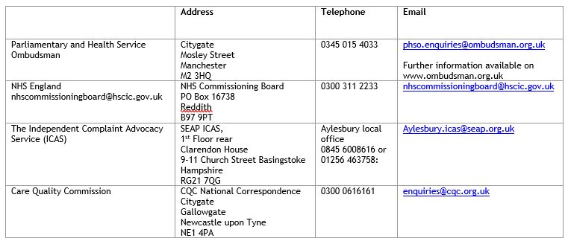

Care Quality Commission

This Medical Centre is registered with the Care Quality Commission.

The Care Quality Commission is the independent regulator of all health and social care services in England. It is their job to make sure that care provided by hospitals, GP surgeries, dentists, ambulances, care homes and services in people’s own homes and elsewhere meets national standards of quality and safety.

How our registration with the CQC will benefit patients:
- They protect patients by tackling poor care and unsafe care services.
- Patients can be assured that practices are inspected regularly and are meeting the standards they should be able to expect.
- The information they publish will help patients make informed choices about where they receive care and what they can expect.
- Patients can communicate directly with CQC if they have concerns about their care or want to give feedback.
- Their judgements are patient-focussed, and they check if patients’ experience of care is what they should be able to expect.
- Patients should experience consistent standards of care, whether they're receiving health or social care, because the essential standards apply to all health and social care services.
- Patients will know that they're being treated by staff who have the right qualifications to do so.

You can also refer any complaints to the CQC:
Tel: 03000 616161
Email: enquiries@cqc.org.uk
Address: CQC National Correspondence, Citygate, Gallowgate, Newcastle upon Tyne, NE1 4PA

Integrated Care Board

We work with ICBs to commission (or buy) a range of services on your behalf such as hospital and dental services, optometry, pharmacy, mental health services and the Ambulance Service.

We work closely with local partners, patients and the public to improve health, reduce inequalities and integrate health and social care services.
Contact details:
Tel: 0800 148 8890
Email: blmkicb.contactus@nhs.net

Patient Participation Group (PPG)

We encourage our PPG to be made up of a diverse group of patients ranging in age from sixth form students, parents with young children through to retired people with a lifetime of experience.

The group works with the practice to explore the changing needs of patients and provide feedback to the practice of any change you would like to see.

Contact Address:
The PPG, Newport Pagnell Medical Centre,
Queens Avenue, Newport Pagnell, MK16 8QT
blmkicb.npmcppg@nhs.net

Patient Reference Group (PRG)

As a surgery, we would like to know how we can improve our service to you and how you perceive our staff and surgery.

To help us with this, we have a ‘virtual Patient Reference Group’ called the PRG whereby membership enables you to have your say. We will ask the members of this representative group some questions from time to time, such as what you think about our opening times or the quality of care and/or service you have received. We will contact you via email and keep our surveys succinct so it shouldn’t take up too much of your time.

We aim to have a group of at least 100 patients from as broad a spectrum as possible in order to obtain a representative sample of our total population. If you are happy for us to contact you occasionally via email, there is a form available to complete on our website.

Useful Numbers & Websites

NPMC Surgery 01908 611767

NPMC Appointments 01908 617111

NHS 111

Milton Keynes Hospital 01908 660033

Northampton Hospital 01604 634700

Bedford Hospital 01234 355122

Jardine’s Pharmacy 01908 610583

Samaritans 01908 667777

Smoking Cessation 0300 1231044

NHS Choices: www.nhs.uk
National Pharmacy Association: www.askyourpharmacist.co.uk
Consumer Health Information Centre www.chic.org.uk
Self Care Forum www.selfcareforum.org

NEWPORT PAGNELL MEDICAL CENTRE, Queens Avenue, Newport Pagnell, MK16 8QT
NPMC@Willen, Beaufort Drive, Willen, Milton Keynes, MK15 9EY
NPMC@Kingfisher, 26 Elthorne Way, Newport Pagnell, MK16 0JR

Tel: 01908 611767
Email: blmkicb.npmcmail@nhs.net Website: www.npmc.nhs.uk

