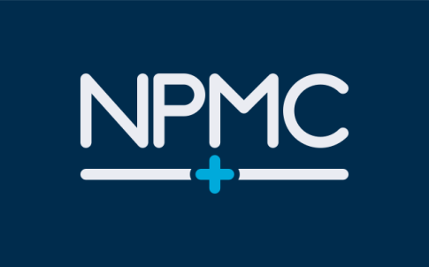
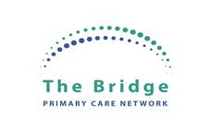

Newport Pagnell Medical Centre

(part of The Bridge Primary Care Network)

Fair Processing Notice

Information for patients

Information about you and the care you receive is shared in a secure system to support your treatment and care. It is important that the NHS can use this information to plan and improve services for all patients. Information is linked from all places where you receive care, such as from your GP, hospital or other community service, to provide a full picture. This allows the care you received in one area to be compared against the care you have received in another, so we can see what has worked best for you.
Information such as your postcode and NHS number, but not your name, will be used to link your records in a secure system, your identity is protected. Information which does not reveal your identity can then be used by others, such as researchers and those planning health services, to make sure the best care possible is provided for everyone.
You have a choice. If you are happy for your information to be used in this way you do not have to do anything. If you have any concerns or wish to prevent this from happening, please complete the “opt out form” on our website, https://www.npmc.nhs.uk/patient-record or collect one from reception and return it to the practice. You will also be given this form upon registering with the practice.
We have a duty to make sure that you know this is happening and the choices you have, when you make your decision please remember that information helps to provide better care as explained in the Data Protection Privacy Notice for Patients.
Fair processing under the Data Protection Act 2018 ensures Newport Pagnell Medical Centre is required to process personal data fairly and lawfully. The methods by which these processes are governed and explained to patients are known as ‘fair processing’. The General Data Protection Regulation (GDPR) ‘encompasses the obligation to provide fair processing information, typically through a privacy notice. It emphasises the need for transparency over how personal data is accessible.
Fair processing includes: informing patients about what type of information will be collected, how it is intended to be used, how it may be shared providing assurance that patient data will be safe, confidential and used appropriately.
How your information is used and shared is controlled by law and strict rules are in place to protect your privacy. We need to make sure that you know this is happening and the choices you have. Please take time to read this. You need to make a choice. Benefits of sharing information can help improve understanding, locally and nationally, of the most important health needs and the quality of the treatment and care provided by local health services. It may also help researchers by supporting studies that:
- Identify patterns in diseases
- Responses to different treatments and potential solutions
- Find more effective ways of preventing, treating and managing illnesses
- Guide local decisions about changes that are needed to respond to the needs of local patients
- Support public health by anticipating risks of particular diseases, conditions and help to take action to prevent problems
- Improve public understanding of the outcomes of care, giving confidence in health and care services which guide decisions about how NHS resources will be managed fairly so that they can best support the treatment and management of illness for the benefit of patients.
What happens with the information? Only the minimum amount of information needed to help improve patient care and the services provided is used. A thorough process is followed before any information can be shared. We sometimes release information to approved researchers, if this is allowed under the strict rules in place to protect your privacy. We are very careful with the information and we follow strict rules about how it is stored and used. We will make sure that the way we use information is in line with the law, national guidance and best practice. Reports that are published will never identify a particular person.
Do I have a choice? Yes. You have the right to prevent confidential information about you from being shared or used for any purpose other than providing your care, except in special circumstances. If you do want not any identifiable information relating to yourself to be shared outside of Newport Pagnell Medical Centre please complete an opt out form which is available on our website https://www.npmc.nhs.uk/patient-record and from Reception. This will then be recorded in your medical record. This will prevent your confidential information being used other than where necessary by law (for example, if there is a public health emergency).
This will restrict the use of information held by other places where you receive care, such as hospitals and community services. Your choice will not affect the care you receive.
If you are happy for your information to be shared you do not need to do anything.
You can also get further information from www.hscic.gov.uk.

