
You and Your General Practice

What You Can Expect (Your Rights)


Contacting Us
  - Open Monday–Friday, 8:00 AM–6:30 PM
  - Call us, visit in person, use the NHS App, or our website

When We’re Closed



  - Urgent (non-emergency)? Call 111 or visit NHS 111 online
  - Emergency? Call 999 or go to A&E

Appointments
  - Tell us what you need so we can help quickly
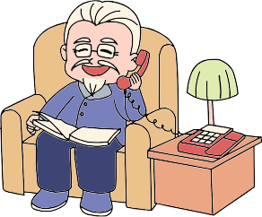
  - We’ll reply within one working day with:
  - Same-day/Future appointment
  - Phone call or message
  - Advice From pharmacy or NHS service

Who You Might See

  - GP, nurse, pharmacist, or other trained staff
  - Carers can speak for you with your consent
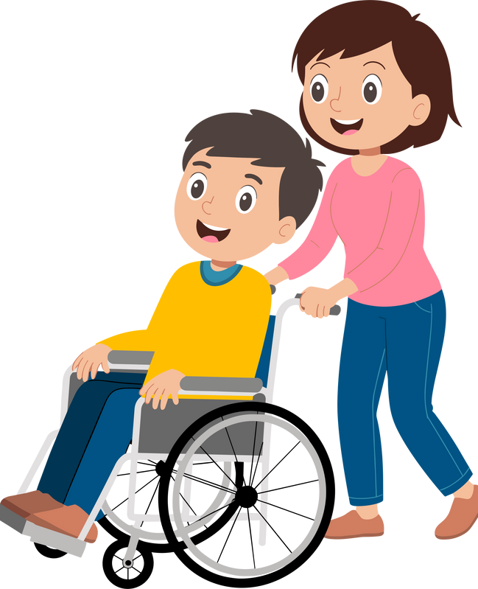

  - You can ask for a preferred clinician (may wait longer)

Extra Support
  - From age 16, you can book alone
  - Tell us if you need a translator, wheelchair access, or extra help

Your Rights
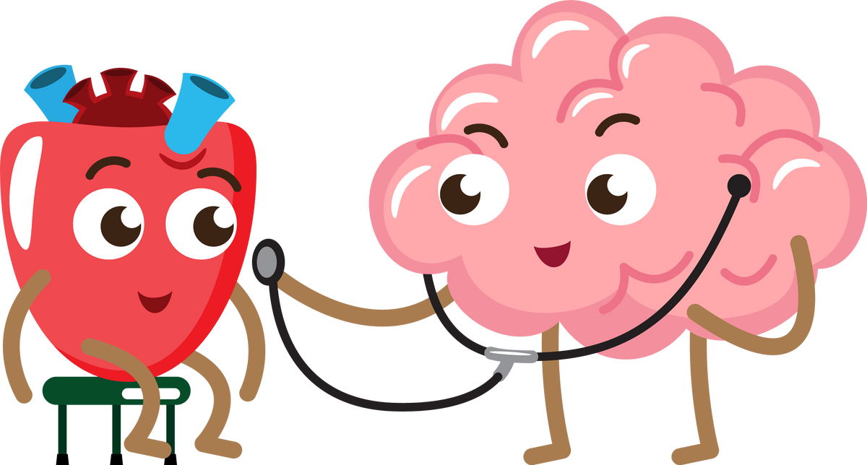
  - Register with any local practice — no ID or proof of address needed
  - Choose your hospital for referrals if available
  - Be treated with respect, kindness, and Fairness




You and Your General Practice

How You Can Help

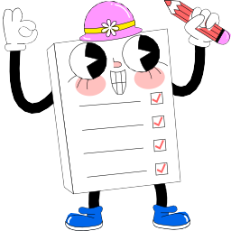
Be Ready
we can make
your care better!
  - Think about what you want to say before your appointment

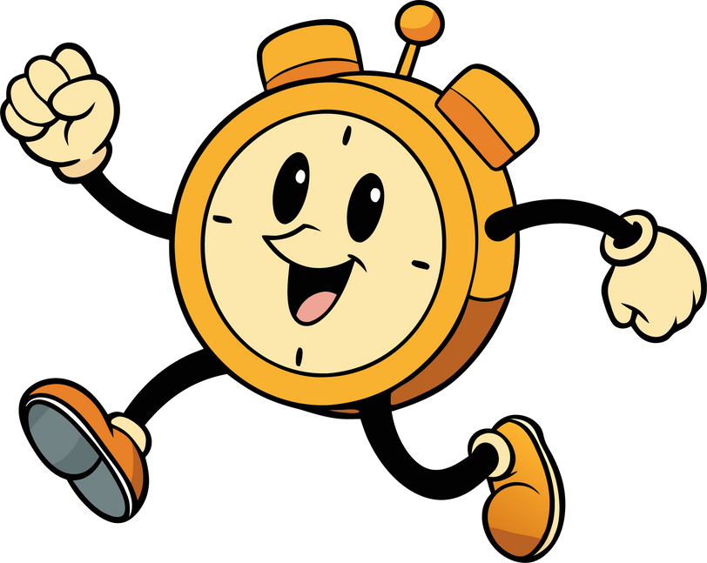
Be On Time
  - Arrive promptly or cancel if you can’t come

Use Services Wisely
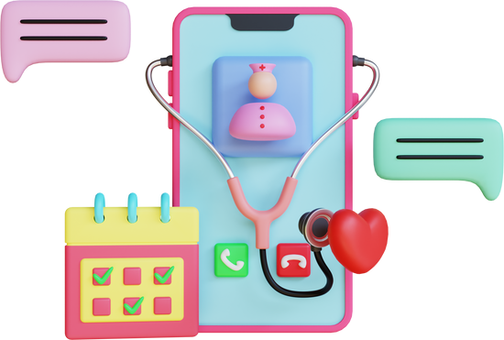
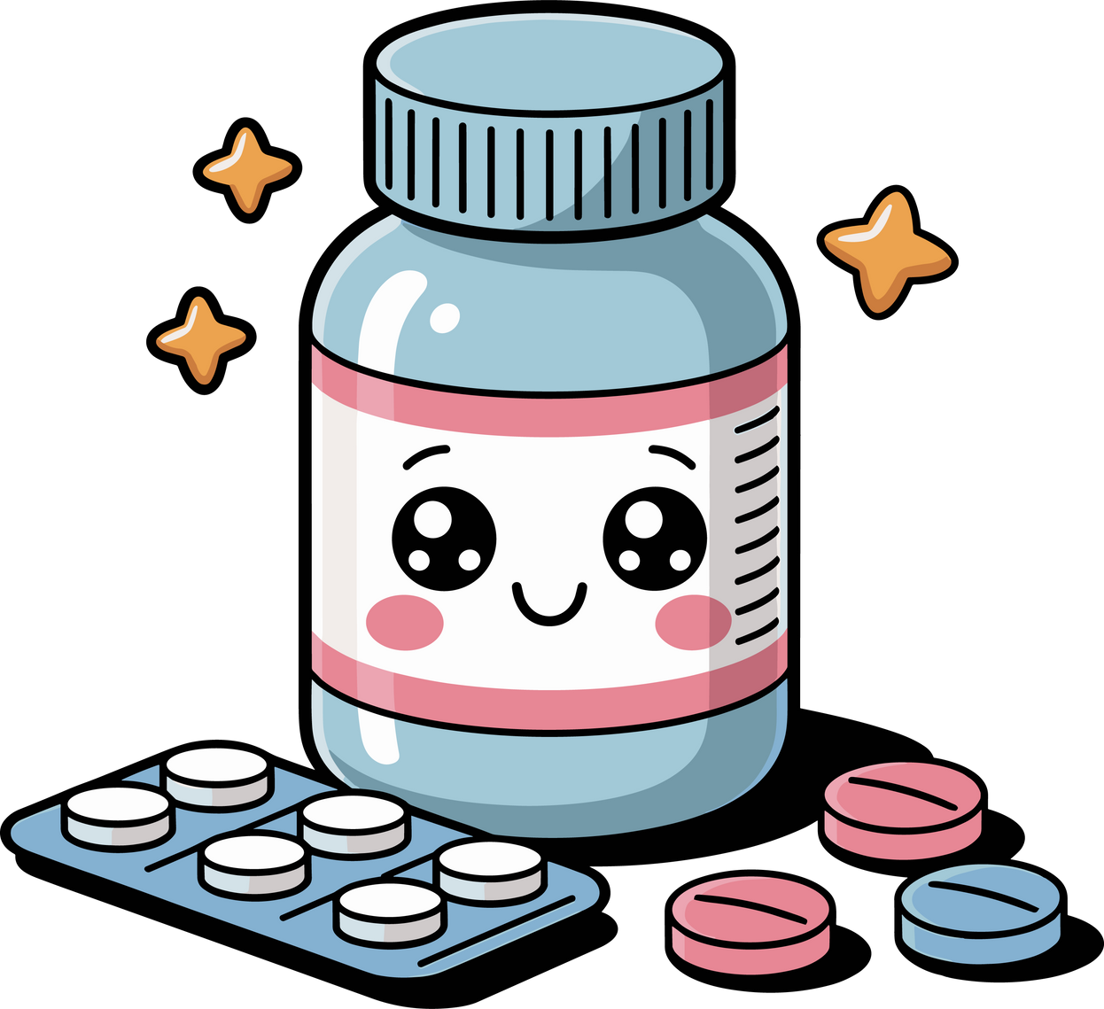
  - Use the NHS App for prescriptions, and results
  - Turn on notifications so you don’t miss messages
  - Order only what medicines you need

Join In
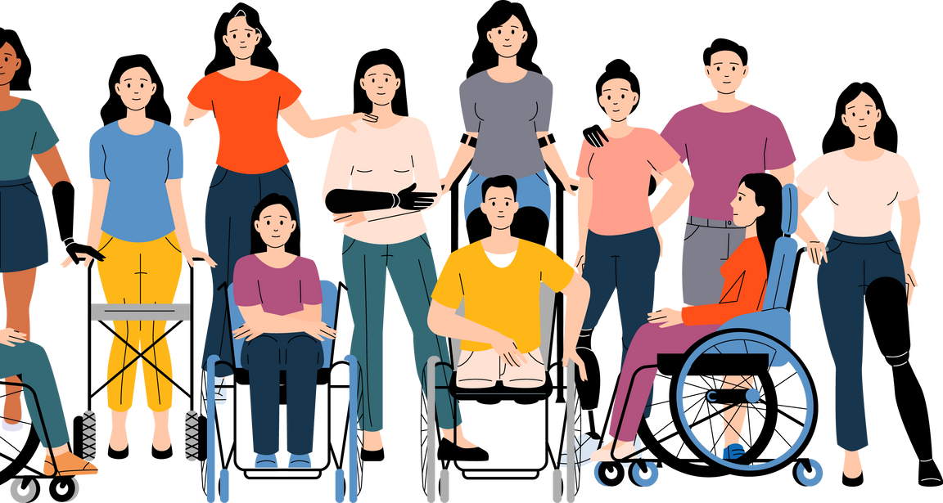
  - Join the Patient Participation Group to share ideas


Give Feedback
  - Speak to the Practice Team
  - Or contact Healthwatch or Lincolnshire Integrated Care Board
Together,

