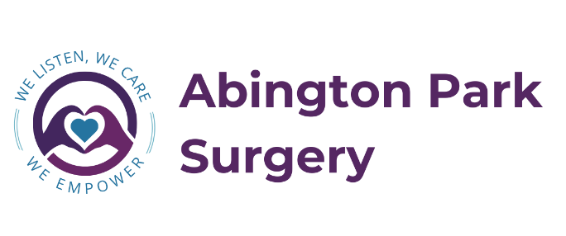

Patient Participation Group (PPG) Meeting Agenda/Minutes

Notes of meeting held on 5th Sep 2024
Abington Park Surgery

Present:

- Hannah Farrell HF
- Gina Centrella GC
- Harry
- Theresa
- Susan

Welcome and thanks to all who attended and supported promoting the PPG and the NHS app.  We have had 11 applications which will be reviewed so we have a diverse group, and they will be contacted with a response and invite to the next meeting. | GC
- Surgery update – Total Triage  As part of our contract with the NHS we are going to a system of “total triage” from 30th Sep 24.  This will give all patients equal access to appointments. An online form will be completed of 5 simple questions such as your concern, how long you have had it, what have you tried and your expectations, this will be triaged by a team (Current plan is GP, higher level nurse and receptionist but may be changed to 2 GP’s, paramedic). You will then be contacted within 24 hours with either an appointment or link to make an appointment or other suitable outcome. Advice may be to see a nurse, paramedic or pharmacist, or to see a GP on either a red on the day appointment, an amber appointment within 5 days or a green general appointment.  More details will be going out to all patients over the next 2 weeks.  The form will be available on the website, the NHS app or via the link we send. For patients that don’t have access such as no smartphone, can’t read/write they can still call in and fill it in with a receptionist or if they come in person, they will have support to complete it.  We asked for volunteers to trial this when ready and Harry, Theresa and Susan were happy to do this and then we will be asking for volunteers to come into surgery once it’s up and running to possibly complete a questionnaire with patients about the new triage system. | HF
- Surgery update - Website  We are in the process of updating our website to make it more use friendly.  Can I ask you to log on to the current website, tell us any difficulties, what you like, what you don’t like, and anu ideas of what you would like to see.  If you could send responses to gina.centrella@nhs.net | GC
- PPG

We want this to be your group, so we’re looking for ideas of what you would like to do. Ideas from the group?

Theresa will look out for some guidelines/formats for PPG.

We discussed about getting an active PPG member from another surgery in to discuss ideas and what they do and what works for them. (Todays attenders thought this was a good idea)

Today’s group thought it would be good to get a GP in for a few minutes to give an update – if this is something you all agree we can get people into the meetings.

We thought it would be good for you as the group to discuss what you would like on the agenda, if the chair could then put it together and share with us 2 weeks before the meeting then we can add surgery updates and make any arrangements for people/speakers. For this to work it would mean you all being in touch outside of the meeting, so Theresa suggested a WhatsApp group.

If you would like me to share your name, email and mobile number for Theresa to add you to this group please email them to me ( Gina).

- OAB

We spoke about how we want to support different groups of patients such as carers and veterans and we would like your support if we hold coffee morning as such for them.

I am on holiday for the next week so any emails after today will be dealt with on my return

- Next meeting

5th Dec 24 13:30 – 14:30

