Transport Guide

York Street Health Practice (LS9 8AA)

Address: 68 York Street, Leeds, LS9 8AA

🚶 Walking
- The practice is in Leeds city centre, close to shops and services.
🚌 Buses
- Leeds City Bus Station is a short walk away (about 3 minutes).
- Map link: https://goo.gl/maps/LeedsBusStation
🚆 Trains
- Leeds Railway Station is about 15 minutes’ walk from the practice.
- Map link: https://goo.gl/maps/LeedsTrainStation
🚖 Taxis
- Taxi ranks are near the bus and train stations.
- Private taxis can be booked by phone or app.
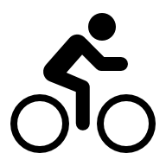
Bike
- There are on street bike racks, opposite, outside Northern Ballet.
- There are bike lanes outside the practice which go into Leeds centre centre and up York Road/towards St James's Hospital.

