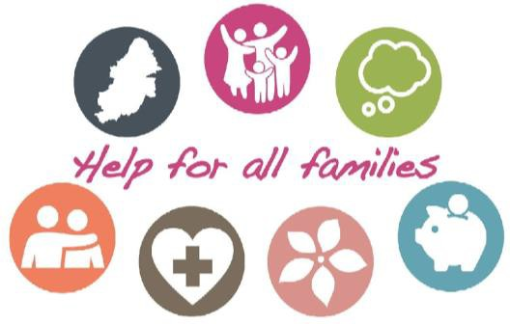

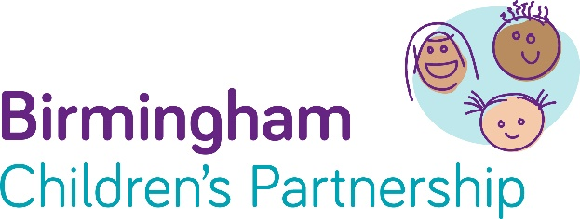

From Birmingham with love – Here are some of our partners’ most used services and support, which might make life a little bit easier…

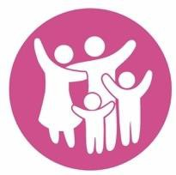
- Online parenting course. We’ve pre-paid for every parent in Birmingham to access a parenting course. Just enter the access code “COMMUNITY” at the top of the page to claim. There are courses for parents, carers and grandparents of children from bump to 19. Learn about how your child develops and get tips to manage their behaviour.



- Mental health support. In these difficult times we have to look after our mental health. For young people aged 11-25 there are forums, guides and counselling available completely free at Kooth. If your child 0-25 needs support, get in touch with Pause by calling 0207 841 4470 or email. Adults can get support from MIND by calling 0121 262 3555. Or for urgent help call Forward Thinking Birmingham on 0300 300 0099. And remember to stay active.


- Financial help. If you’ve lost your job or are struggling for food or rent, there are services that can help. Local welfare provision can make a big difference if you are in a crisis and need food, fuel or basic white goods. Discretionary Housing Payments may be able to help with rent. And there are food banks across Birmingham that are here to help.

- Domestic abuse. For women and children affected by domestic abuse please see guidance or confidentially contact Birmingham and Solihull Women’s Aid.
For Men, please contact Respect. In addition Ask for ANI and the Safe Spaces scheme where victims can access help through pharmacies.

- Problems with drugs or alcohol. A new, discrete app called Staying Free is available on Android or Apple. Use the code “birmingham11” for pre-paid access. To speak to someone call Change Grow Live.
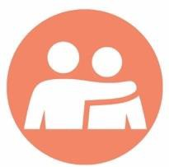
- Bereavement support. It’s a terrible time to lose a loved one — you can get help by calling 0121 687 8010 or from Cruse.

- Warm Spaces – A list of places offering a hot drink, biscuits and chat: Birmingham Warm Welcome Spaces | Birmingham Warm Welcome Spaces | Birmingham City Council


- Early help for families. If anyone in your family needs more help, from public services or community groups, then please contact our voluntary sector local leads. We have ten areas which can connect you to support across the city.

If you are worried about a child, please call Birmingham’s Children's Advice and Support Service on 0121 303 1888. In an emergency, including child abuse, contact the Police on 999. You can also chat to the Police.
For any other help, from public services or community groups, then please contact our voluntary sector local team. There are ten area hubs across the city which can connect you to support.

