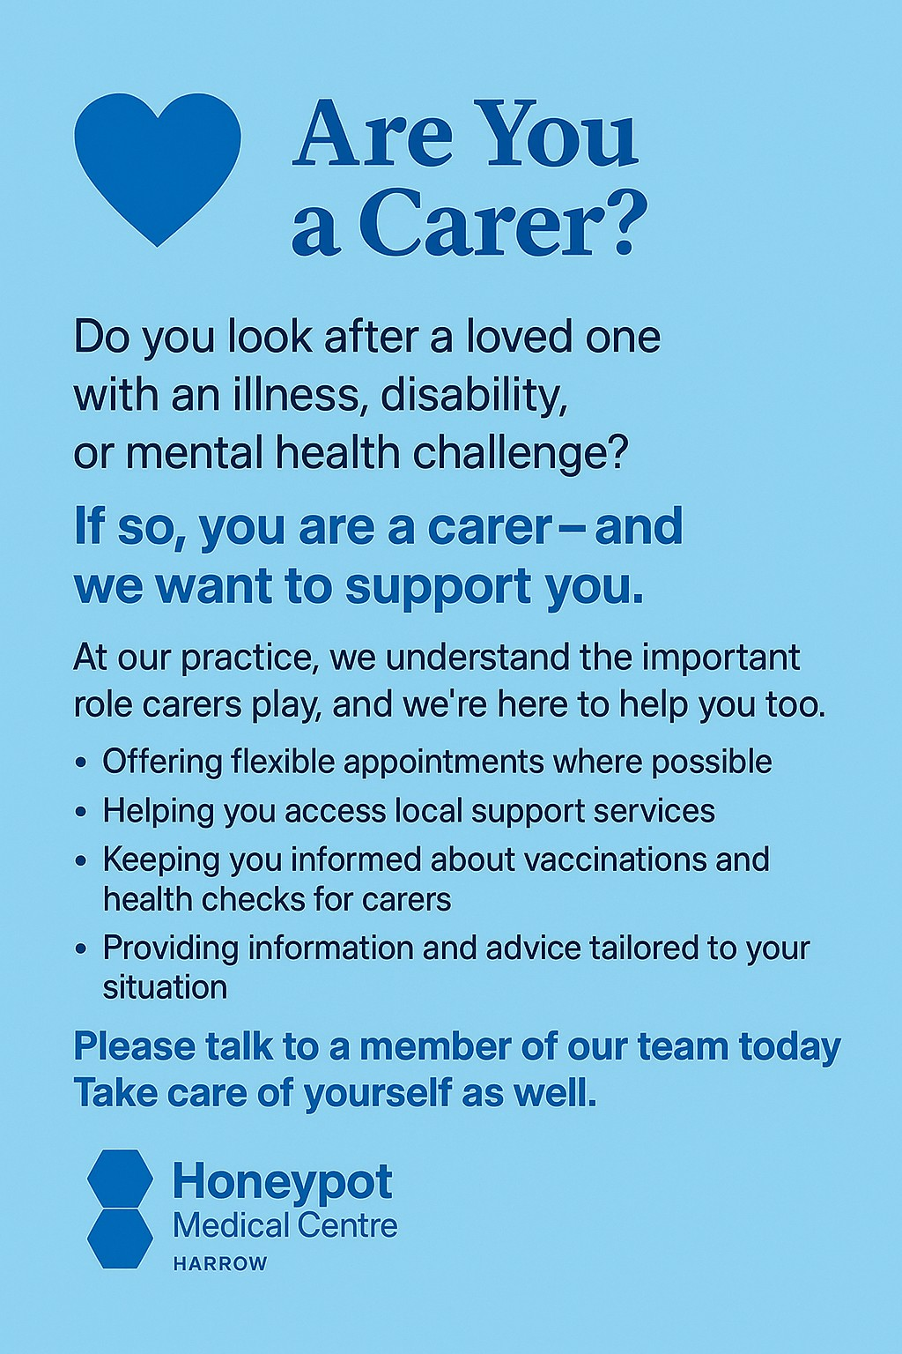
Are you currently caring for someone?
A carer is anyone who looks after someone needing help - Anyone who provides unpaid care for a family member, friend or neighbour due to illness, disability, mental health condition or addiction is a carer.

To tell us you are a carer for someone you can fill out this registration form. Please fill out this form and hand it back to one of the reception team. We want to support patients who are in a caring role and so we encourage carers to speak to a member of the reception team about booking an annual carer health check.
A carer health check is a proactive review offered to unpaid carers by GP practices. Its aim is to support carers physical, emotional and mental wellbeing, recognising the impact caring can have on their health. Typically, it involves a physical health review, mental health and emotional wellbeing, social and practical support, care role assessment and a follow up and action plan. Anyone who provides unpaid care for a family member, friend or neighbour due to illness, disability, mental health condition or addiction is a carer and eligible for a health check.

Carer

Name:
Address:

Telephone/Mobile: NHS Number (if known):
Email: DoB:
GP Surgery:
I give consent for my details to be held, as a carer, by the GP/Surgery and for them to contact me about the patient named below as necessary
Yes / No

Signed: Date:
Person being supported or cared for

Name:
Address (if different from the carer above):

Telephone/Mobile: NHS No (if known):
Email: DoB:
GP Surgery:

Please send completed forms to: nhsnwl.honeypot@nhs.net

