
Patient Completed Physiotherapy Self-Referral Form
(Not available for patients under 16 years)

Date:

GP Name GP Surgery

You can now self-refer to physiotherapy for muscle and joint problems without needing to see your GP. Please read and complete all parts of this form.

Please consult your GP URGENTLY or NHS 24 by calling 111 if you have recently/suddenly developed:  - Difficulty passing urine or controlling bladder / bowels  - Numbness or tingling around your back passage or genitals  - Numbness, pins and needles or weakness in both legs |  | Please inform your GP of this referral if you:  - Have recently become unsteady on your feet  - Are feeling generally unwell / fever  - Have a history of cancer  - Have any unexplained weight loss
Name: Date of Birth: (not available for those under 16 years) M / F
Address:
Postcode: Telephone Home:
Telephone Mobile: Do you consent to receiving text messages: Yes / No
Do you have any special requirements? (e.g. interpreter) Yes / No Please describe:

Email:
Do you consent to receiving emails from the MSK service? Please circle Yes / No
Please mark on the diagram below the location of your main problem with a cross (X) where you are having your symptoms  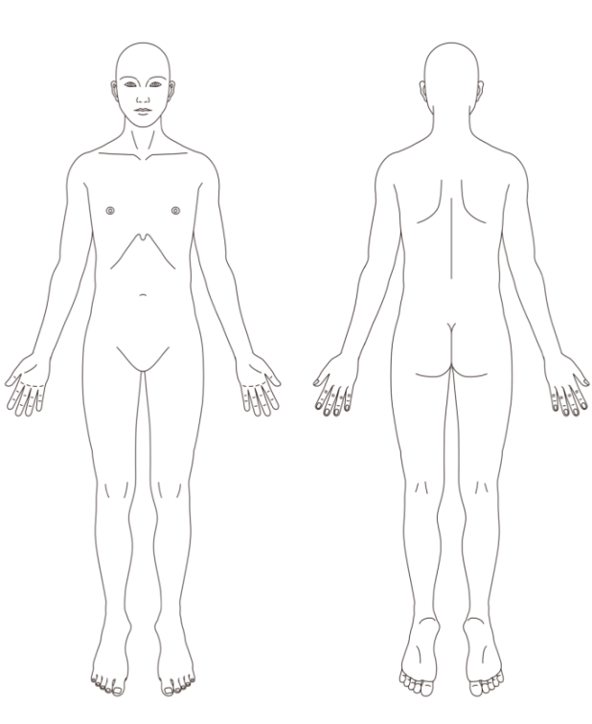 | Is your pain / problem due to a recent fall or injury? Yes / No  Please describe your current problem and symptoms below:  Please turn over

Please answer the following questions about your current problems and how they affect you, on average, over the course of a week.

Are your day to day activities affected by your symptoms? | Not at all Mildly Moderately Severely
Are your symptoms disturbing your sleep? | No Yes, difficulty getting to sleep  Yes, woken up from sleep Yes, unable to sleep at all
If in pain, how would you describe it? | Mild Moderate Severe
How long have you had your current problem? Please state how long if more than 12 weeks | Less than 2 weeks 2-6 weeks 7-12 weeks More than 12 weeks ______ weeks
Have you had physiotherapy for this problem before? | Yes No If yes, how long ago? ________________  Did it help? Yes / No
Did your problem start: | Gradually Suddenly As a result of an injury
Are your symptoms: | Improving Staying the same Worsening
Are you: | Still working Off sick due to this problem On long term disability  Other e.g. retired / student / carer/ parent (please circle)
Employment status – are you: | Employed Unemployed Retired Student Carer
Due to your current problem are you unable to?  Please give details: | Work Play sport Care for a dependent Drive Other

Please tick the box where you would like to have your Physiotherapy:

Please post, email or deliver in person to:  MSK Physiotherapy Department  Ashfield Health & Wellbeing Centre  Portland Street  Kirkby in Ashfield, NG17 7AE  Email address not-tr.mska-mphysiotherapy@nhs.net  OR  Return it to the receptionist at your GP practice | Physiotherapy is provided at clinics listed below. Please tick where you may wish to be treated.  Ashfield Health and Wellbeing Centre  Newark Hospital, Newark  Collingham Medical Centre  Crown (Clipstone) Medical Centre  Southwell Medical Centre  Mansfield Community Hospital  Kings Mill Hospital Mansfield  If necessary, you will be offered a choice of where to be seen, but we reserve the right to withdraw a location if waiting times become excessive.

