MERSHAM MEDICAL CENTRE

Health Check for People with a Learning Disability

Please fill in these pages with the help of your carer (if you have one) before you come and visit the doctor.

Please bring with you all your medicines whether prescribed by the doctor or not, your health action plan if you have one and a urine sample in a small bottle.

Date of health check
Name
Date of Birth
Male / Female
Address

Main Carer
Key social care contact
(name and contact
details)

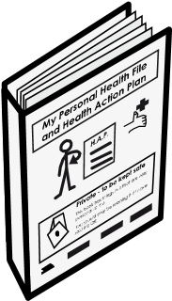 | Do you have a Health Action Plan? Yes ◻ No ◻  If so, please fill it out and bring it with you to your appointment.
 | I communicate by… (tick as many as you like)
 | Talking ◻
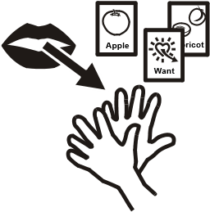 | 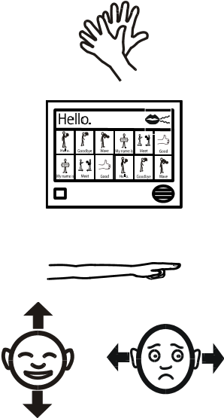  Signing ◻  Using a communication aid ◻  Pointing ◻  Using gestures  (nodding, raising eyebrows) ◻

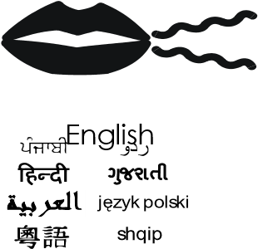 | The language I speak and understand best is...
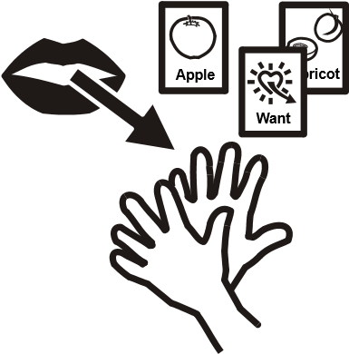 | Do have any difficulty in Yes ◻ No ◻ communicating?  If you do, what help do you need to communicate?
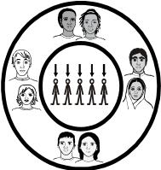 | Ethnicity
 | Religion
 | Do you have a job |  | Yes ◻ No ◻
 | What job do you do?
 | Who looks after you? Tell us the names of all the people who look after you.
 |  | Family carer:
 |  | Paid carer:
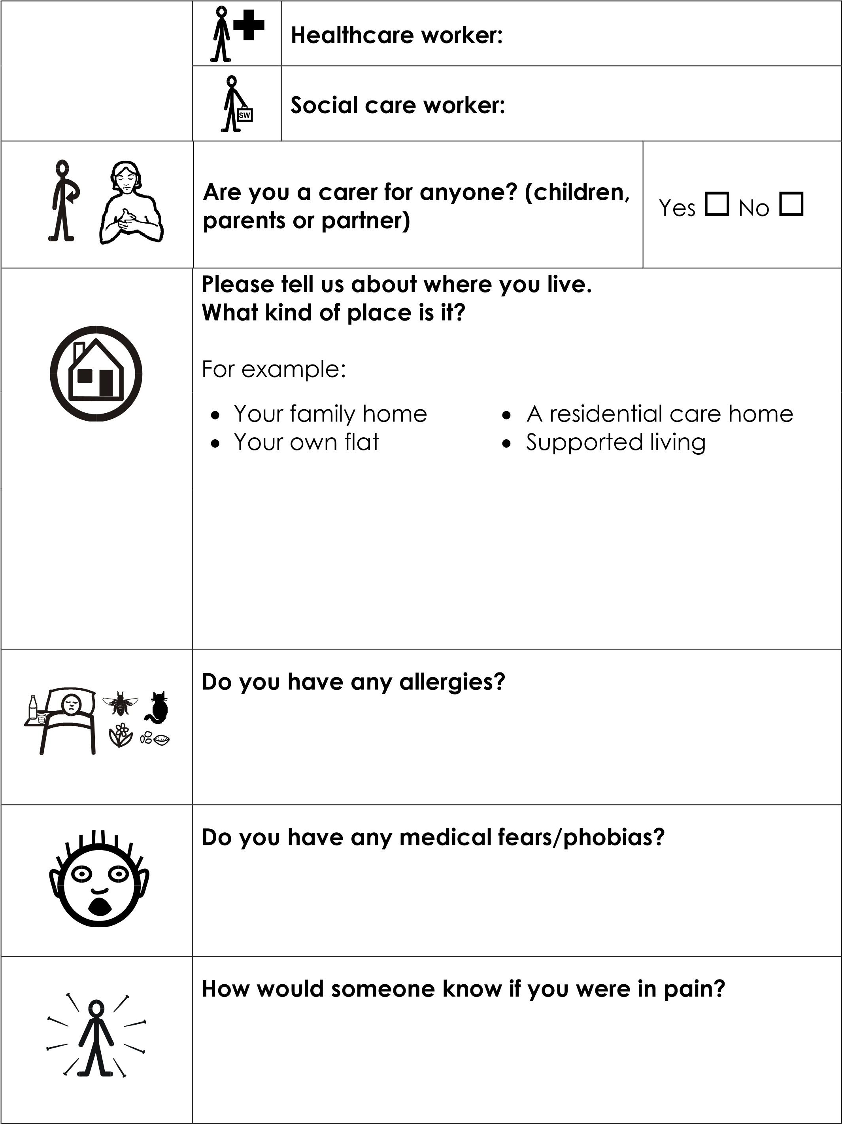

 | Do you have any problems with your eyes and seeing things?  What was the date of your last optician’s appointment? | Yes ◻ No ◻
 | Do you have any difficulty hearing? | Yes ◻ No ◻
 | Do you have a hearing aid? | Yes ◻ No ◻
 | Do you wear it? | Yes ◻ No ◻
 | Do you visit an audiologist?  Date of your last appointment? | Yes ◻ No ◻
 | Do you have any problems with your teeth or mouth?  If so, what? | Yes ◻ No ◻
 | Do you visit the dentist regularly?  Date of last appointment? | Yes ◻ No ◻
 | Do you have any problems with your feet?  If so, what? | Yes ◻ No ◻
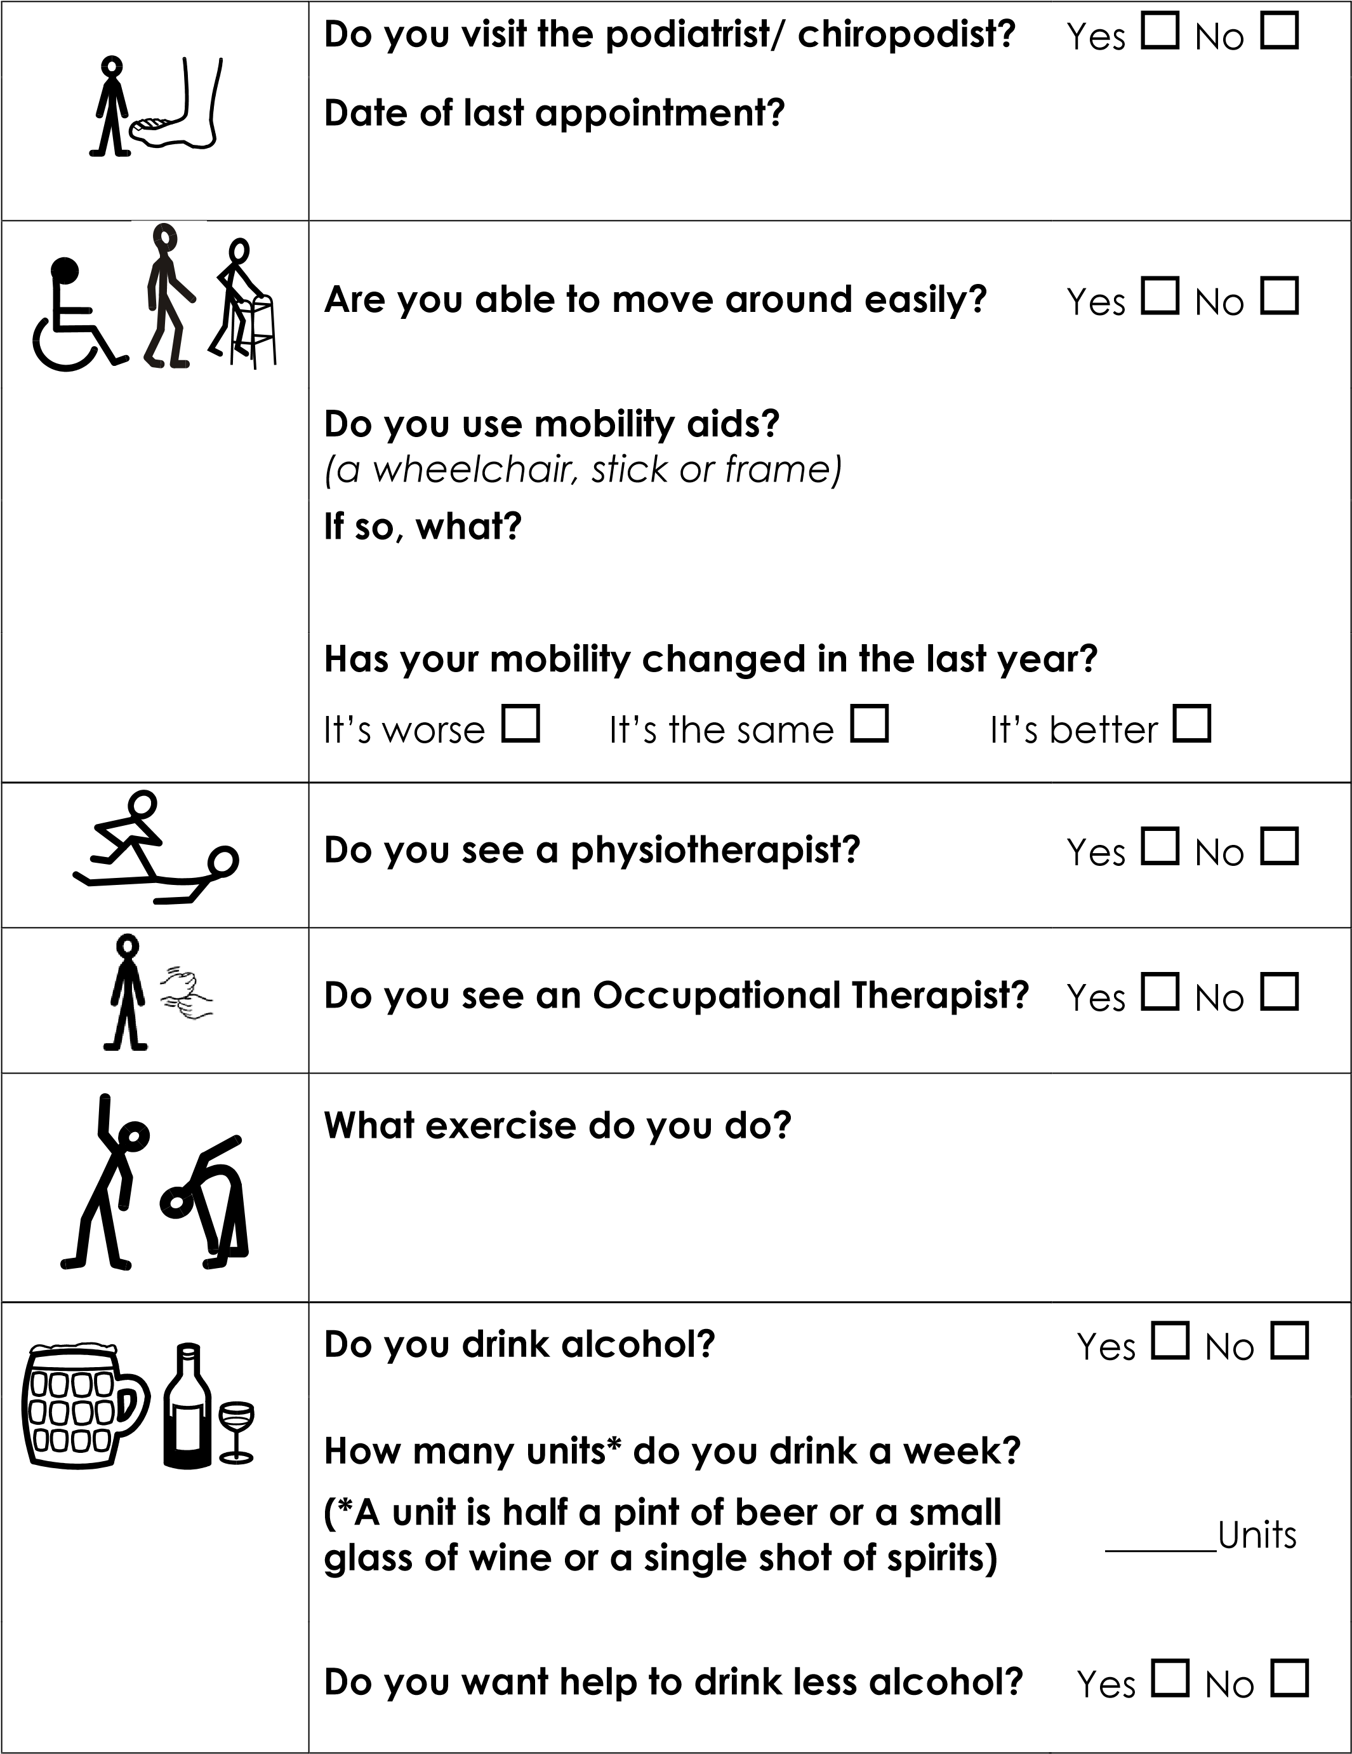

 | Do you smoke? | Yes ◻ No ◻
 | How many cigarettes a day? | ______
 | Would you like help to stop smoking? | Yes ◻ No ◻
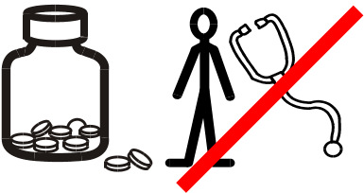 | Do you take any tablets or medicines that are not from your doctor? E.g.  vitamins, painkillers, laxatives | Yes ◻ No ◻
 | Do you use any drugs like cannabis, ecstasy etc  If Yes, do you want help to stop using these drugs? | Yes ◻ No ◻  Yes ◻ No ◻
 | Do you have sex? | Yes ◻ No ◻
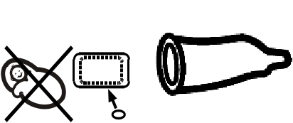 | Do you use contraceptives? | Yes ◻ No ◻
 | Do you have problems sleeping? | Yes ◻ No ◻
 | Do you ever try to hurt yourself? | Yes ◻ No ◻
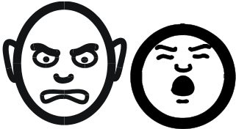 | Do you get angry and shout at people a lot? | Yes ◻ No ◻
 | Has your appetite changed recently? | Yes ◻ No ◻

 | Do you feel anxious and worried a lot of the time? | Yes ◻ No ◻
 | Do you feel sad for long periods of time and find it difficult to cheer yourself up? | Yes ◻ No ◻
 | Do you or your carer think there has been a change in your memory? | Yes ◻ No ◻
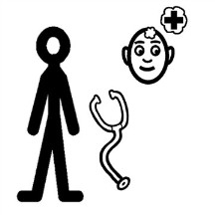 | Do you see a psychologist? | Yes ◻ No ◻  Yes ◻ No ◻
 | Are you worried about your weight?
 | (either putting on too much weight or losing weight)
 | Do you have any difficulties eating and  drinking? Yes ◻ No ◻  If Yes, what help do you need with eating and drinking?  Do you have any problems with  swallowing? ^{Yes} ◻ ^{No} ◻  Do you have any burning pain in the  centre of your chest? Yes ◻ No ◻  (“heartburn” or indigestion)
 | Do you see a speech therapist to help you with eating, drinking or communication? |  | Yes ◻ No ◻
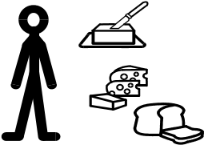 | Do you see a Dietician? |  | Yes ◻ No ◻
Do you have constipation or diarrhoea? Yes ◻ No ◻
Does it hurt when you wee? Yes ◻ No ◻
 | Is there any blood in your wee? | Yes ◻ No ◻
 | Do you have any other problems when you wee? | Yes ◻ No ◻
 | Do you have any problems with urinary (wee) incontinence? | Yes ◻ No ◻
 | Do you have any problems with faecal (poo) incontinence? | Yes ◻ No ◻
 | Do you see a continence nurse? | Yes ◻ No ◻
 | Do you have continence aids or medicine?  If so, what? | Yes ◻ No ◻

MEN AND WOMEN AGED 60 - 69:
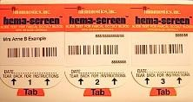 | If you are aged between 60 and 69, have you been sent a kit to test for bowel cancer?  When did you last do the test? | Yes ◻ No ◻

FOR MEN:

Has there been any pain or swelling in
your testicles?

Yes
◻

No
◻

FOR WOMEN:
 | Have you noticed any pain or lumps in your breasts? | Yes ◻ No ◻
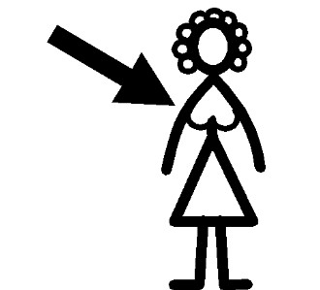 | If you are over 50, have you been for a breast screening test?  When was your last test? | Yes ◻ No ◻
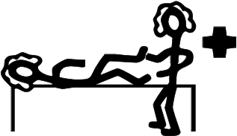 | If you are aged 25 to 64, have you had a cervical smear test?  When was your last test? | Yes ◻ No ◻
 | Do you have periods? | Yes ◻ No ◻
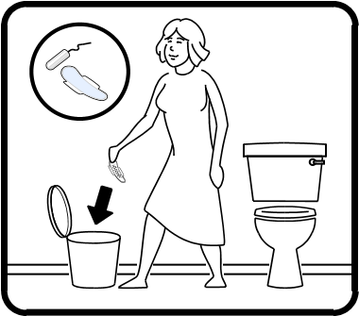 | Do you have any problems with your periods?  Are your periods painful?  Is the bleeding very heavy? | Yes ◻ No ◻  Yes ◻ No ◻  Yes ◻ No ◻
Is there any irregular bleeding?
(for example, between periods) ^{Yes} ◻ ^{No} ◻
Do you have any vaginal discharge that
is smelly or makes you sore? Yes ◻ No ◻

 | Do you have any problems with your hair, skin or nails?  If so, what? | Yes ◻ No ◻
12  3  1  4  5  7  8  10  11  2  6  9 | Are there any medical problems or illnesses that run in your family?
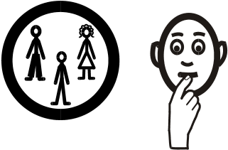  ?? | Do other people in your family have a  Yes ◻ No ◻  learning disability?
 | Do you have any other health conditions?
??  name | Does your kind of learning disability have a name?
?? | Were you born with the learning disability or did something cause it?
 | Do you see a psychiatrist? | Yes ◻ No ◻
 | Do you have epilepsy?  Do you know what kind of epilepsy you have?  In the last year have you started to shake or have movements that you cannot control? | Yes ◻ No ◻  Yes ◻ No ◻

 | Has your carer noticed that sometimes you are not concentrating? (e.g. seem to have absences) | Yes ◻ No ◻
 | Do you see a specialist doctor or nurse about your epilepsy? | Yes ◻ No ◻
 | Do you get any pain in your chest?  When does the chest pain happen? | Yes ◻ No ◻
 | Do you have any swelling of your ankles or feet? | Yes ◻ No ◻
 | Do you feel you have an uneven heart beat or your heart beating fast? | Yes ◻ No ◻
 | Do you have any pain in your abdomen? | Yes ◻ No ◻
 | Have you got any swellings in your groin? (just above the crease at the top of your legs) | Yes ◻ No ◻
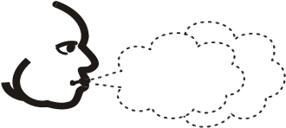 | Do you have any problems with your breathing? | Yes ◻ No ◻
 | Do you cough?  Do you cough up anything? | Yes ◻ No ◻  Yes ◻ No ◻
Simple Symbols © Somerset Total Communication 2011. Other symbols and photos © Nottingham Mencap 2012 Please do not reuse these images without permission.

